[**Politics**](https://www.cnn.com/politics)

[SCOTUS](https://www.cnn.com/politics/supreme-court)

[Congress](https://www.cnn.com/politics/congress)

[Facts First](https://www.cnn.com/politics/fact-check)

[2024 Elections](https://www.cnn.com/election/2024)

[Watch](https://www.cnn.com/video)[Listen](https://www.cnn.com/audio)[Live TV](https://www.cnn.com/live-tv)

Sign in

[[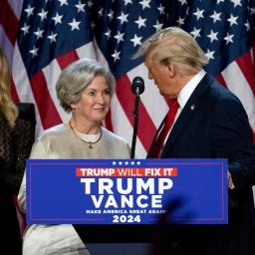](https://edition.cnn.com/politics/live-news/trump-transition-news-11-26-24/index.html)](https://edition.cnn.com/politics/live-news/trump-transition-news-11-26-24/index.html)

[The latest on Trump’s presidential transition](https://edition.cnn.com/politics/live-news/trump-transition-news-11-26-24/index.html)

[[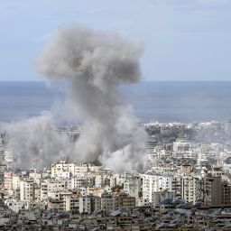](https://edition.cnn.com/world/live-news/israel-hezbollah-ceasefire-deal-gaza-war-11-26-24-intl-hnk/index.html)](https://edition.cnn.com/world/live-news/israel-hezbollah-ceasefire-deal-gaza-war-11-26-24-intl-hnk/index.html)

[Israeli cabinet vote on Hezbollah ceasefire deal](https://edition.cnn.com/world/live-news/israel-hezbollah-ceasefire-deal-gaza-war-11-26-24-intl-hnk/index.html)

**September 15, 2024: Apparent Trump assassination attempt**

[[](https://www.cnn.com/profiles/paul-leblanc)](https://www.cnn.com/profiles/paul-leblanc)[[](https://www.cnn.com/profiles/jack-forrest)](https://www.cnn.com/profiles/jack-forrest)[[](https://www.cnn.com/profiles/maureen-chowdhury)](https://www.cnn.com/profiles/maureen-chowdhury)[](https://www.cnn.com/profiles/kathleen-magramo)

By [Michelle Shen](https://www.cnn.com/profiles/michelle-shen), [Paul LeBlanc](https://www.cnn.com/profiles/paul-leblanc), [Isabelle D’Antonio](https://www.cnn.com/profiles/isabelle-dantonio), [Jack Forrest](https://www.cnn.com/profiles/jack-forrest), [Maureen Chowdhury](https://www.cnn.com/profiles/maureen-chowdhury), [Kathleen Magramo](https://www.cnn.com/profiles/kathleen-magramo) and Lex Harvey, CNN

Updated 7:05 AM EDT, Mon September 16, 2024

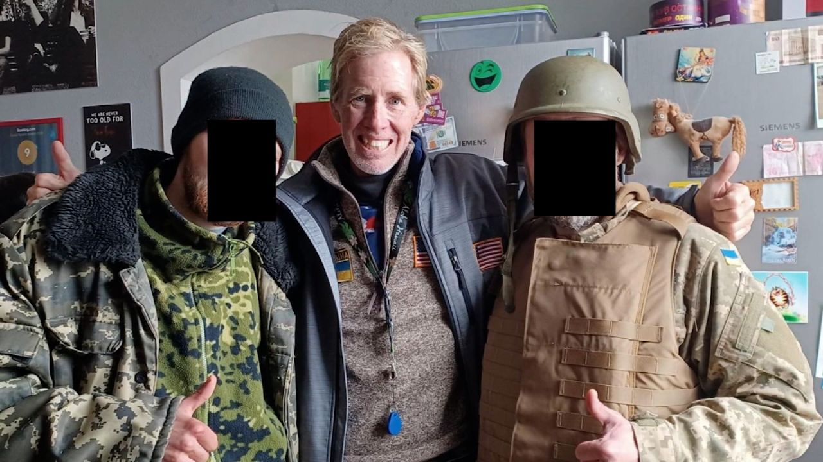

What we know about person detained in what FBI calls assassination attempt on Trump

03:46 - Source: [CNN](https://www.cnn.com/)

**What we covered here**

* The FBI said it “is investigating what [appears to be an attempted assassination](https://www.cnn.com/2024/09/15/politics/donald-trump-safe-shots/index.html)” of Donald Trump at his Florida golf club. Trump was not harmed in the incident.
* The Secret Service had [spotted a rifle barrel](https://www.cnn.com/politics/live-news/trump-harris-election-09-15-24#h_fff37e0df922eb36ec8dbd5cc87ead87) sticking out of a fence and agents fired at a man who was in the bushes along the perimeter, according to Palm Beach County Sheriff Ric Bradshaw. The suspect [fled in a car](https://www.cnn.com/politics/live-news/trump-harris-election-09-15-24#h_b2e7ea3e053ca5ac1f1396b6d8a6640d) and was detained after being stopped on the highway.
* The person detained is [Ryan Wesley Routh](https://www.cnn.com/2024/09/15/politics/trump-attempted-assassination-man-detained/index.html), according to three law enforcement sources. [Routh](https://www.cnn.com/2024/09/15/politics/trump-attempted-assassination-man-detained/index.html), who owns a small construction company in Hawaii, had criticized Trump on social media and is a [staunch supporter of Ukraine](https://www.cnn.com/politics/live-news/trump-harris-election-09-15-24#h_529831e69948ef34655b83035f6931ad).
* The suspect was [300 to 500 yards away from Trump](https://www.cnn.com/politics/live-news/trump-harris-election-09-15-24#h_fff37e0df922eb36ec8dbd5cc87ead87). Law enforcement [found](https://www.cnn.com/politics/live-news/trump-harris-election-09-15-24#h_f3f046e7ffc2a1f2a126176b552e366c) an AK-47-style rifle, GoPro camera and backpacks where the suspect was positioned.

AllCatch UpAnalysis

**87 Posts**Sort By           Latest           Oldest

6:55 p.m. 8:53:31, September 16, 2024

*Our live coverage of the apparent assassination attempt on Donald Trump*[*has moved here.*](https://www.cnn.com/politics/live-news/trump-assassination-attempt-election-news-09-16-24/index.html)

5:43 p.m. 8:53:31, September 16, 2024

**Routh wanted to create a foreign force to protect Taiwan. But some listed volunteers said they'd never heard of him**

By CNN’s Isaac Yee, Teele Rebane, Jessie Yeung

Ryan Routh had repeatedly called for bolstering Taiwan’s defenses [against China](https://www.cnn.com/world/asia/taiwan) and hoped to set up a foreign legion akin to that [in Ukraine](https://www.cnn.com/2024/09/15/politics/trump-attempted-assassination-man-detained/index.html).

The man, who was detained in connection with an apparent attempt to assassinate former president Donald Trump on Sunday, is listed as an “International Volunteer Center Coordinator” on a website named Taiwan Foreign Legion.

The group claims it is “recruiting former military and civilians from around the world” willing to defend Taiwan in the event of a war with China.

CNN reached out to over a dozen people listed as “supporters” on the group’s website. But several said they had not heard of the group or its activities, and some had never heard of Routh.

All claimed they did not know how their names and contact information had been shared on the pro-Taiwan website.

Unlike Ukraine, Taiwan does not have an official foreign legion. Taiwan’s Foreign Ministry and Defense Ministry declined to comment on Routh.

China’s ruling Communist Party says Taiwan is part of its territory, despite never having controlled it, and has vowed to take the island by force if necessary.

The US is bound by law to supply the self-governing island with weapons to defend itself, and support for Taiwan is a rare issue of broadly bipartisan consensus in Washington.

5:04 p.m. 8:53:31, September 16, 2024

**Ryan Routh criticized Trump in his self-published book on the Ukraine war**

From CNN's Jessie Yeung

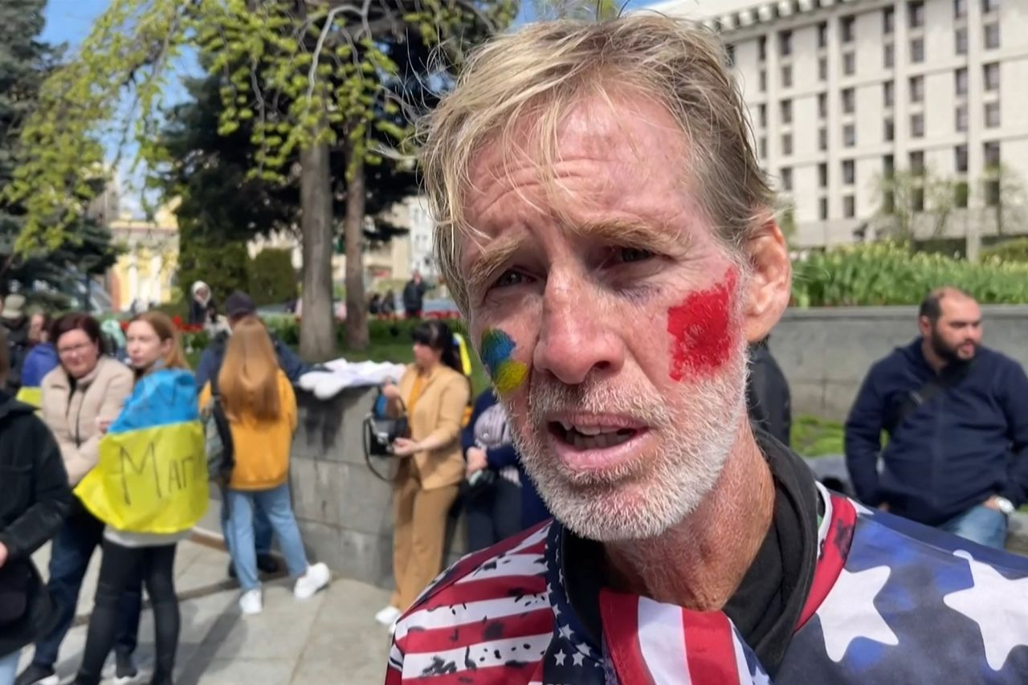

Ryan Wesley Routh attends a rally to urge foreign leaders and international organisations to help provide humanitarian corridors for the evacuation of civilians and Ukrainian servicemen from Mariupol, Ukraine, on April 27, 2022.

AFP/Getty Images

[Ryan Wesley Routh](https://www.cnn.com/2024/09/15/politics/trump-attempted-assassination-man-detained/index.html) decried Donald Trump as an “idiot,” a “buffoon” and a “fool” in his self-published book on the war in Ukraine and geopolitics.

The 58-year-old, who was detained Sunday in connection with an [apparent assassination attempt on Trump](https://www.cnn.com/2024/09/15/politics/donald-trump-safe-shots/index.html), [wrote last year about his unsuccessful efforts to aid Ukraine](https://www.cnn.com/politics/live-news/trump-harris-election-09-15-24#h_9de54118c4ba8e2b96e3545de07985bf) in its war against Russia and also weighed in on multiple global crises.

Routh wrote that the former US president’s withdrawal from the Iran nuclear deal in 2018 was a “tremendous blunder” that drove Tehran closer to Moscow, which it has supplied with drones that have caused devastation across Ukraine.

Routh also gave his opinions on the political situation in Afghanistan, and urged Afghan refugees to fight for Ukraine.

He also wrote about Taiwan, North Korea and Venezuela, drawing comparisons between the authoritarian rule of President Nicolas Maduro and the January 6 insurrection at the US Capitol.

“We have mirrored (Venezuela’s) devastating events with our own catastrophe on January 6th perpetrated by Donald Trump and his undemocratic posse,” Routh wrote.

Appearing to reference his former support for Trump, Routh wrote that he must take part of the blame for electing him as president, writing: “but I am man enough to say that I misjudged and made a terrible mistake.”

6:29 p.m. 8:53:31, September 16, 2024

**How global leaders are reacting to the apparent Trump assassination attempt**

From CNN's Lex Harvey

Leaders around the world are condemning the apparent assassination attempt on Donald Trump and offering their support.

*Here’s what they’re saying:*

* **Israel:**Prime Minister Benjamin Netanyahu said he and his wife Sara were “shocked by the second assassination attempt against President Trump and were relieved to hear that it too failed. But we should not rely on luck,” he said in a post to [X](https://x.com/israelipm/status/1835462455050342551?s=46&t=IV8KMN2S1o4Jt3KkL9I7ag), adding that he hopes “all measures will be taken to ensure that such deadly attacks on a candidate for the US presidency will be foiled in advance.”
* **Australia:**Prime Minister Anthony Albanese expressed “concern” and said it is “a good thing” Trump is safe. “Everyone wants the democratic process to be peaceful and to be orderly,” he told reporters.
* **Ukraine:**President Volodymyr Zelensky said he is glad to hear Trump is “safe and unharmed” in a [post on X](https://x.com/ZelenskyyUa/status/1835608512451272706). This is our principle: the rule of law is paramount and political violence has no place anywhere in the world.”
* **Hungary**: Prime Minister Viktor Orbán, a longtime Trump supporter, said [on X](https://x.com/PM_ViktorOrban): “It is clear that President Trump’s life is in danger, until his victory.”

4:49 p.m. 8:53:31, September 16, 2024

**Here's what we know about the apparent assassination attempt on Trump**

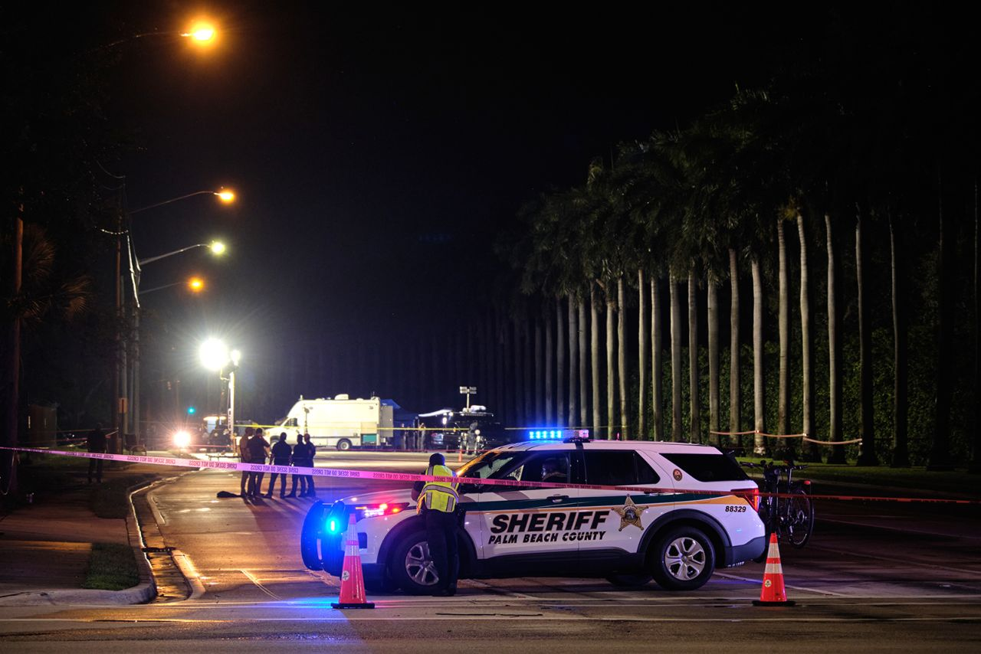

Law enforcement outside the Trump International Golf Club in West Palm Beach, Florida on September 15.

Carlos Escalona/Anadolu/Getty Images

The FBI said it “is investigating what [appears to be an attempted assassination](https://www.cnn.com/2024/09/15/politics/donald-trump-safe-shots/index.html)” of Donald Trump at his Florida golf club, [just two months after](https://www.cnn.com/politics/live-news/trump-harris-election-09-15-24#h_08a254029bb4f5089da43c8221739c43) an attempt to kill the Republican presidential nominee at a Pennsylvania rally.

The former president was not harmed.

[Ryan Wesley Routh](https://www.cnn.com/politics/live-news/trump-harris-election-09-15-24#h_d945993aaf373a028298567e3670a039), a 58-year-old owner of a small construction company in Hawaii, has been detained in connection with Sunday’s incident, according to three law enforcement sources.

*Here’s what happened:*

* **Gunshots during golf:**Trump was moving between [holes five and six](https://www.cnn.com/politics/live-news/trump-harris-election-09-15-24#h_ac7956ac5a6f744782a2d7a1fd3aace9) at the Trump International Golf Club in West Palm Beach with donor Steve Witkoff when gunshots went off. The golf game was a [last-minute addition](https://www.cnn.com/politics/live-news/trump-harris-election-09-15-24#h_52a0dcf75f7db11a2209e29c4ffa5d1f) to Trump’s schedule, sources said.
* **Secret Service spots a rifle:** A Secret Service agent [spotted a rifle barrel](https://www.cnn.com/politics/live-news/trump-harris-election-09-15-24#h_fff37e0df922eb36ec8dbd5cc87ead87) sticking out of a fence and agents fired at a man in the bushes along the perimeter, according to Palm Beach County Sheriff Ric Bradshaw. Bradshaw said his office was alerted at 1:30 p.m. ET that the Secret Service had fired gunshots. The person was [300 to 500 yards away](https://www.cnn.com/politics/live-news/trump-harris-election-09-15-24#h_fff37e0df922eb36ec8dbd5cc87ead87) from Trump, an official said. The suspect then [fled in a car](https://www.cnn.com/politics/live-news/trump-harris-election-09-15-24#h_b2e7ea3e053ca5ac1f1396b6d8a6640d).
* **Witness spots a man in the bushes:** A witness [saw the suspect](https://www.cnn.com/politics/live-news/trump-harris-election-09-15-24#h_b2e7ea3e053ca5ac1f1396b6d8a6640d) run from the bushes and took a picture of his car that led to the suspect’s apprehension.
* **Highway chase:**Police [flooded Interstate 95](https://www.cnn.com/politics/live-news/trump-harris-election-09-15-24#h_a50807b5ff9c090b872de7ebd49cec74) before stopping the suspect’s car and detaining him. The suspect was not armed when law enforcement officials took him out of the car, and he has not made any statements. The person in custody is [Routh](https://www.cnn.com/politics/live-news/trump-harris-election-09-15-24#h_00593ed682bab491861fed6aea558684), according to three law enforcement sources.
* **Evidence found in bushes:**Law enforcement officials [found](https://www.cnn.com/politics/live-news/trump-harris-election-09-15-24#h_f3f046e7ffc2a1f2a126176b552e366c) an AK-47-style rifle with a scope; two backpacks that had ceramic tiles in them to augment a bulletproof vest; and a GoPro where the suspect was positioned. “This whole set-up indicates a very high level of pre-planning,” former FBI deputy director Andrew McCabe [told CNN](https://www.cnn.com/2024/09/15/us/video/suspect-evidence-police-recovered-donald-trump-gunshot-florida-mccabe-digvid).
* **Mental health assessment:**Investigators expect a federal court in South Florida will require “a mental health assessment” of Routh before any possible criminal proceedings, a law enforcement source [told CNN](https://www.cnn.com/politics/live-news/trump-harris-election-09-15-24#h_b8d14a6cc0b3af7418fc114a724be698).

4:43 p.m. 8:53:31, September 16, 2024

**Man detained in apparent assassination attempt was strong supporter of Ukraine**

From CNN staff

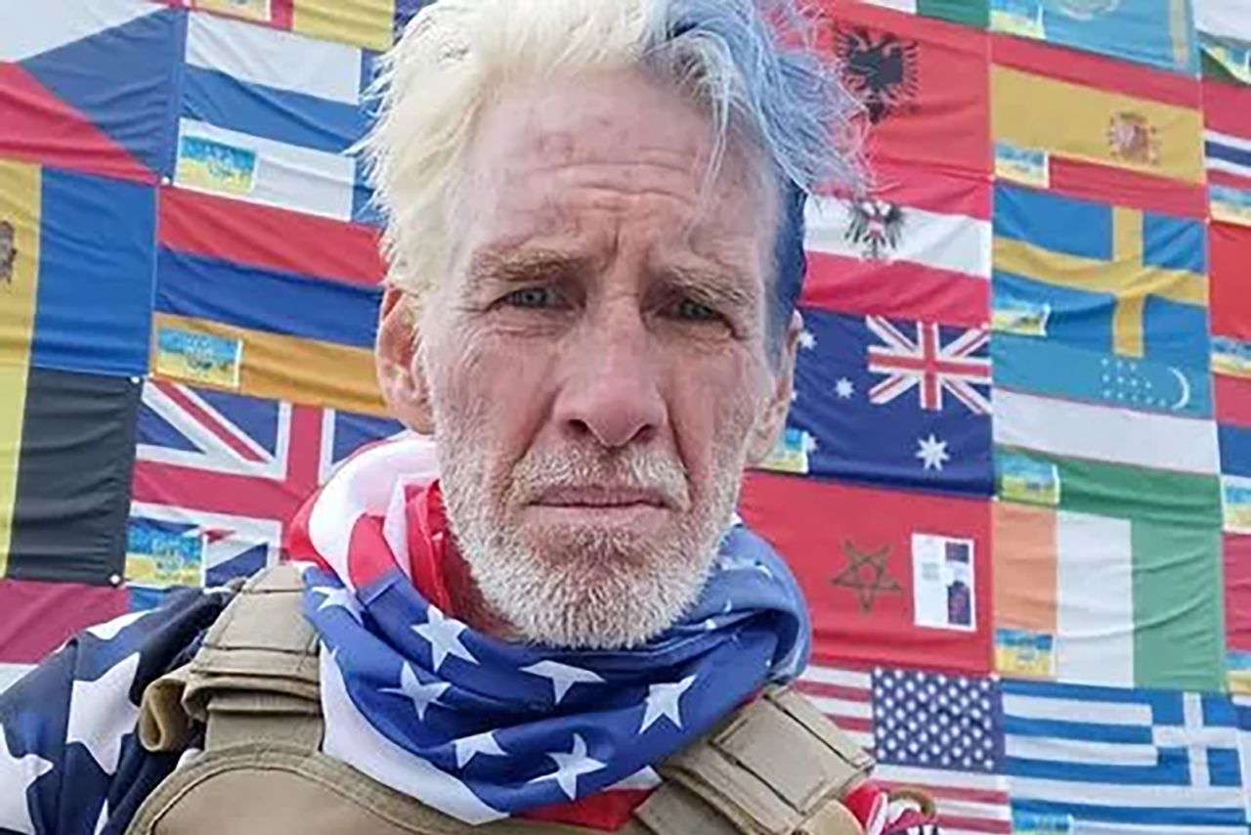

Ryan Wesley Routh

From Ryan Routh/Facebook

[Ryan Wesley Routh](https://www.cnn.com/2024/09/15/politics/trump-attempted-assassination-man-detained/index.html), who authorities suspect was planning to attack former President Donald Trump as he played a round of golf, was a staunch supporter of Ukraine and visited the country in 2022.

Routh traveled to Ukraine following Russia’s full-scale invasion of its neighbor more than two years ago, according to video and images geolocated by CNN to Kyiv’s Independence Square, as well as [interviews with foreign press](https://www.cnn.com/politics/live-news/trump-harris-election-09-15-24#h_f00062d4b79e770ef2fcead689937459).

Video shows Routh attended a rally at the square in support of Ukrainian troops on May 1, 2022, and visited the same location about six weeks later, where a photo shows him standing beside a Ukraine flag emblazoned with an appeal for international volunteers to support the war effort

In an April 2022 video by AFP in Kyiv, Routh called Putin a “terrorist” and said “he needs to be ended.”

“We need everybody from around the globe to stop what they’re doing and come here now and support the Ukrainians to end this war,” Routh said.

A representative from Ukraine’s foreign legion[told CNN](https://www.cnn.com/politics/live-news/trump-harris-election-09-15-24#h_7558c557bcb8b46953b2b87b4430333a) that Routh had contacted them several times but that he was never part of the military unit in which overseas volunteers fight.

Routh also expressed support for Ukraine on social media. In dozens of posts on X in 2022, he said he was willing to die in the fight and that “we need to burn the Kremlin to the ground.”

“I AM WILLING TO FLY TO KRAKOW AND GO TO THE BORDER OF UKRAINE TO VOLUNTEER AND FIGHT AND DIE…Can I be the example We must win,” Routh said in an X post in March 2022.

Routh then used Facebook to encourage foreigners to fight in the war. He tried to enlist Afghan conscripts in a flurry of posts, beginning in October 2023, presenting himself as an off-the-books liaison for the Ukrainian government.

“Afghan Soldiers- Ukraine is somewhat interested in 3000 soldiers, so I need every soldier that has a passport to send me a copy of their passport to send to Ukraine,” he wrote in one such post, which was published in English and Pashto.

*This post has been updated with more information on Routh’s time in Ukraine.*

3:51 p.m. 8:53:31, September 16, 2024

**"He was never part of the Legion," Ukrainian officer says of Ryan Routh**

From CNN's Kostya Gak

A representative from Ukraine’s foreign legion confirmed with CNN that [Ryan Wesley Routh](https://www.cnn.com/2024/09/15/politics/trump-attempted-assassination-man-detained/index.html) had contacted them several times but said he was never part of the military unit in which overseas volunteers fight.

“We can confirm this person reached out to us online multiple times,” Oleksandr Shaguri, an officer of the Foreigners Coordination Department of the Land Forces Command, told CNN over the phone.

Shaguri said “the best way to describe his messages is — delusional ideas.”

“He was offering us large numbers of recruits from different countries but it was obvious to us his offers were not realistic. We didn’t even answer, there was nothing to answer to. He was never part of the Legion and didn’t cooperate with us in any way.”

Routh expressed [support for Ukraine](https://www.cnn.com/politics/live-news/trump-harris-election-09-15-24#h_529831e69948ef34655b83035f6931ad) in dozens of X posts in 2022, saying he was willing to die in the fight and that “we need to burn the Kremlin to the ground.”

He also visited Ukraine in 2022, according to video and photos geolocated by CNN as well as media interviews he gave while there.

Routh then used his Facebook account last year to encourage foreigners to fight in the war. He tried to enlist Afghan conscripts in a flurry of posts, beginning in October 2023, presenting himself as an off-the-books liaison for the Ukrainian government.

3:30 p.m. 8:53:31, September 16, 2024

**Journalist who interviewed Ryan Routh in Ukraine describes meeting an "idealistic" man**

From CNN's Teele Rebane

Newsweek Romania journalist Remus Cernea, who met the man detained in connection with an [apparent assassination attempt on Donald Trump](https://www.cnn.com/2024/09/15/politics/donald-trump-safe-shots/index.html) in Ukraine on several occasions, told CNN he was surprised by [Ryan Routh](https://www.cnn.com/2024/09/15/politics/trump-attempted-assassination-man-detained/index.html)’s involvement in the incident.

“For me, it’s a surprise because I viewed him as an idealistic innocent genuine person, without any murderous instinct,” Cernea said.

Cernea first met Routh in Kyiv’s Independence Square in June of 2022, [where Routh was rallying people](https://www.cnn.com/politics/live-news/trump-harris-election-09-15-24#h_529831e69948ef34655b83035f6931ad) to join the foreign legion or to help Ukraine through various humanitarian aid organizations.

At the time, Routh gave Newsweek Romania an interview where he said:

“To me a lot of other conflicts are gray, but this conflict is definitely black and white. This is about good versus evil.”

When Cernea met Routh again about a year later, he said, Routh was visibly frustrated that more people had not come to Ukraine’s help.

“Why aren’t there thousands of people here in Kyiv coming to support and join the foreign legion, why aren’t they here?” Cernea remembers him lamenting.

“It’s a very sad story for the whole world, for the US, and for Ryan,” Cernea said.

4:05 p.m. 8:53:31, September 16, 2024

**What we know about the man detained after apparent assassination attempt on Trump**

From CNN staff

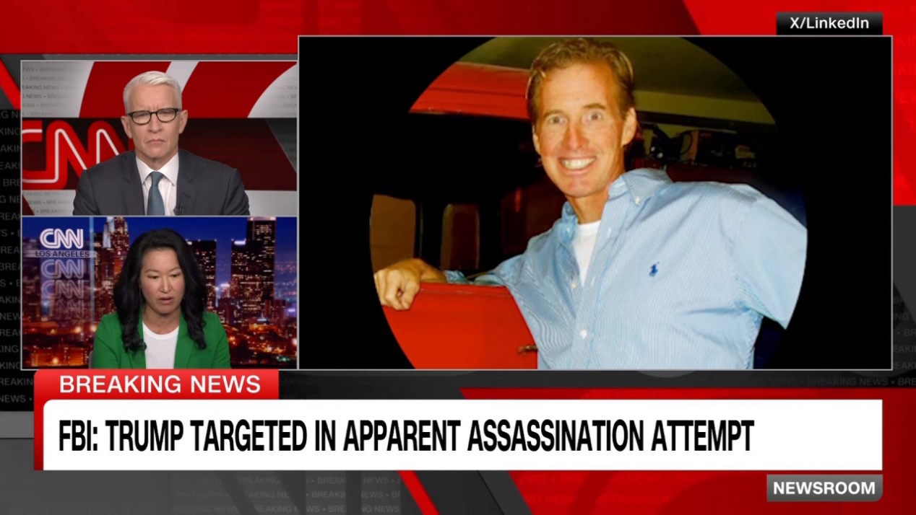

03:46 - Source: cnn

[Ryan Wesley Routh](https://www.cnn.com/2024/09/15/politics/trump-attempted-assassination-man-detained/index.html), a 58-year-old owner of a small construction company, has been detained in connection with an [apparent assassination attempt on Donald Trump](https://www.cnn.com/2024/09/15/politics/donald-trump-safe-shots/index.html) in Florida, according to three law enforcement sources.

*Here’s what we know about him:*

* **Trump detractor:**A [frequent Trump critic](https://www.cnn.com/politics/live-news/trump-harris-election-09-15-24#h_6c76192322e97d6b2caa9ef849a73a35) on social media, Routh posted on X about the assassination attempt on the former president in July, encouraging President Joe Biden and Vice President Kamala Harris to visit those wounded at the rally. “Trump will never do anything,” Routh wrote.
* **North Carolina ties:**Routh was registered as an “unaffiliated” voter in the state in 2012. He also voted in North Carolina’s Democratic primary in March of this year, according to public records.
* **Brushes with the law:**Routh was [arrested in 2002](https://www.cnn.com/politics/live-news/trump-harris-election-09-15-24#h_8cf3e9fc2f622f7e340f5a89b3bcb2f2) after being pulled over by police and allegedly putting his hand on a firearm before barricading himself in a business. He was also ordered to pay tens of thousands to plaintiffs in civil suits and has been repeatedly accused by state and federal authorities of failing to pay his taxes on time.
* **Silent when apprehended:**Routh [stayed silent](https://www.cnn.com/politics/live-news/trump-harris-election-09-15-24#h_5824004dc11cbc179755681fde5132c0) when detained, according to local state attorney David Aronberg. “It looked like a person who has done this before, not necessarily this crime, but someone who has had repeated interactions with law enforcement,” he told CNN’s Anderson Cooper.
* **Support for Ukraine:**Routh expressed [support for Ukraine](https://www.cnn.com/politics/live-news/trump-harris-election-09-15-24#h_529831e69948ef34655b83035f6931ad) in dozens of X posts in 2022, saying he was willing to die in the fight and that “we need to burn the Kremlin to the ground.” He also [visited Ukraine](https://www.cnn.com/politics/live-news/trump-harris-election-09-15-24#h_529831e69948ef34655b83035f6931ad). In a video shot by AFP in Kyiv in 2022, Routh called Putin a “terrorist” and urged people to come fight for Ukraine. Routh also tried to enlist Afghan conscripts to fight in the war, presenting himself as an off-the-books liaison for the Ukrainian government.
* **Views on global politics:**In a [self-published book](https://www.cnn.com/politics/live-news/trump-harris-election-09-15-24#h_9de54118c4ba8e2b96e3545de07985bf), Routh weighed in on the political situations in Afghanistan, Taiwan, and North Korea. He further detailed his support for Ukraine, and said he tried to enlist in the war but was turned away at the Poland-Ukraine border.
* **Affordable-housing builder:**Routh said on his LinkedIn page that he started a company in 2018 called Camp Box Honolulu in Hawaii, which builds storage units and tiny houses. A [story](https://www.staradvertiser.com/2019/11/18/hawaii-news/kauhale-homeless-concept-generating-offers-of-donations/) in the Honolulu Star-Advertiser said he donated a structure for homeless people.
* **Son speaks out:**[Oran Routh](https://www.cnn.com/politics/live-news/trump-harris-election-09-15-24#h_22afe880b841f055b1d5c118260a7a41) said he hopes everything has “just been blown out of proportion” and it’s not like his father “to do anything crazy, much less violent.” He called his father “a loving and caring father, and honest hardworking man.”

*This post has been updated with the latest developments.*

2:30 p.m. 8:53:31, September 16, 2024

**Ryan Routh self-published a book. Here's what it said about his time in Ukraine**

From CNN's Jessie Yeung

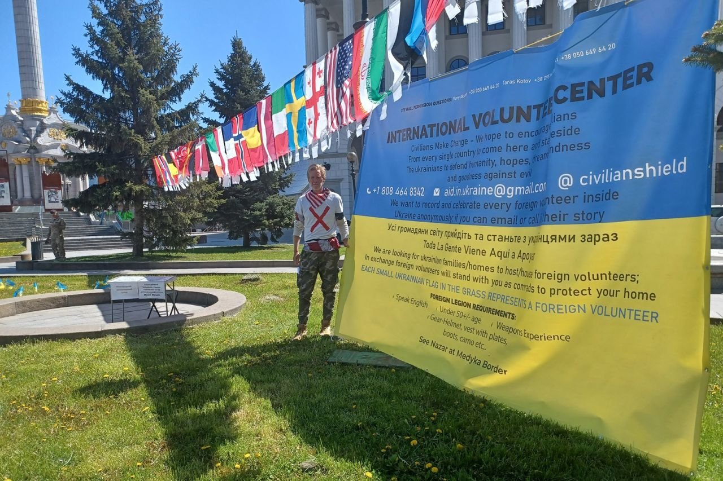

This image geolocated by CNN shows Ryan Routh at Independence Square in Kyiv, Ukraine.

Radio Taiwan International

[Ryan Wesley Routh](https://www.cnn.com/2024/09/15/politics/trump-attempted-assassination-man-detained/index.html), the 58-year-old man detained Sunday in connection with an [apparent assassination attempt on Donald Trump](https://www.cnn.com/2024/09/15/politics/donald-trump-safe-shots/index.html) in Florida, self-published a book last year detailing his efforts to support Ukraine in the war against Russia.

In the 291-page book, Routh described his disillusionment with the war in Ukraine, which he called “unwinnable.”

The book also discussed the Taliban takeover of Afghanistan and the political situation in Taiwan, which has faced growing military threats from China.

The book, released on Amazon with no publisher listed, is titled: “Ukraine’s Unwinnable War: The Fatal Flaw of Democracy, World Abandonment and the Global Citizen-Taiwan, Afghanistan, North Korea and the end of Humanity.” CNN has not independently verified his accounts in the book.

In it, Routh describes how he had traveled to the Poland-Ukraine border in an effort to enlist in the war — but “at 56 with absolutely no military experience I was reluctantly turned away by the staff” at the border office.

Instead, he tried to enlist more fighters for the war effort — [traveling to Kyiv](https://www.cnn.com/politics/live-news/trump-harris-election-09-15-24#h_529831e69948ef34655b83035f6931ad) and setting up a makeshift volunteer center at Independence Square before it was disassembled by police. He then “lost all arguments and calls to city hall,” he writes, and spent several months camped out in protest at various locations around the city.

“I had given every ounce of motivation and energy that I could muster for Ukraine and came up empty handed,” he said, describing his unsuccessful attempts to build drones for the Ukrainian army with a team of international engineers.

1:44 p.m. 8:53:31, September 16, 2024

**Israeli prime minister expresses shock after apparent Trump assassination attempt**

From CNN's Tamar Michaelis

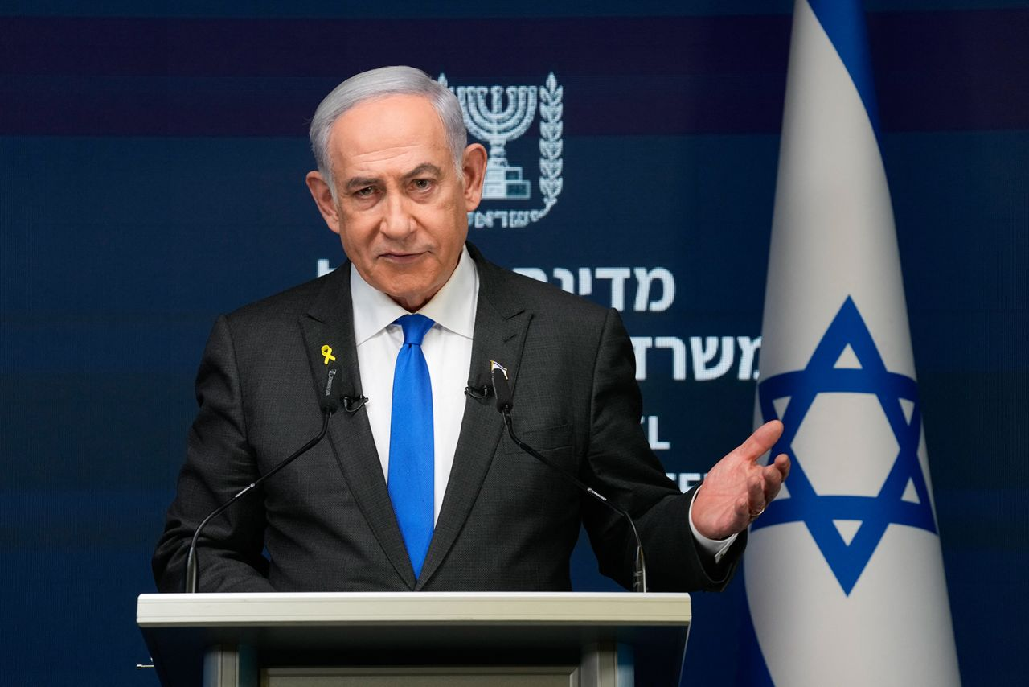

Benjamin Netanyahu speaks during a news conference in Jerusalem on September 2.

Ohad Zwigenberg/POOL/AFP/Getty Images/File

Israeli Prime Minister Benjamin Netanyahu said he was shocked after hearing about the apparent assassination attempt on Donald Trump.

“Sara and I were shocked by the second assassination attempt against President Trump and were relieved to hear that it too failed. But we should not rely on luck,” he wrote on [X](https://x.com/israelipm/status/1835462455050342551?s=46&t=IV8KMN2S1o4Jt3KkL9I7ag).

“We send our best wishes to Donald and Melania along with our hopes that all measures will be taken to ensure that such deadly attacks on a candidate for the US presidency will be foiled in advance.”

1:07 p.m. 8:53:31, September 16, 2024

**Law enforcement expects court to order "mental health assessment" of suspect, source says**

From CNN’s Josh Campbell

Federal agents investigating an apparent assassination attempt on Donald Trump on Sunday expect a federal court in South Florida will require “a mental health assessment” of [Ryan Wesley Routh](https://edition.cnn.com/2024/09/15/politics/trump-attempted-assassination-man-detained/index.html) before any possible criminal proceedings, a law enforcement source told CNN.

Based on numerous “unusual rants” believed to be posted by Routh online regarding international geopolitical events, the source said federal investigators expect his mental health will be examined as part of court proceedings to determine whether he is fit for any trial.

No charges have been filed, but mental health assessments are not uncommon in cases involving threats to federal officials by individuals who may be experiencing mental health issues, the source said. CNN is attempting to determine if Routh has attorney representation.

12:19 p.m. 8:53:31, September 16, 2024

**Analysis: Apparent assassination attempt on Trump has unpredictable political consequences**

From CNN's Stephen Collinson

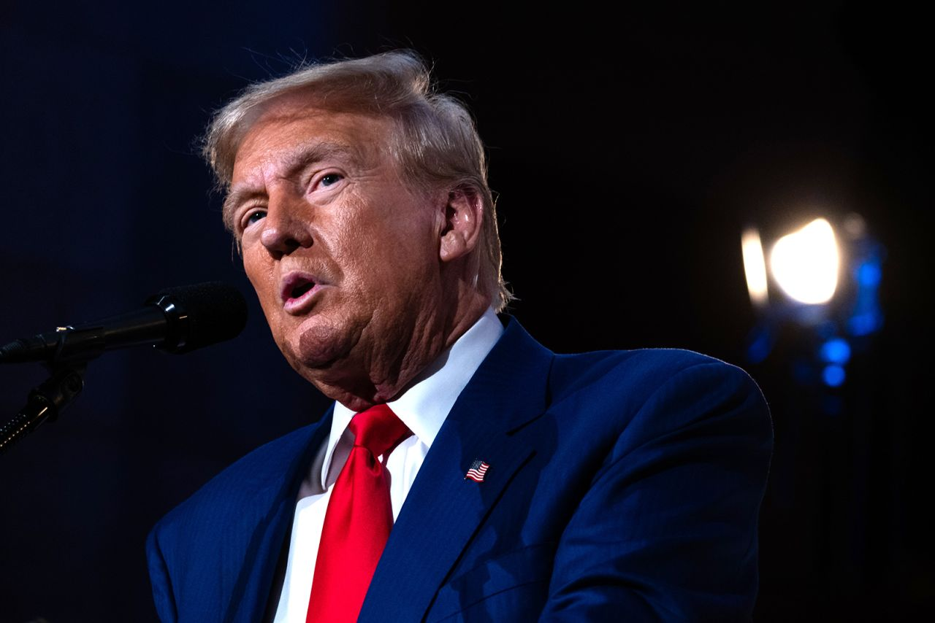

Donald Trump addresses an event in New York on September 5.

Spencer Platt/Getty Images

There’s no political playbook for how to deal with [another apparent assassination attempt](https://www.cnn.com/politics/live-news/trump-harris-election-09-15-24/index.html?t=1726456687400) against a major-party presidential candidate within weeks of an election.

Yet that’s where the rival campaigns now find themselves after what looks like a second [attempt to kill Republican nominee Donald Trump](https://www.cnn.com/2024/09/15/politics/donald-trump-safe-shots/index.html) in the latest twist to a political season defying precedent and highlighting the nation’s deep polarization.

Twice within two months, America has narrowly avoided seeing a major political figure assassinated during an election season — and the toxic forces that such an outrage could unleash in a country wracked by visceral partisan divides.

That such incidents happen at all speaks to the undercurrent of violence that is a constant shadow over American politics, one that is exacerbated by the easy availability of firearms. Both nominees now address outdoor crowds from behind bulletproof screens. There will now be fresh fears that a tempestuous period running up to Election Day could take the country further down a dark road.

After decades without an assassination attempt against a high-level executive branch official, a haunting reality has been revived this year: those who offer themselves for the highest office are potentially putting their lives on the line.

[**Read the full analysis.**](https://www.cnn.com/2024/09/16/politics/political-consequences-trump-assassination-attempt-analysis/index.html)

1:01 p.m. 8:53:31, September 16, 2024

**Trump thanks Secret Service and law enforcement for after apparent assassination attempt**

From CNN's Katherine Sullivan

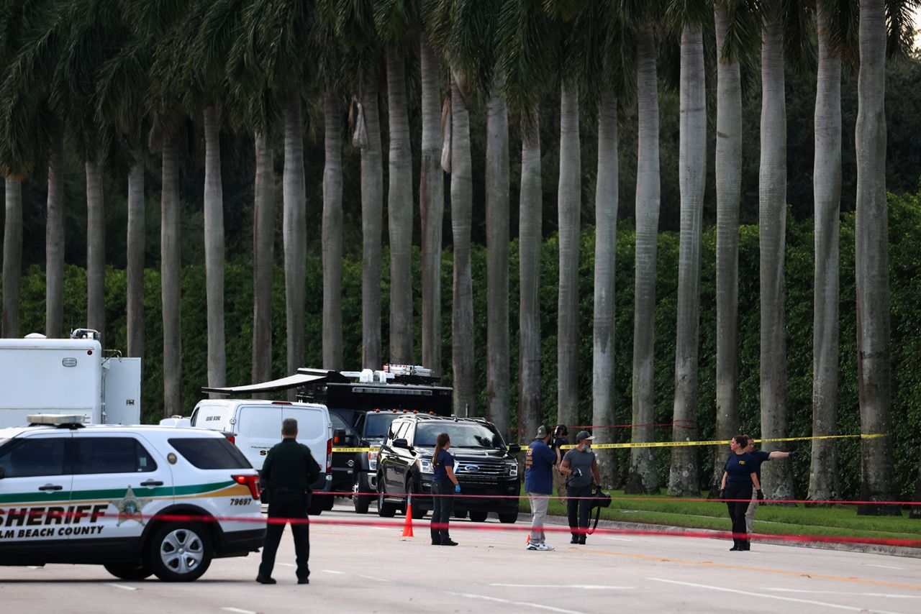

Law enforcement officers work around Trump International Golf Club after an apparent assassination attempt of former President Donald Trump on September 15.

Marco Bello/Reuters

Former President Donald Trump on Sunday thanked the US Secret Service and other law enforcement officials after an [apparent assassination attempt](https://www.cnn.com/politics/live-news/trump-harris-election-09-15-24/index.html?t=1726442631670) while he was golfing in West Palm Beach, Florida.

**“THE JOB DONE WAS ABSOLUTELY OUTSTANDING.” Trump posted on Truth Social.**

“I would like to thank everyone for your concern and well wishes - It was certainly an interesting day! Most importantly, I want to thank the U.S. Secret Service, Sheriff Ric Bradshaw and his Office of brave and dedicated Patriots, and, all of Law Enforcement, for the incredible job done today at Trump International in keeping me, as the 45th President of the United States, and the Republican Nominee in the upcoming Presidential Election, SAFE.”

The former president was not harmed in the incident. He had been golfing with donor Steve Witkoff when shots were fired, according to a source familiar with the matter.

11:43 a.m. 8:53:31, September 16, 2024

**Roads around Trump International Golf Club still closed nine hours after apparent assassination attempt**

From CNN's Kathleen Magramo

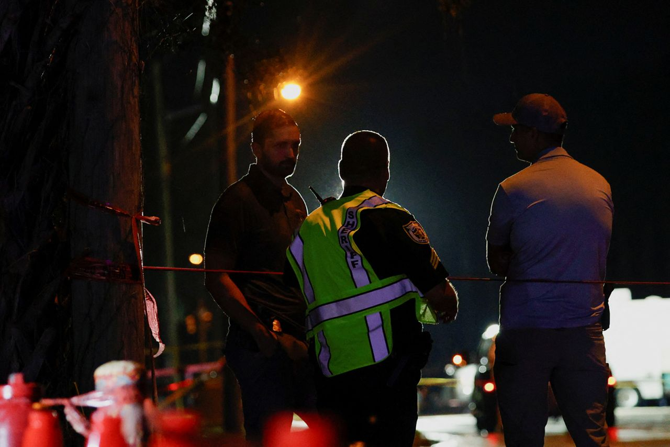

Law enforcement personnel investigate the area around Trump International Golf Club after an apparent assassination attempt of former President Donald Trump on September 15.

Marco Bello/Reuters

The presence of law enforcement outside Trump International Golf Club in West Palm Beach remains heavy, and the road nearest the apparent assassination attempt was still closed nine hours after the incident, CNN Correspondent Randi Kaye reported from the scene.

Heavily trafficked roads around the golf club are also still closed and there has been a regular stream of police vans going in and out of the gates.

At Summit Boulevard, just in front of the golf club gate, there are a lot of bushes between where the 5th and 6th hole comes together, Kaye said, where perhaps somebody could have poked their way through until they reached the fence.

The person detained in connection with the apparent assassination attempt is [Ryan Wesley Routh](https://edition.cnn.com/2024/09/15/politics/trump-attempted-assassination-man-detained/index.html), according to three law enforcement sources.

“We understand from law enforcement that he was very calm. He wasn’t displaying any emotion,” Kaye said.

Trump International Golf Club abuts three heavily trafficked roads: Kirk Road, Summit Boulevard and Congress Avenue. The Palm Beach International Airport is also nearby.

12:42 p.m. 8:53:31, September 16, 2024

**Man detained in connection with apparent Trump assassination attempt stayed "silent" when apprehended**

From CNN's Jerome Taylor

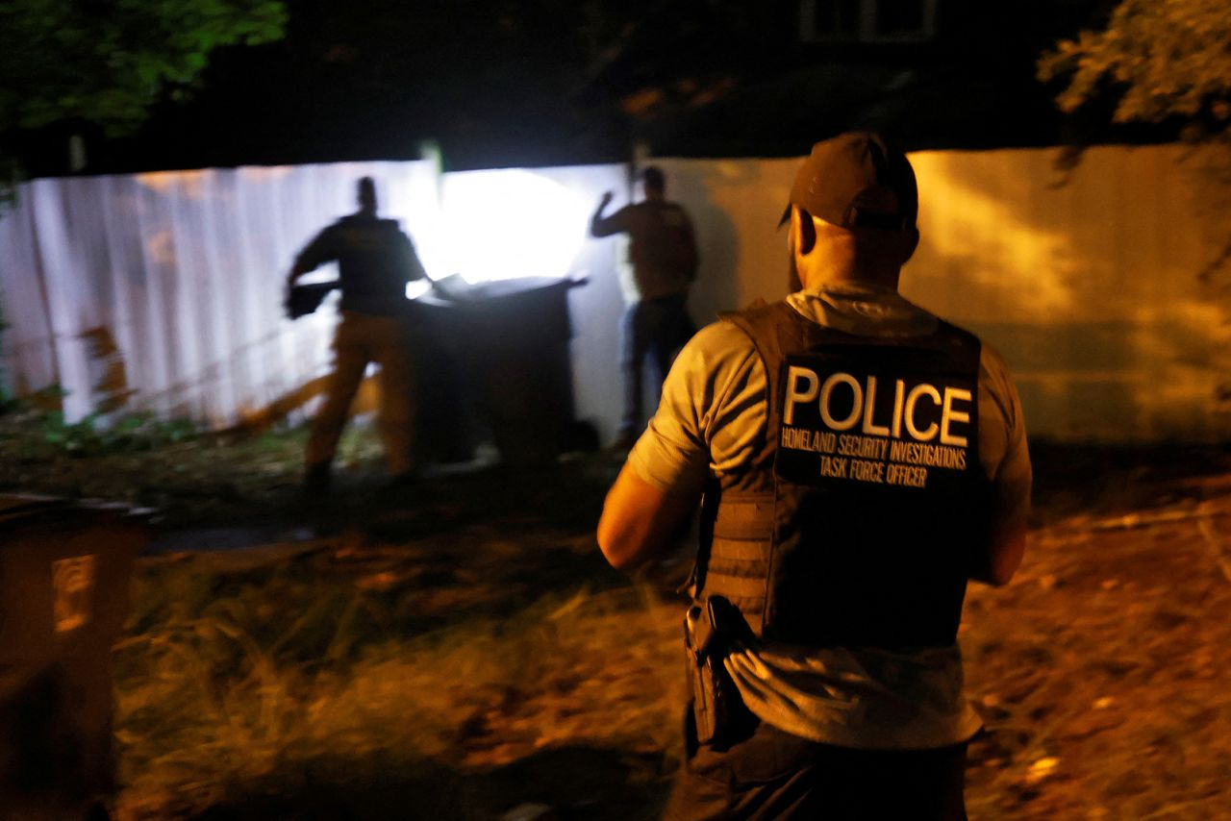

Secret Service and Homeland Security agents check the home of Ryan W. Routh in Greensboro, North Carolina, U.S. on September 15.

Jonathan Drake/Reuters

The man detained in connection with an apparent assassination attempt on former President Donald Trump in Florida remained silent when he was apprehended by law enforcement, according to a local state attorney.

“He knew enough to stay silent,” David Aronberg, State Attorney for Palm Beach County, Florida, told CNN’s Anderson Cooper on Sunday evening.   
“He did not apparently speak to officers, he was calm. So, it looked like a person who has done this before, not necessarily this crime, but someone who has had repeated interactions with law enforcement.”

Aronberg did not name the suspect but said he had a “rap sheet.”

The person detained is [Ryan Wesley Routh](https://edition.cnn.com/2024/09/15/politics/trump-attempted-assassination-man-detained/index.html), according to three law enforcement sources.

Aronberg described the apparent assassination attempt as “another too close for comfort incident.” But he also praised the US Secret Service for quickly spotting the alleged shooter and firing shots at him.

“If you’re Secret Service, it really is an act of heroism to see a person with this dangerous weapon poking through the fence. And it was really a great job by Secret Service to fire the first shot,” he said.

11:17 a.m. 8:53:31, September 16, 2024

**"Bewildered why we’re in this situation for a second time," Florida Democratic Rep. says**

From CNN's Kathleen Magramo

Democratic Rep. Jared Moskowitz of Florida, who serves on the bipartisan task force investigating the assassination attempt on Donald Trump during a campaign rally in Pennsylvania in July, said people in Congress are “bewildered why we’re in this situation for a second time.”

“I’m deeply concerned about what’s going on right now. I’m deeply concerned, quite frankly for the former president’s safety. The secret service has lot to explain how an individual able to get yet again in this close to the former president,” Moskowitz told CNN’s Anderson Cooper.

He says the protocols and resources committed to the former president “seem to be wholly inadequate,” especially in outdoor environments.

Moskowitz said that, although much remains unknown, the man detained in connection with the apparent assassination attempt on Trump on a golf course should not have been able to obtain a firearm in the state of Florida. He said it should not be ruled out that the man may have brought the weapon into the state.

“I think the American people should be deeply concerned on why a second individual, clearly disturbed, was able to get this close to the former president with a weapon.”

12:10 p.m. 8:53:31, September 16, 2024

**Motorist details "insane" scene on interstate with suspect after apparent assassination attempt on Trump**

From CNN’s Sarah Dewberry

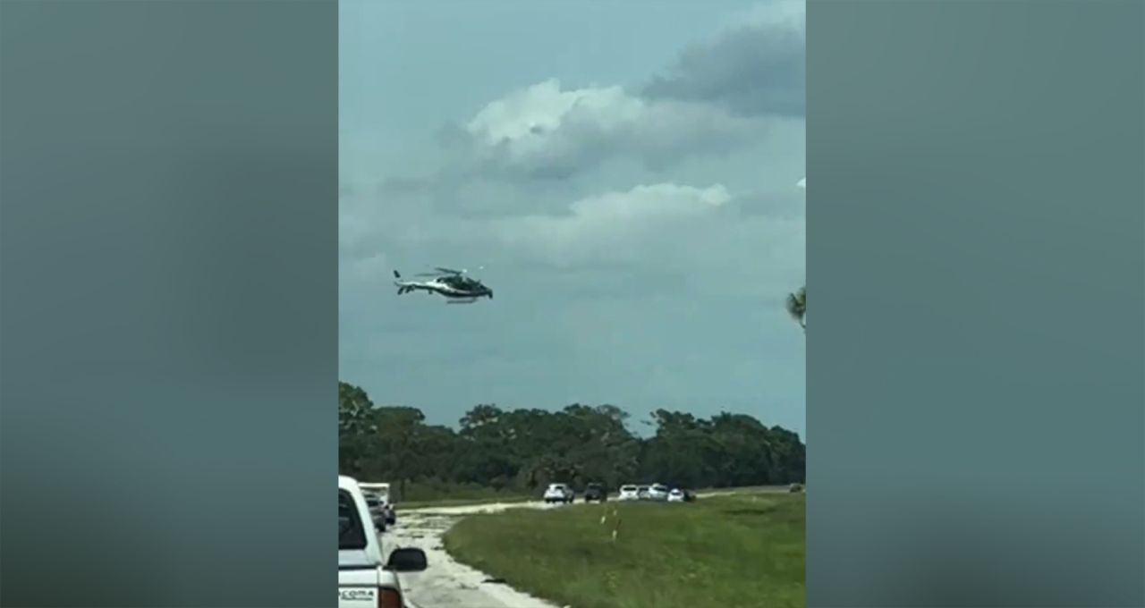

Dannyspitin/X

Motorist Daniel Rodriguez told CNN that he and his family were driving back to Orlando on the I-95 interstate from a soccer match when they encountered a “wild scene” as sheriff’s deputies stopped a suspect after an apparent assassination attempt on former President Donald Trump.

“We saw multiple officers starting to speed up behind us,” Rodriguez said. “We saw a black Nissan speed up and merge in and out of traffic. We saw a helicopter flying in the air and many more police starting to appear. Then, a state trooper pulled over and stopped the traffic lane.”

Rodriguez said that they initially thought it was an accident.

**“It was insane,” Rodriguez said. “A Nissan went blazing right by us, and multiple troopers going at least 90mph passed us, too.”**

Rodriguez said they were then stuck in traffic for two hours.

“By the end, I can say there were at least 20 patrol cars behind the Nissan,” Rodriguez said. “We waited patiently until police escorted us out of traffic. I had a pair of binoculars and saw police and several agents pointing rifles at the suspect.”

11:27 a.m. 8:53:31, September 16, 2024

**Trump's golf outing was last-minute decision, sources say**

From CNN's Kristen Holmes

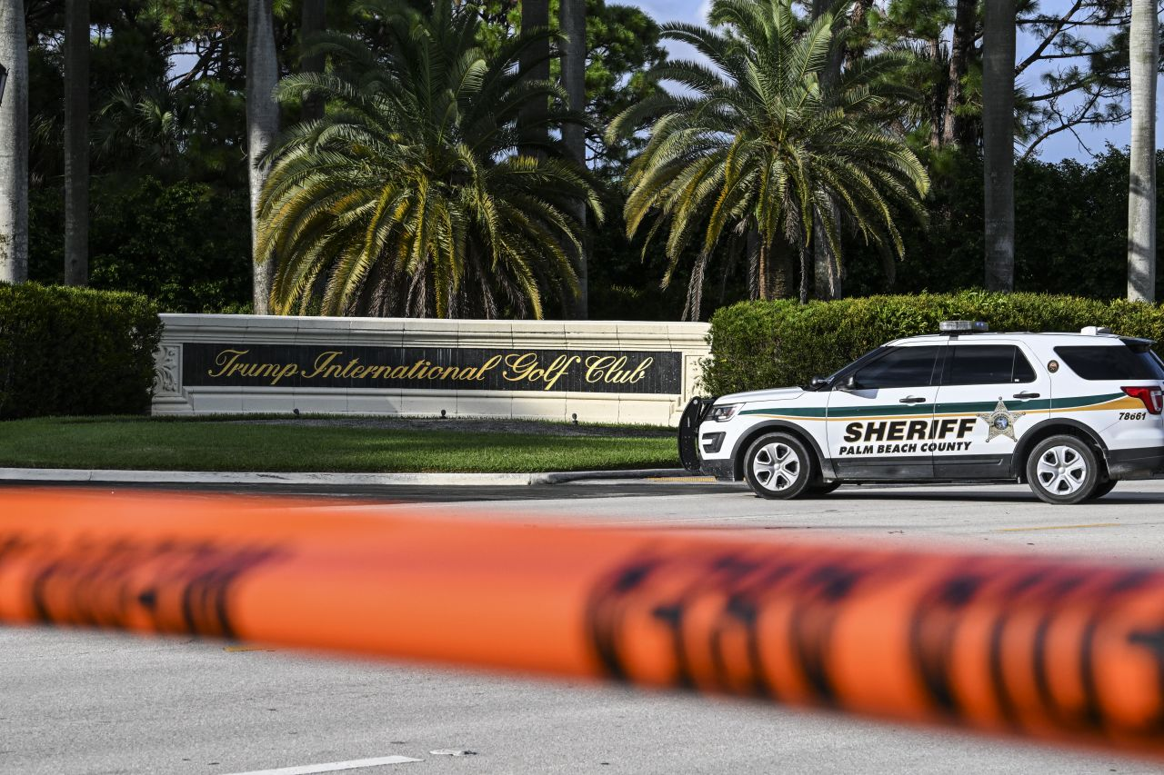

A Sheriff car blocks the street outside the Trump International Golf Club in West Palm Beach, Florida, on September 15.

Chandan Khanna/AFP/Getty Images

Former President Donald Trump’s golf game on Sunday was a last-minute addition to his schedule, two sources familiar with the matter said.

Trump had no public events on his schedule for Sunday.

11:05 a.m. 8:53:31, September 16, 2024

**"I condemn political violence," Harris says**

From CNN staff

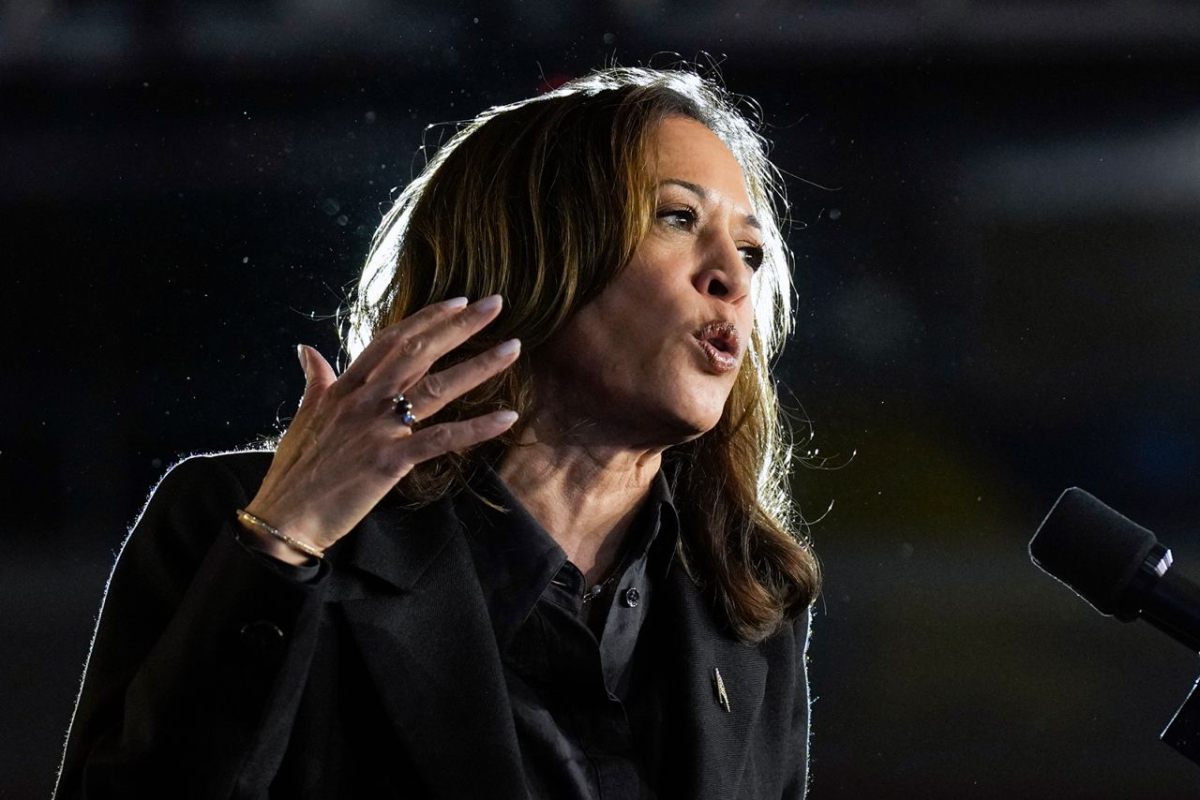

Democratic presidential nominee Vice President Kamala Harris speaks during a campaign event, in Wilkes-Barre, Pa., on September 13.

Jacquelyn Martin/AP

Vice President Kamala Harris said she is “disturbed” and condemns “political violence” after an apparent assassination attempt on former President Donald Trump on Sunday.

“I am deeply disturbed by the possible assassination attempt of former President Trump today. As we gather the facts, I will be clear: I condemn political violence. We all must do our part to ensure that this incident does not lead to more violence,” Harris said in a statement released by the White House on Sunday night.

“I am thankful that former President Trump is safe. I commend the U.S. Secret Service and law enforcement partners for their vigilance,” Harris said.  
“As President Biden said, our Administration will ensure the Secret Service has every resource, capability, and protective measure necessary to carry out its critical mission.”

10:47 a.m. 8:53:31, September 16, 2024

**FBI launching global investigation into apparent assassination attempt on Trump, source says**

From CNN's Josh Campbell

The FBI’s investigation into an apparent assassination attempt on Donald Trump in Florida has gone global as officials work to flesh out the background of Ryan Wesley Routh, the individual detained, a law enforcement source tells CNN.

Authorities are working to obtain search warrants on social media accounts believed to be associated with Routh, the source said.

Some of Routh’s suspected online activity also involved using platforms headquartered outside the United States, the source said, which will involve working with international partners to identify everything the FBI possibly can about the detained individual.

The FBI is also aware of Routh’s suspected online claims about foreign travel, the source said, which will be part of the bureau’s investigation.

While early in the investigation, authorities have not identified any co-conspirators potentially targeting Trump, the source said.

9:53 a.m. 8:53:31, September 16, 2024

**The man authorities detained had prior run-ins with the law, records show**

From CNN’s Curt Devine, Isabelle Chapman, Daniel Medina, Majlie de Puy Kamp, Scott Glover, Audrey Ash and Rob Kuznia

Records from North Carolina, dating back a couple decades, show that the man detained in the apparent assassination attempt on former President Donald Trump on Sunday has had previous scrapes with the law.

In 2002, Ryan Wesley Routh was arrested after he was pulled over by police and allegedly put his hand on a firearm and then drove and barricaded himself in a business, according to a Greensboro News & Record [article](https://greensboro.com/man-with-gun-barricades-self-inside-business/article_3006b4f9-9370-5b08-a54e-46c87faf6cbe.html) that year that cited police. Law enforcement confirmed the arrest to CNN on Sunday.

Public records reveal several court cases involving Routh since the 1990s.

State and federal authorities have repeatedly accused him of failing to pay his taxes on time. For example, he faced a federal tax lien in 2008 of about $32,000, according to court records.

In 1998, the state alleged he committed an offense related to a “worthless check,” though that case was dismissed.

Separately, judges have ordered him to pay tens of thousands of dollars to plaintiffs in various civil suits.

Routh’s eldest son, Oran, told CNN via text that Routh was “a loving and caring father, and honest hardworking man.”

The son wrote, “I don’t know what’s happened in Florida, and I hope things have just been blown out of proportion, because from the little I’ve heard it doesn’t sound like the man I know to do anything crazy, much less violent.”

11:07 a.m. 8:53:31, September 16, 2024

**Man detained in apparent assassination attempt on Trump criticized former president on social media**

From CNN’s Curt Devine, Isabelle Chapman, Daniel Medina, Majlie de Puy Kamp, Scott Glover, Audrey Ash and Rob Kuznia

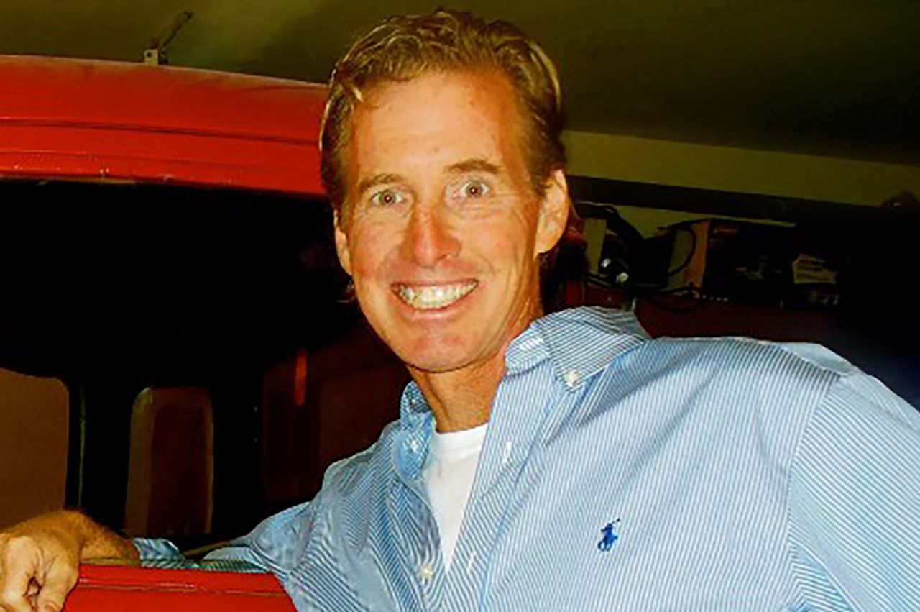

Ryan Wesley Routh

Ryan Wesley Routh/LinkedIn

A 58-year-old man detained Sunday in connection with an apparent assassination attempt on Donald Trump in Florida is a self-employed affordable housing builder in Hawaii who went on social media to weigh in on politics and current events, at times criticizing the former president.

[Ryan Wesley Routh](https://www.cnn.com/2024/09/15/politics/trump-attempted-assassination-man-detained/index.html), who authorities suspect was planning to attack the former president as he played a round of golf, posted comments on an X account linked to him referencing the assassination attempt on Trump in July.

Routh tagged President Joe Biden and Vice President Kamala Harris, in separate posts, encouraging them to visit those injured at the rally.

“You and Biden should visit the injured people in the hospital from the Trump rally and attend the funeral of the murdered fireman. Trump will never do anything for them,” he wrote in a post directed at Harris.

In an April post on X tagging Biden’s presidential account, he wrote Biden’s campaign should be: “called something like KADAF. Keep America democratic and free. Trumps should be MASA …make Americans slaves again master. DEMOCRACY is on the ballot and we cannot lose.”

9:02 a.m. 8:53:31, September 16, 2024

**Acting Secret Service Director Rowe heads to Florida after attempted Trump assassination**

From CNN’s Holmes Lybrand

Ronald Rowe, acting director of the US Secret Service, is traveling to Florida in the wake of the apparent assassination attempt of former President Donald Trump, a law enforcement source familiar with the matter told CNN.

The official declined to comment on Rowe’s itinerary.

Rowe has been in the top job at the Secret Service since [Kimberly Cheatle resigned](https://www.cnn.com/2024/07/23/politics/secret-service-director-kimberly-cheatle/index.html) in July amid scrutiny over security lapses related to the assassination attempt against Trump in Butler, Pennsylvania.

Rowe also visited the site of the Butler shooting, and he has [testified on Capitol Hill](https://www.cnn.com/2024/07/29/politics/secret-service-ronald-rowe-trump-shooting-testimony/index.html) and briefed members of Congress about the investigation into that shooting. Rowe has been asked to brief lawmakers about the Florida incident as well.

8:53 a.m. 8:53:31, September 16, 2024

**DeSantis says Florida will conduct its own investigation into "attempted assassination"**

From CNN's Steve Contorno

Florida Gov. Ron DeSantis announced his state will conduct “its own investigation regarding the attempted assassination” of former President Donald Trump, his one-time GOP primary opponent, in West Palm Beach.

“The people deserve the truth about the would be assassin and how he was able to get within 500 yards of the former president and current GOP nominee,” DeSantis [wrote](https://x.com/govrondesantis/status/1835476568212201744?s=46&t=eyFgGC7EnMhSDs2aBbaNHQ) on X.

9:40 a.m. 8:53:31, September 16, 2024

**Biden "relieved" Trump was unharmed in assassination attempt**

From CNN's Sam Fossum

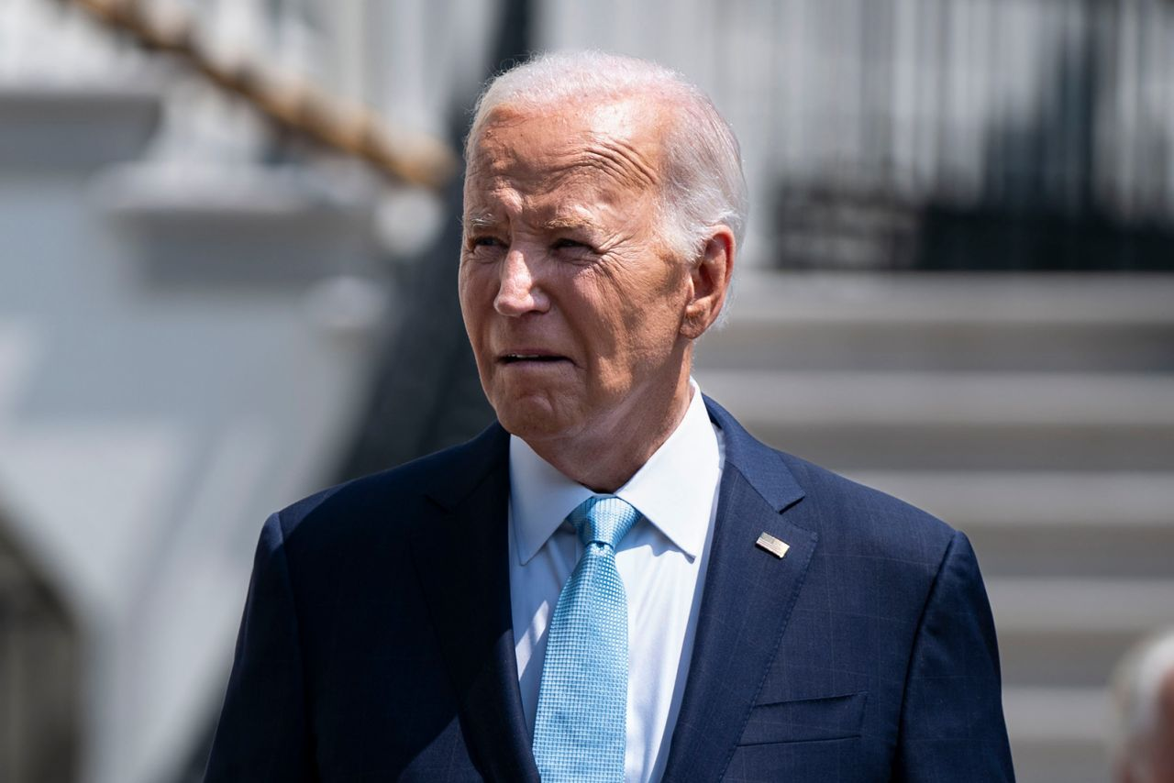

President Joe Biden departs the White House in Washington, DC. on August 15.

Bonnie Cash/Getty Images

President Joe Biden commended the work of the Secret Service and law enforcement following the [assassination attempt](https://www.cnn.com/2024/09/15/politics/donald-trump-safe-shots/index.html) against former President Donald Trump, saying he was “relieved” to hear that Trump was unharmed.

“I have been briefed by my team regarding what federal law enforcement is investigating as a possible assassination attempt of former President Trump today. A suspect is in custody, and I commend the work of the Secret Service and their law enforcement partners for their vigilance and their efforts to keep the former President and those around him safe. I am relieved that the former President is unharmed,” Biden wrote in the statement.

He also condemned political violence or “any violence” and said that he has directed his team to ensure that the Secret Service has all the resources necessary to protect the former president.

“As I have said many times, there is no place for political violence or for any violence ever in our country, and I have directed my team to continue to ensure that Secret Service has every resource, capability and protective measure necessary to ensure the former President’s continued safety,” he added.

8:52 a.m. 8:53:31, September 16, 2024

**"It doesn't sound like the man I know to do anything crazy," son of man detained says**

From CNN's Mike Figliola

The son of the person detained following the shooting incident on former President Donald Trump’s golf course in Florida on Sunday told CNN that he hopes everything has “just been blown out of proportion” and that it’s not like his father “to do anything crazy, much less violent.”

Oran Routh, son of Ryan Routh, said his father is loving, caring and hardworking.

“Ryan is my father, and I don’t have any comment beyond a character profile of him as a loving and caring father, and honest, hardworking man. I don’t know what’s happened in Florida, and I hope things have just been blown out of proportion, because from the little I’ve heard, it doesn’t sound like the man I know to do anything crazy, much less violent. He’s a good father, and a great man, and I hope you can portray him in an honest light,” Oran Routh said.

CNN reported earlier that officials detained Ryan Routh following the shooting incident on Sunday, according to three law enforcement sources.

8:41 a.m. 8:53:31, September 16, 2024

**Mayorkas condemns violence against public officials and candidates**

From CNN's Holmes Lybrand

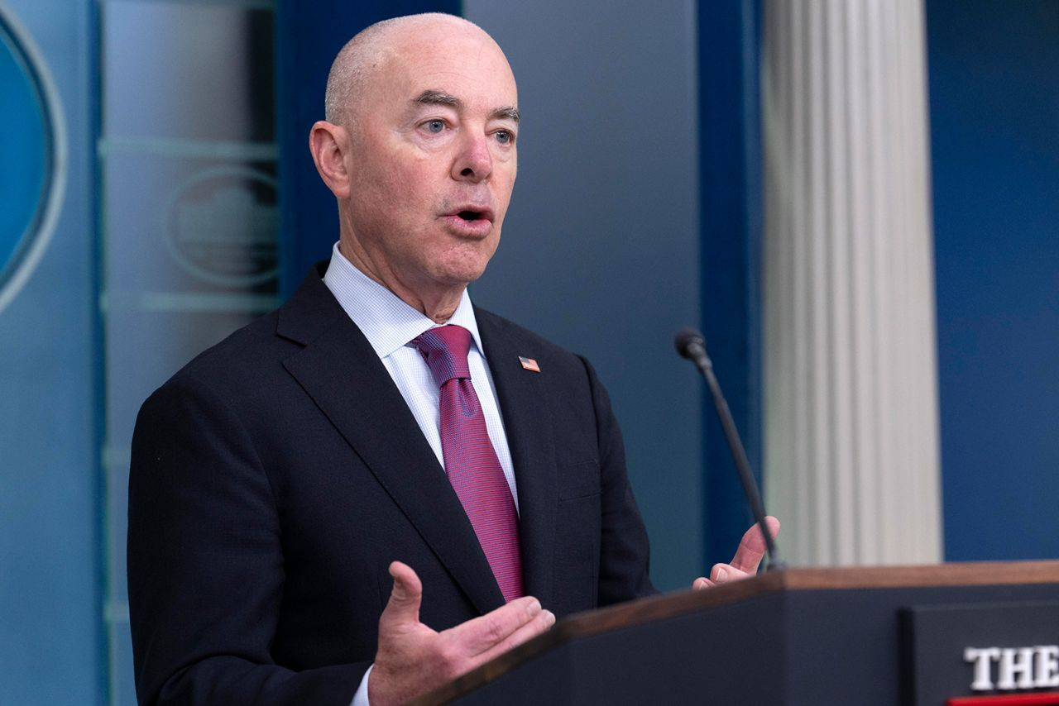

Alejandro Mayorkas speaks during a press briefing at the White House in Washington, on July 15.

Jacquelyn Martin/AP

Secretary of Homeland Security Alejandro Mayorkas on Sunday condemned violence against public officials and candidates.

In a post [on X](https://x.com/SecMayorkas/status/1835472636169646342), Mayorkas also commended the US Secret Service for “its quick action to preempt this apparent assassination attempt and protect the former President.”

“DHS and the Secret Service are closely working with federal, state and local law enforcement partners to learn all of the facts surrounding this incident. The safety and security of Presidential candidates and other protectees is the highest priority for the Secret Service, ” Mayorkas said.

8:07 a.m. 8:53:31, September 16, 2024

**Trump was on the golf course when the Secret Service fired shots. See it on a map.**

Former President Donald Trump was at his Trump International Golf Club, between the fifth and sixth holes, when the Secret Service fired on a suspect spotted some distance ahead of the former president on the course.

Here’s where the incident happened:

8:04 a.m. 8:53:31, September 16, 2024

**Senate Minority Leader McConnell is “very grateful President Trump is safe”**

From CNN's Morgan Rimmer

Senate Minority Leader Mitch McConnell said Sunday he is “very grateful President Trump is safe after another attempted assassination attempt.”

“There is no place for political violence in our country, and those responsible for it must be held to account. I hope and expect (the Secret Service) and the FBI will conduct a thorough, swift, and transparent investigation,” the Kentucky Republican wrote [on X](https://x.com/leadermcconnell/status/1835464933879820585?s=46&t=0kSbRS3cR7LAmIrwwezTmQ).

7:59 a.m. 8:53:31, September 16, 2024

**Trump updates fundraising site with new statement: "I will never surrender"**

From CNN's Jack Forrest

Former President Donald Trump updated his [fundraising website](https://secure.winred.com/trump-national-committee-jfc/lp-website-trump-response-v5-00) with a defiant message after the security incident.

“FEAR NOT! I am safe and well, and no one was hurt. Thank God! But, there are people in this world who will do whatever it takes to stop us.I will not stop fighting for you. I will Never Surrender,” the website says.

“I will always love you for supporting me. Through our UNITY we will Make America Great Again.”

9:49 a.m. 8:53:31, September 16, 2024

**Trump is "unstoppable," House speaker posts after visiting former president this afternoon**

From CNN's Morgan Rimmer and Annie Grayer

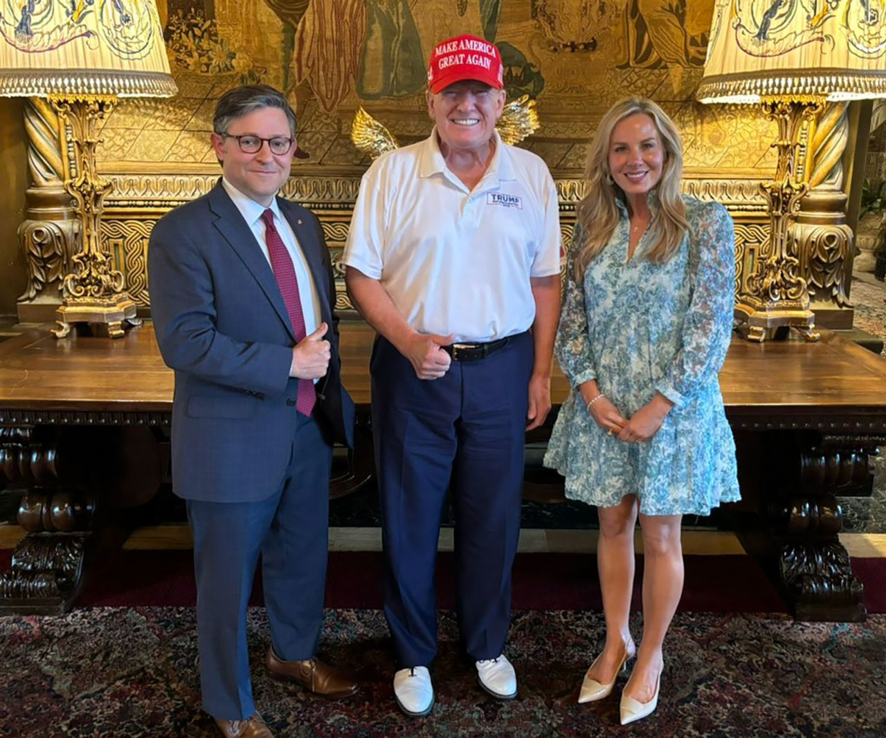

House Speaker Mike Johnson posted this photo with former President Donald Trump to X on Sunday evening.

From @SpeakerJohnson/X

House Speaker Mike Johnson met with Donald Trump this afternoon following what the FBI is calling an apparent assassination attempt against the former president in South Florida.

“Kelly and I are departing Mar-a-Lago, where we just spent a few hours with President Trump and are thanking God for protecting him today — once again,” [the Louisiana Republican said in a post](https://x.com/speakerjohnson/status/1835462291698983407?s=46) on X. “No leader is American history has endured more attacks and remained so strong and resilient. He is unstoppable.”

7:54 a.m. 8:53:31, September 16, 2024

**Trump campaign managers tell staff: "Your safety is always our top priority"**

From Kristen Holmes and Kaitlan Collins

Donald Trump’s campaign managers Chris LaCivita and Susie Wiles updated staff after shots were fired near the former president Sunday, telling them in an email that “safety is always our top priority.”

“This is not a matter that we take lightly. Your safety is always our top priority. We ask that you remain vigilant in your daily comings and goings. Be observant and maintain a constant level of situational awareness. We urge you to always follow direction from law enforcement, including USSS, local police, and office armed security guards,” the email obtained by CNN said.

CNN [previously reported](https://www.cnn.com/politics/live-news/trump-harris-election-09-15-24#h_92a3d412284833ffd31f3eac14f504cf) that Trump’s campaign office in West Palm Beach, Florida, went into lockdown after the Sunday incident.

LaCivita and Wiles also praised the Secret Service. “President Trump and everyone accompanying him are safe thanks to the great work of the United States Secret Service,” they said.

7:27 a.m. 8:53:31, September 16, 2024

**Trump says his "resolve is only stronger after another attempt on my life"**

From CNN's Rashard Rose

Former President Donald Trump said in a second fundraising email Sunday that his “resolve is only stronger” after shots were fired near him at the Trump International Golf Club in South Florida.

“My resolve is only stronger after another attempt on my life!” the email said.

“I will never slow down. I will never give up. I WILL NEVER SURRENDER!”

7:25 a.m. 8:53:31, September 16, 2024

**Here's what we know so far as the FBI investigates apparent assassination attempt of Trump**

From CNN's Michelle Shen

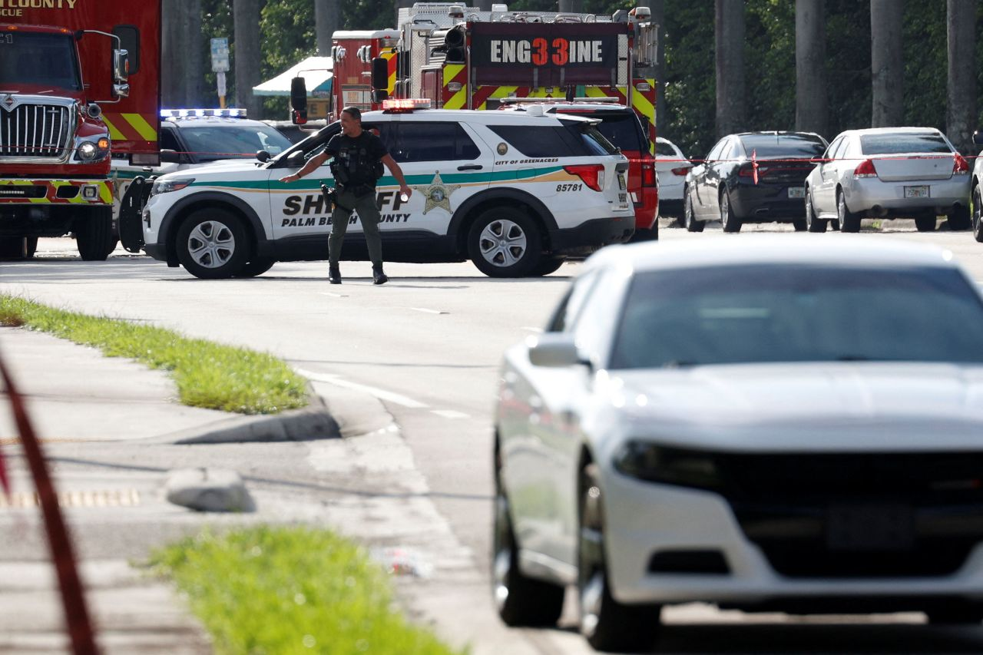

Law enforcement investigates reports of shots fired outside Trump International Golf Club in West Palm Beach, Florida, on Sunday.

Marco Bello/Reuters

The FBI “is investigating what [appears to be an attempted assassination](https://www.cnn.com/2024/09/15/politics/donald-trump-safe-shots/index.html)” of Donald Trump, the agency said Sunday, [just two months after](https://www.cnn.com/politics/live-news/trump-harris-election-09-15-24#h_08a254029bb4f5089da43c8221739c43) an attempt on the former president’s life at a Pennsylvania rally.

The former president is safe after shots were fired at Trump International Golf Club in South Florida on Sunday. Here’s what happened:

* **Secret Service spots a rifle:** A Secret Service agent, who was a number of holes ahead of the former president, [spotted a rifle barrel](https://www.cnn.com/politics/live-news/trump-harris-election-09-15-24#h_fff37e0df922eb36ec8dbd5cc87ead87) sticking out of a fence and “engaged” with the suspect.
* **Gunshots during golf:**Trump was moving between [holes five and six](https://www.cnn.com/politics/live-news/trump-harris-election-09-15-24#h_ac7956ac5a6f744782a2d7a1fd3aace9) at his golf course, the Trump International Golf Club in West Palm Beach, with donor Steve Witkoff when gunshots went off. The course was immediately locked down, according to a source familiar.
* **Sheriff alerted:** Palm Beach County Sheriff Ric Bradshaw said his office was alerted at 1:30 p.m. ET that gunshots were fired by the US Secret Service.
* **Witness spots a man in the bushes:** A witness [saw the suspect](https://www.cnn.com/politics/live-news/trump-harris-election-09-15-24#h_b2e7ea3e053ca5ac1f1396b6d8a6640d) run from the bushes and took a picture of his vehicle that led to the man’s apprehension, according to the Palm Beach County sheriff.
* **Highway gets flooded with police:** Martin County Sheriff William D. Snyder [said his agency](https://www.cnn.com/politics/live-news/trump-harris-election-09-15-24#h_bf81413addfefa690a4d1fbc1cd7fe85) “flooded” Interstate 95 and closed a large swath of the highway before eventually safely stopping the suspect’s vehicle and detaining him.
* **Man taken into police custody:**The suspect was not armed when law enforcement officials took him out of the car, and he has not made any statements regarding his alleged involvement in the incident, Bradshaw said. According to three law enforcement sources, the person in custody in connection with the incident is [Ryan Wesley Routh](https://www.cnn.com/politics/live-news/trump-harris-election-09-15-24#h_00593ed682bab491861fed6aea558684).
* **Man leaves rifle and belongings in the bushes:**Law enforcement officials found an AK-47 style rifle with a scope; two backpacks, which were hung on the fence and had ceramic tile in them; and a GoPro where the suspect was positioned in the bushes.

7:07 a.m. 8:53:31, September 16, 2024

**US officials recently briefed Trump campaign on new intel about Iran threat, sources say**

From CNN’s Kaitlan Collins, Zachary Cohen and Sean Lyngaas

US intelligence officials recently briefed Donald Trump’s campaign about new indications that [Iran was planning to escalate attacks](https://www.cnn.com/2024/07/16/politics/iran-plot-assassinate-trump-secret-service/index.html) on the former president and those around him, multiple sources familiar with the matter told CNN.

At this point, there is no indication that the intelligence is related to the apparent second assassination attempt against on Trump on Sunday, the sources said. The intelligence briefing given in recent days related to potential physical and cybersecurity attacks, adding to the overall elevated security threat against Trump.

CNN previously reported that authorities had obtained intelligence about a plot by Iran to assassinate Trump in the weeks before the [attempted assassination of the former president at a campaign rally in Pennsylvania in July](https://www.cnn.com/politics/live-news/trump-rally-shooting-07-18-24/index.html). There has been no indication that Thomas Matthew Crooks, the would-be assassin who was shot and killed that day, was connected to the plot.

Separately, the US government has concluded the Iranian government is [behind a hack-and-leak operation](https://www.cnn.com/2024/08/19/politics/us-concludes-iran-behind-trump-biden-harris-hacking/index.html) targeting Trump’s campaign and also attempted to target the Biden-Harris campaign.

7:04 a.m. 8:53:31, September 16, 2024

**Task force investigating first Trump assassination attempt requests new briefing with Secret Service**

From CNN's Zack Cohen

The congressional task force investigating the [first attempted assassination](https://www.cnn.com/politics/live-news/trump-harris-election-09-15-24#h_08a254029bb4f5089da43c8221739c43) of former President Donald Trump is requesting a briefing with the US Secret Service following the Sunday security incident at Trump’s golf club in Florida.

“We are thankful that the former President was not harmed, but remain deeply concerned about political violence and condemn it in all of its forms. The Task Force will share updates as we learn more,” GOP Rep. Mike Kelly and Democratic Rep. Jason Crow said in a joint statement.

7:15 a.m. 8:53:31, September 16, 2024

**Person detained in apparent assassination attempt identified, sources say**

From CNN's John Miller, Evan Perez and Hannah Rabinowitz

The person in custody in connection with the apparent attempted assassination of former President Donald Trump is Ryan Wesley Routh, according to three law enforcement sources.

**What we know so far about the person detained:**

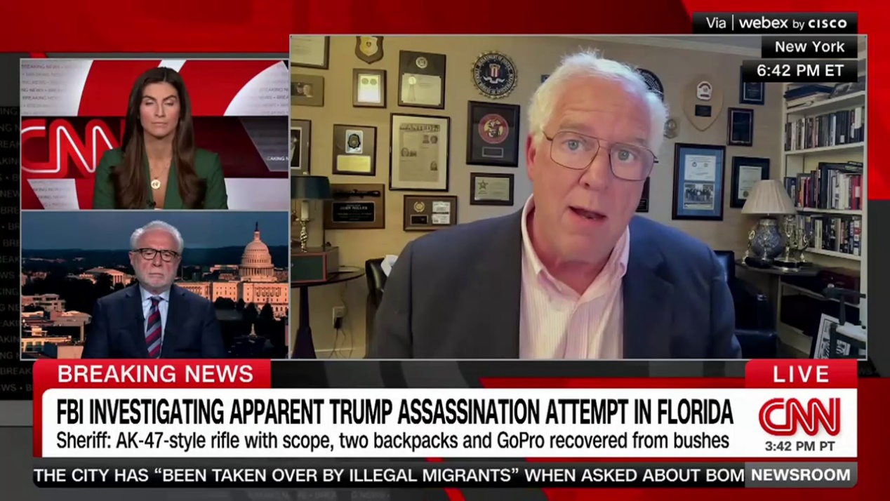

01:41 - Source: cnn

6:31 a.m. 8:53:31, September 16, 2024

**A flashback to the July Trump assassination attempt, and what's happened since then**

From CNN's Michelle Shen

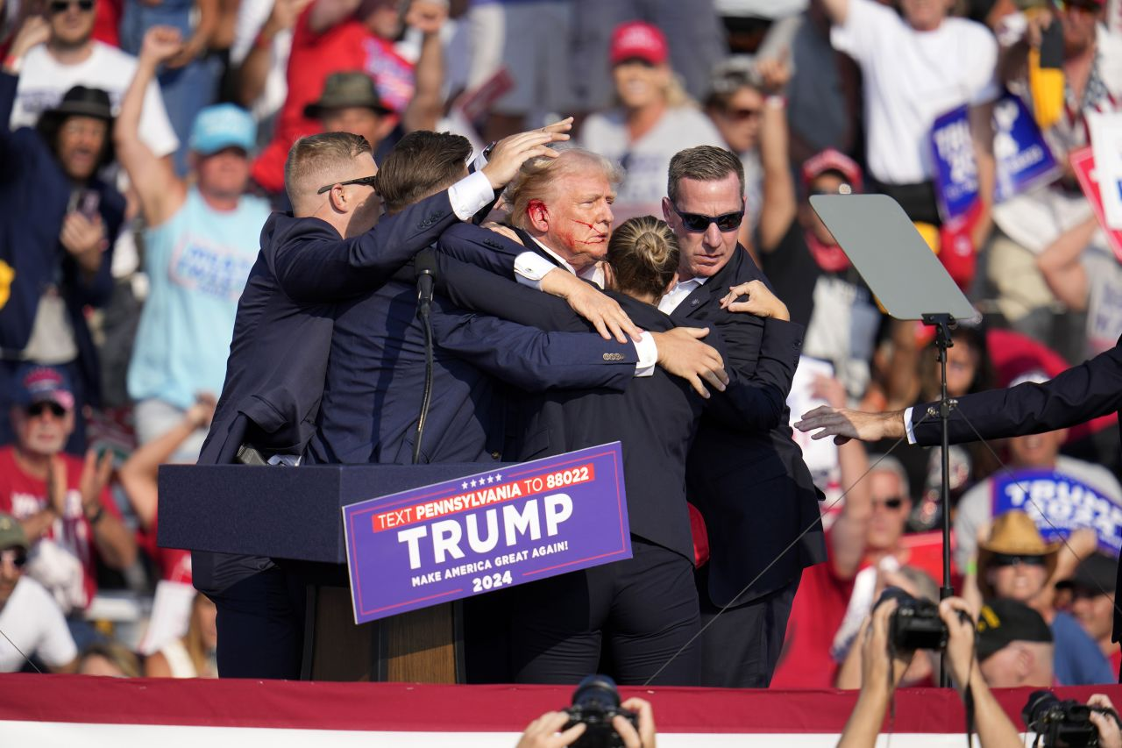

Former President Donald Trump is helped off the stage after an attempted assassination during a campaign rally in Butler, Pennsylvania, on July 13.

Gene J. Puskar/AP

Not too long ago, Trump was the target of an assassination attempt during a July rally in Butler, Pennsylvania, when a [staccato of shots](https://www.cnn.com/2024/07/14/politics/timeline-trump-rally-shooting-dg/index.html) rang out in the middle of his speech, killing one attendee and severely injuring two others. According to the FBI, either a bullet or a [bullet fragment struck Trump](https://www.cnn.com/2024/07/26/politics/fbi-trump-interview-assassination-attempt/index.html), wounding him on the ear.

The incident sparked a broader investigation around lapses in Trump’s security apparatus, increasing scrutiny on the Secret Service. Amid a possible second assassination attempt, lawmakers and officials are still in the process of investigating the first attempt on Trump’s life.

**A flashback to Trump’s rally in Pennsylvania:**Video showed some attendees noticed the gunman on the roof at least one minute and 57 seconds before the shooting began, and several rally attendees tried to call attention to the gunman as Trump was speaking on the stage. The shooter, [Thomas Matthew Crooks](https://www.cnn.com/2024/07/19/politics/trump-rally-gunman-portrait-motive-invs/index.html), was fatally shot at the scene.

**Secret Service boosts security:** Since the incident, the Secret Service has bolstered Trump’s security detail and surrounds the former president with [bulletproof glass](https://www.cnn.com/2024/08/15/politics/secret-service-trump-bulletproof-glass/index.html) at campaign rallies. A senior official told CNN additional security measures would also include increasing the number of agents and certain technological changes, though the official declined to provide more details.

**The fallout:** Then-Secret Service Director Kimberly Cheatle [resigned in July](https://www.cnn.com/2024/07/23/politics/secret-service-director-kimberly-cheatle/index.html) amid criticism for security lapses related to the assassination attempt, and the agency is under continued pressure from lawmakers to hold individuals accountable for those failures. Ronald Rowe, now acting director of the Secret Service, had said several times he would wait until the results of internal investigations into the shooting before making personnel decisions over that day’s failures. Multiple Secret Service personnel from the Pittsburgh Field Office and one member of Trump’s security detail involved in the planning for the July 13 rally were reassigned to administrative duties and ordered to work from home.

6:09 a.m. 8:53:31, September 16, 2024

**Schumer briefed by Secret Service director after Trump security incident**

From CNN's Manu Raju and Morgan Rimmer

Senate Majority Leader Chuck Schumer said he has been briefed by acting Secret Service Director Ronald L. Rowe, Jr. after shots were fired at Trump International Golf Club near former President Donald Trump.

“I applaud the Secret Service for their quick response to ensure former President Trump’s safety,” Schumer added.

“There is no place in this country for political violence of any kind. The perpetrator must be prosecuted to the fullest extent of the law.”

7:25 a.m. 8:53:31, September 16, 2024

**Walz says he's "glad" Trump is safe and condemns violence**

From CNN's Sam Fossum

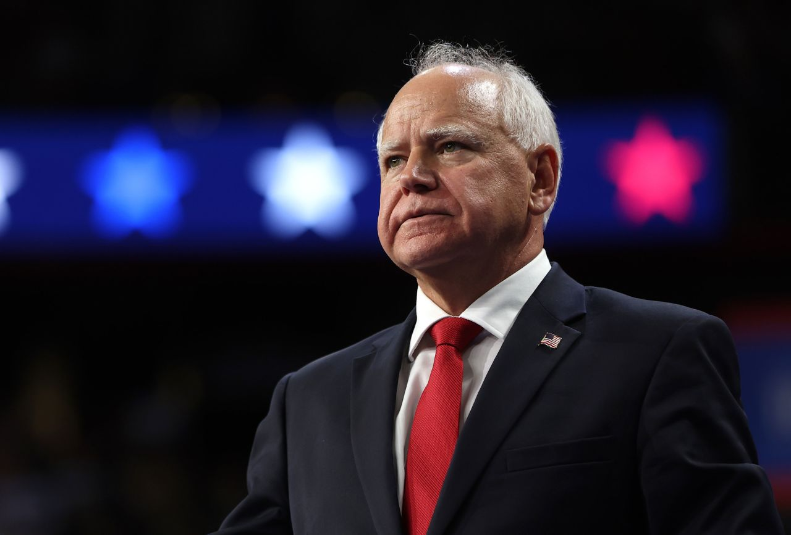

Minnesota Gov. Tim Walz speaks at a campaign rally in Las Vegas, on August 10.

Justin Sullivan/Getty Images/File

Democratic vice presidential nominee Tim Walz said he and his wife are “glad” that former President Donald Trump is safe following what the FBI is saying is an apparent assassination attempt against him.

The statement, which follows closely to what Vice President Kamala Harris wrote earlier, also condemns violence.

“Gwen and I are glad to hear that Donald Trump is safe. Violence has no place in our country. It’s not who we are as a nation,” he [wrote](https://x.com/Tim_Walz/status/1835436418316808234) on X.

7:00 a.m. 8:53:31, September 16, 2024

**Golf courses — in particular Trump’s — have long proved a difficult assignment for Secret Service**

From CNN's Kevin Liptak

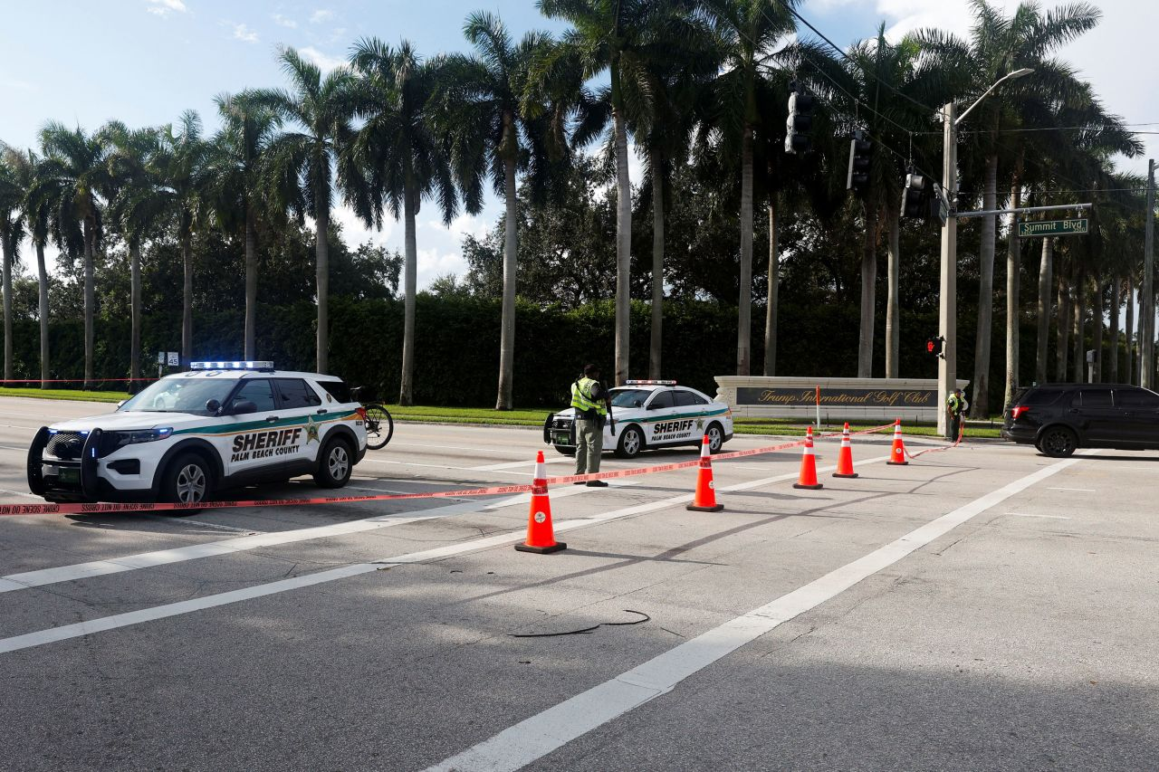

Law enforcement vehicles are parked after reports of shots fired outside Trump International Golf Club in West Palm Beach, Florida, on Sunday.

Marco Bello/Reuters

Golf courses, and in particular Donald Trump’s own properties, have long been a source of concern among Secret Service officials tasked with securing the grounds while the commander in chief plays, according to people familiar with the matter.

A golf course is often the largest outdoor area a president can visit, and their design — often abutting public roads and containing elements like trees and hills that can conceal would-be assassins — make them particularly difficult for the agency to secure.

Like other presidents before him, Trump’s presence at a golf course does not prompt the club to shut down to the general public, nor for the roads to be closed nearby.

Instead, groups of agents in golf clothes typically ride in golf carts ahead and behind the president as he plays and secure the areas in the several minutes before he arrives.

Trump International Golf Club in West Palm Beach abuts three heavily trafficked roads: Kirk Road, Summit Boulevard and Congress Avenue. The Palm Beach International Airport is also nearby.

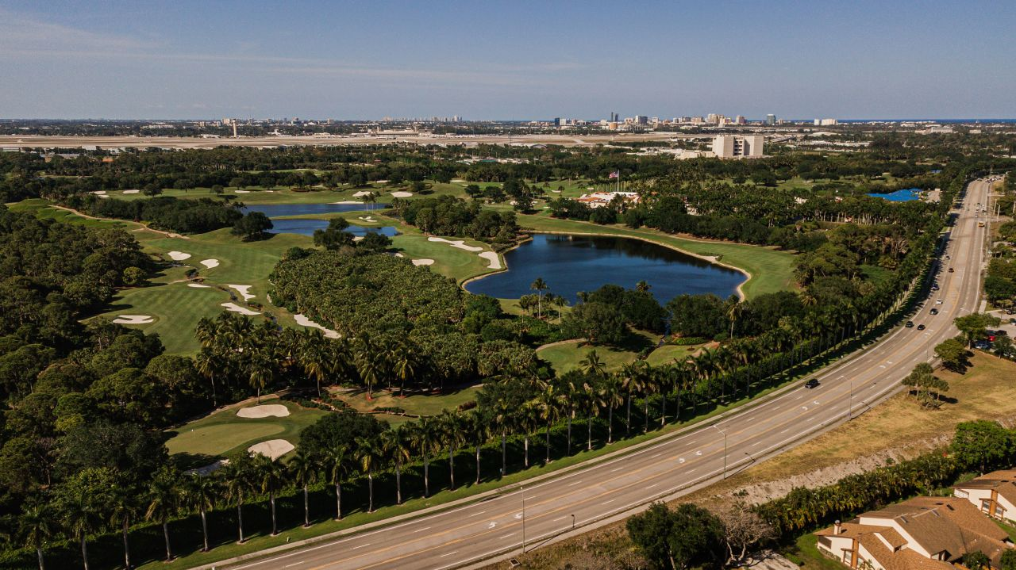

An April 2021 file photo shows an aerial view of Trump International Golf Club in West Palm Beach, Florida.

Crystal Bolin Photography/iStockphoto/Getty Images/File

As president, Trump could often be spotted from across from Kirk Road when he was playing golf. But members of the media were not permitted to stand on the sidewalks near the golf course when Trump was playing.

After he left office, some of those restrictions were lifted. Members of the public were able to have a clear view of Trump from the sidewalks on Summit Boulevard and Congress Avenue.

In a briefing Sunday, the Palm Beach County sheriff acknowledged that with Trump now not a sitting president, the Secret Service was “limited” in its ability to fully surround the golf course.

When he was president, Barack Obama’s most frequent golf outing was to the links at Joint Base Andrews, which, by its nature on a military installation, had restricted access — both to the course itself but also its surroundings.

President Joe Biden rarely golfs.

5:59 a.m. 8:53:31, September 16, 2024

**Trump is back at his Mar-a-Lago estate**

From CNN staff

Former President Donald Trump is back at his Mar-a-Lago estate in Florida following what the FBI is calling an apparent [assassination attempt](https://www.cnn.com/2024/09/15/politics/donald-trump-safe-shots/index.html).

The former president and his motorcade left the Trump International Golf Club in West Palm Beach after Secret Service spotted and engaged with a gunman who was positioned on the perimeter of the club. The suspect fled the scene in a car but was later detained by law enforcement.

6:24 a.m. 8:53:31, September 16, 2024

**Secret Service was "limited" in protection it was able to offer Trump since he is not sitting president, sheriff says**

From CNN's Jack Forrest

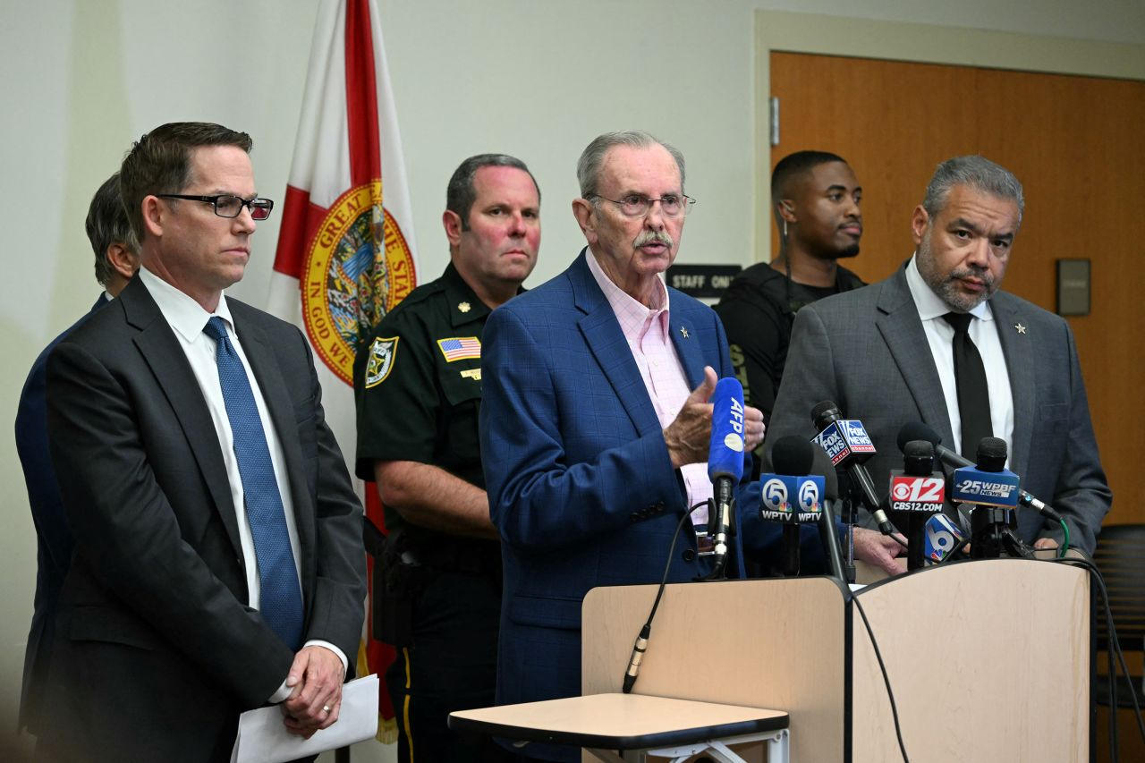

Palm Beach County Sherrif Ric Bradshaw speaks alongside FBI and Secret Service officials during a news conference in West Palm Beach, Florida, on September 15.

Chandan Khanna/AFP/Getty Images

Former President Donald Trump’s South Florida golf course would have been “surrounded” with protection if he were the sitting president, but the US Secret Service was “limited” in the areas it was able to cover ahead of Sunday’s incident, Palm Beach County Sheriff Ric Bradshaw said at a news conference.

“The golf course is surrounded by shrubbery, so when somebody gets into the shrubbery, they’re pretty much out of sight, all right, and at this level that he is at right now, he’s not the sitting president,” Bradshaw said.

“If he was, we would have had this entire golf course surrounded. But because he’s not, security is limited to the areas that the Secret Service deems possible. So, I would imagine that the next time he comes to the golf course, there’ll probably be a little bit more people around the perimeter. But the Secret Service did exactly what they should have done.”

**Watch here:**

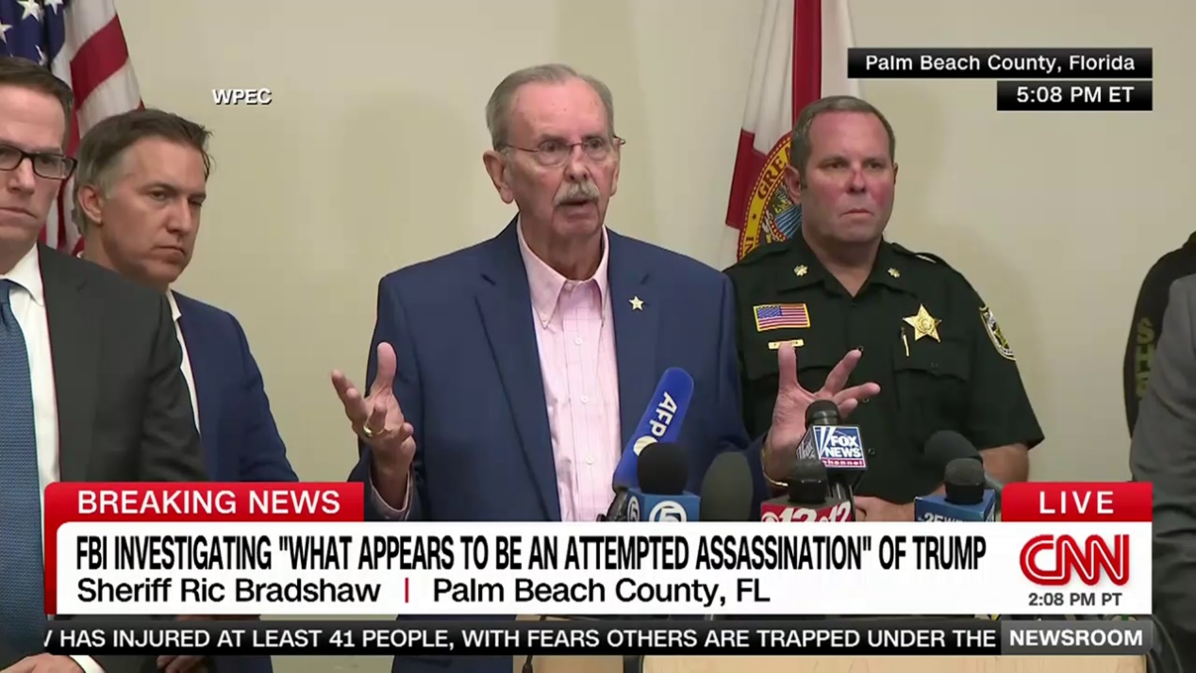

00:43 - Source: cnn

5:45 a.m. 8:53:31, September 16, 2024

**Vance says he spoke with Trump, who is in "good spirits"**

From CNN's Rashard Rose

Republican vice presidential candidate JD Vance said he spoke with former President Donald Trump after the security incident in Florida on Sunday “before the news was public.”

“I’m glad President Trump is safe. I spoke to him before the news was public and he was, amazingly, in good spirits,” Vance said in a [social media post.](https://x.com/JDVance/status/1835428708464873580)

“Still much we don’t know, but I’ll be hugging my kids extra tight tonight and saying a prayer of gratitude,” the Ohio senator added.

5:55 a.m. 8:53:31, September 16, 2024

**Law enforcement found an AK-47 style rifle, GoPro and backpacks where suspect was positioned, sheriff says**

From CNN's Maureen Chowdhury

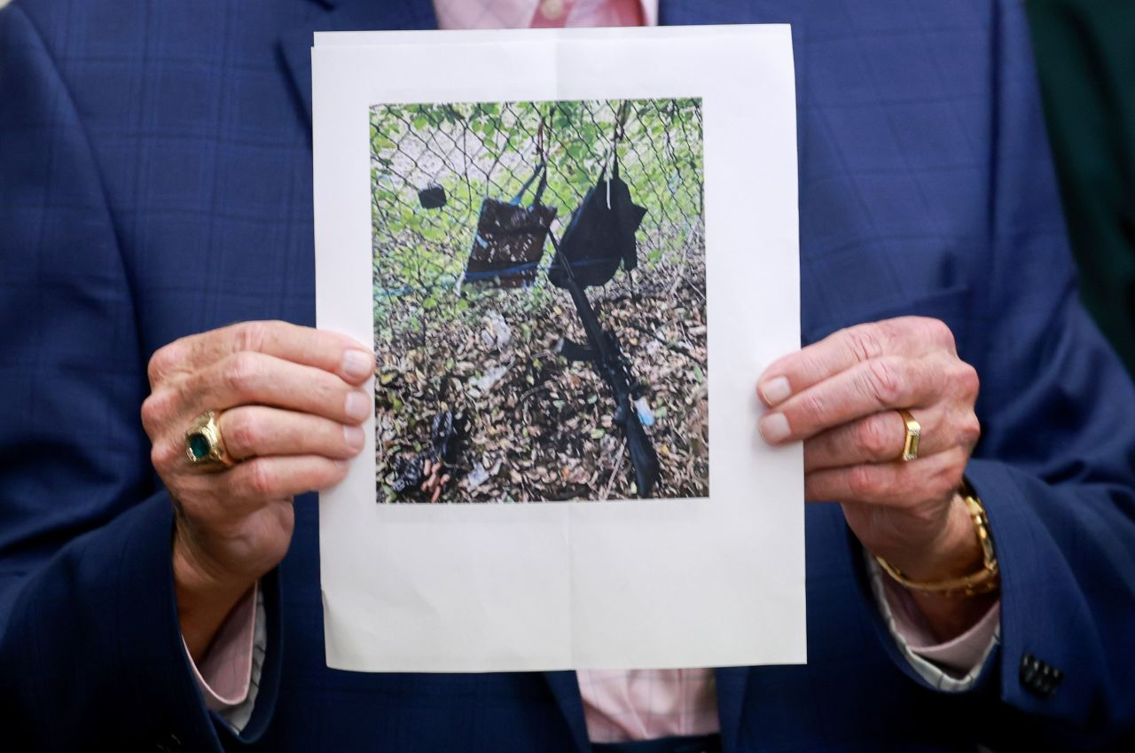

Palm Beach County Sheriff Ric Bradshaw holds a photograph showing a rifle and other items found near where the suspect was discovered Sunday during a press conference in West Palm Beach, Florida.

Joe Raedle/Getty Images

Law enforcement officials found a weapon and other items left behind by the suspect where he was positioned in the bushes near the Trump International Golf Club in South Florida on Sunday.

“In the bushes, where this guy was, is an AK-47 style rifle with a scope; two backpacks, which were hung on the fence and had ceramic tile in them; and a GoPro. … So, those are being processed right now,” Palm Beach County Sheriff Ric Bradshaw said.

5:28 a.m. 8:53:31, September 16, 2024

**Suspect has not made any statements, sheriff says**

From CNN's Maureen Chowdhury

The suspect has not made any statements regarding his involvement in the alleged assassination attempt, said Palm Beach County Sheriff Ric Bradshaw.

Authorities have not named the suspect.

“No statement right now as far as his involvement in the incident and there’s further investigation to be completed,” Bradshaw said.

5:26 a.m. 8:53:31, September 16, 2024

**Trump campaign office in West Palm Beach went on lockdown after shots fired**

From CNN's Kaitlan Collins

Donald Trump’s campaign office in West Palm Beach, Florida, went into lockdown after shots were fired at his golf course Sunday. There were several staffers in the building at the time, a source familiar told CNN.

The lockdown has since lifted.

5:52 a.m. 8:53:31, September 16, 2024

**Suspect in custody was "relatively calm" when detained, sheriff says**

From CNN’s Cindy Von Quednow

A man taken into custody after gunshots were fired near former President Donald Trump at the Trump International Golf Club in West Palm Beach, Florida, was “relatively calm” when detained, Martin County Sheriff William D. Snyder said Sunday.

“He was not displaying a lot of emotions. Never asked, ‘What is this about?’” the sheriff said.

Snyder said the unnamed suspect was not armed when law enforcement officials took him out of the car. Snyder said the sheriff’s office would take the vehicle to FBI custody, which will take over the investigation, along with the Palm Beach County Sheriff’s Office and the US Secret Service.

Snyder said his agency “flooded” Interstate 95 and closed a large swath of the highway before eventually safely stopping the suspect vehicle.

“I have a clear understanding from investigators that we actually do have the suspect that they’re looking for in Palm Beach County,” Snyder said.

5:20 a.m. 8:53:31, September 16, 2024

**FBI asks public to submit information to tip line**

From CNN's Michelle Shen

An FBI representative asked the public to submit any helpful information regarding the security incident investigation via a tip line, 1-800-CALLFBI, or on [the FBI’s website](https://tips.fbi.gov/).

“What we need right now is for the public to avoid the area around the golf course. We will continue support this investigation with the full resources of the FBI,” said Special Agent Jeffrey Veltri of the Miami field office at Sunday’s news conference.

6:20 a.m. 8:53:31, September 16, 2024

**Witness saw suspect run from bushes and get in car**

From CNN's Jack Forrest

A witness saw the suspect later detained in the security incident near former President Donald Trump run from the bushes and took a picture of his vehicle that led to the suspect’s apprehension, according to the Palm Beach County sheriff.

Sheriff Ric Bradshaw said Sunday that his office was alerted at 1:30 p.m. ET of shots fired by the US Secret Service.

“We are able to catch a witness that came to us and said, ‘Hey, I saw the guy running out of the bushes, he jumped into a black Nissan and I took a picture of the vehicle and the tag,’ which was great,” Bradshaw said.

Authorities were able to get a hit on the vehicle and alerted the Martin County Sheriff’s Office, which detained the suspect. The witness was able to then identify the man.

**Watch:**

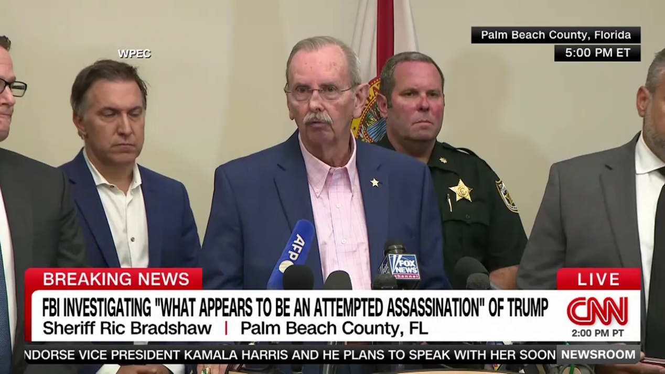

01:49 - Source: cnn

5:31 a.m. 8:53:31, September 16, 2024

**Secret Service agent was able to spot rifle barrel sticking out of fence and engaged suspect, sheriff says**

From CNN's Maureen Chowdhury

Palm Beach County Sheriff Ric Bradshaw said at a news conference Sunday that a Secret Service agent was able to spot a rifle barrel with a scope sticking out of a fence at Trump International Golf Club in West Palm Beach and that the agent “engaged” with the suspect.

The gunman was 300 to 500 yards away from former President Donald Trump, a Secret Service official said. The former president was one or two holes behind because the security detail moves ahead to make sure the area is cleared. The agent noticed the rifle barrel sticking out during the advance check, the official said.

“The US Secret Service personnel opened fire on a gunman located near the property line and this matter is under investigation,” the Secret Service representative said.

*This post has been updated with additional information.*

4:49 a.m. 8:53:31, September 16, 2024

**FBI responding to "what appears to be an attempted assassination" of Trump**

From CNN's Holmes Lybrand

The FBI said Sunday it is responding to West Palm Beach, Florida, and “is investigating what appears to be an attempted assassination” of former President Donald Trump.

A suspect has been detained by local police after shots were fired at Trump’s golf course in West Palm Beach.

4:47 a.m. 8:53:31, September 16, 2024

**Florida GOP congressman calls for US Secret Service to brief Congress this week**

From CNN's Sam Fossum

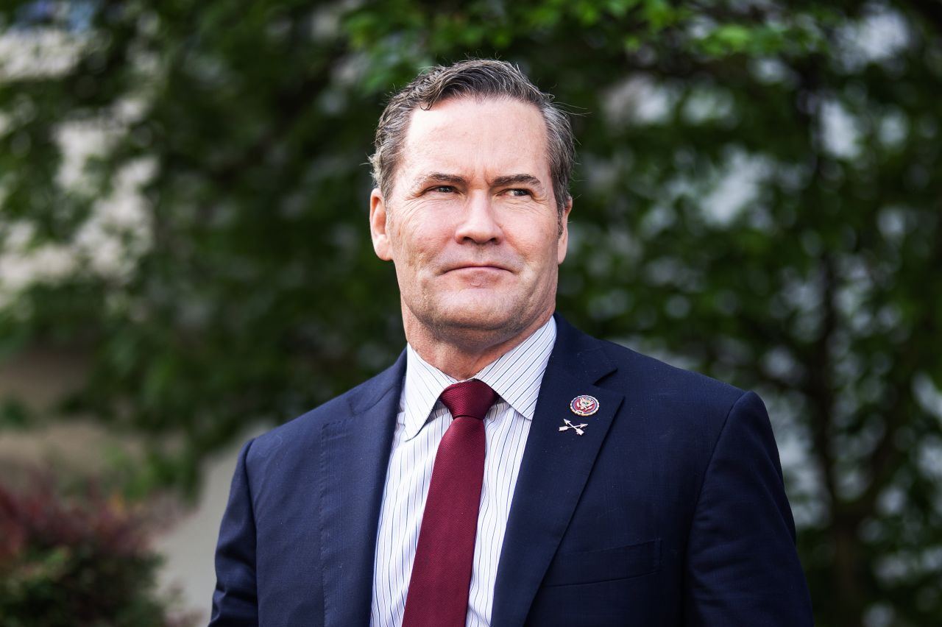

Rep. Michael Waltz is pictured in Washington, DC, on April 30.

Tom Williams/CQ Roll Call/Getty Images/File

Florida Republican Rep. Michael Waltz called for the US Secret Service to brief Congress this week after the security incident near former President Donald Trump.

“As I’ve said before, the July 13th assassination attempt was not an isolated incident that we can take our time investigating as domestic and foreign threats are ongoing. As a member of the Assassination Task Force, I expect the Secret Service to brief us this week,” he wrote on [X](https://twitter.com/michaelgwaltz/status/1835402624104833503).

Waltz is a member of a[bipartisan congressional task force](https://www.cnn.com/2024/08/26/politics/task-force-trump-assassination-attempt-promises-thorough-investigation/index.html) made up of six Democrats and seven Republicans established to investigate the attempted assassination of Trump at a Pennsylvania rally on July 13.

4:43 a.m. 8:53:31, September 16, 2024

**Trump was between holes 5 and 6 on golf course, suspect farther ahead, sources say**

From CNN's Kristen Holmes, Holmes Lybrand and Evan Perez

Former President Donald Trump was moving between holes five and six at his South Florida golf course when the security incident happened Sunday, a source briefed on the matter told CNN.

The suspect, who the Secret Service engaged with, was a number of holes ahead of the former president, according to two law enforcement sources.

The Secret Service fired at the suspect as a protective measure, that source said.

Trump was golfing with donor Steve Witkoff when the incident happened, a source familiar with the matter told CNN.

4:37 a.m. 8:53:31, September 16, 2024

**Trump in "good spirits," Sen. Graham says after speaking with him**

From CNN's Sam Fossum

Former President Donald Trump is in “good spirits” after the security incident that occurred at his golf course earlier Sunday, according to Trump ally Republican Sen. Lindsey Graham. of South Carolina.

“Just spoke with President Trump. He is one of the strongest people I’ve ever known. He’s in good spirits and he is more resolved than ever to save our country,” [Graham wrote on social media platform X.](https://x.com/LindseyGrahamSC/status/1835388250489253959)

4:37 a.m. 8:53:31, September 16, 2024

**Vance doesn't address reporters as he boards campaign plane**

From CNN's Kit Maher

Republican vice presidential candidate JD Vance did not address reporters as he boarded his campaign plane Sunday following a security incident involving former President Donald Trump in South Florida.

Vance, Trump’s running mate, was boarding the plane at Cincinnati/Northern Kentucky International Airport to return to Washington, DC.

One reporter yelled out to ask whether Vance had talked to Trump or heard anything about the shots fired near the former president while he was playing golf.

4:12 a.m. 8:53:31, September 16, 2024

**"I AM SAFE AND WELL!" Trump says in fundraising email**

From CNN's Rashard Rose

Former President Donald Trump said in a fundraising email that he is “safe and well” following the security incident at his golf course in South Florida earlier Sunday.

“There were gunshots in my vicinity, but before rumors start spiraling out of control, I wanted you to hear this first: I AM SAFE AND WELL!” the email said. “Nothing will slow me down. I will NEVER SURRENDER! I will always love you for supporting me.”

5:55 a.m. 8:53:31, September 16, 2024

**Martin County Sheriff's Office takes suspect into custody who is “believed to be connected” to incident**

From CNN staff

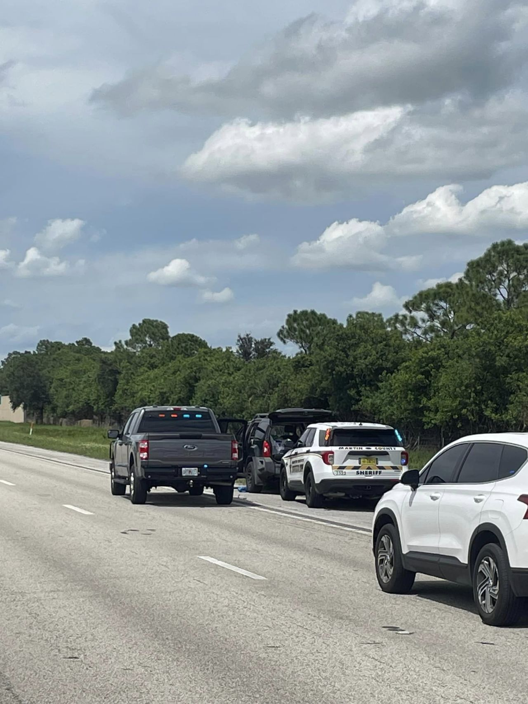

The Martin County Sheriff’s Office posted this photo on Facebook on September 15, writing that they have “stopped a vehicle and taken a suspect into custody" that authorities believe is connected to the incident at Trump International Golf Club in West Palm Beach, Florida.

Martin County Sheriff's Office/Facebook

A suspect who authorities believe is connected to Sunday’s incident at Trump International Golf Course has been taken into custody, according to a Facebook post from the Martin County Sheriff’s Office in Florida.

The sheriff’s office “has stopped a vehicle and taken a suspect into custody,” the [post](https://www.facebook.com/share/p/uTZ7vkuR58foi4SY/) said. A section of Interstate 95 near State Route 714 in Martin County is shut down, the office said.

“We will update this information as it becomes available,” the post continued.

Martin County is north of Palm Beach County, where Sunday’s incident at Trump International took place.

3:59 a.m. 8:53:31, September 16, 2024

**Attorney General Garland briefed on Trump security incident**

From CNN's Hannah Rabinowitz

Attorney General Merrick Garland has been briefed on the security incident involving former President Donald Trump in Florida Sunday, according to the Department of Justice.

DOJ spokesperson Dena Iverson said Garland is monitoring the situation and is receiving regular updates following the security incident at the Trump International Golf Club.

3:55 a.m. 8:53:31, September 16, 2024

**Biden, Harris briefed on the security incident involving Trump**

From CNN's Sam Fossum

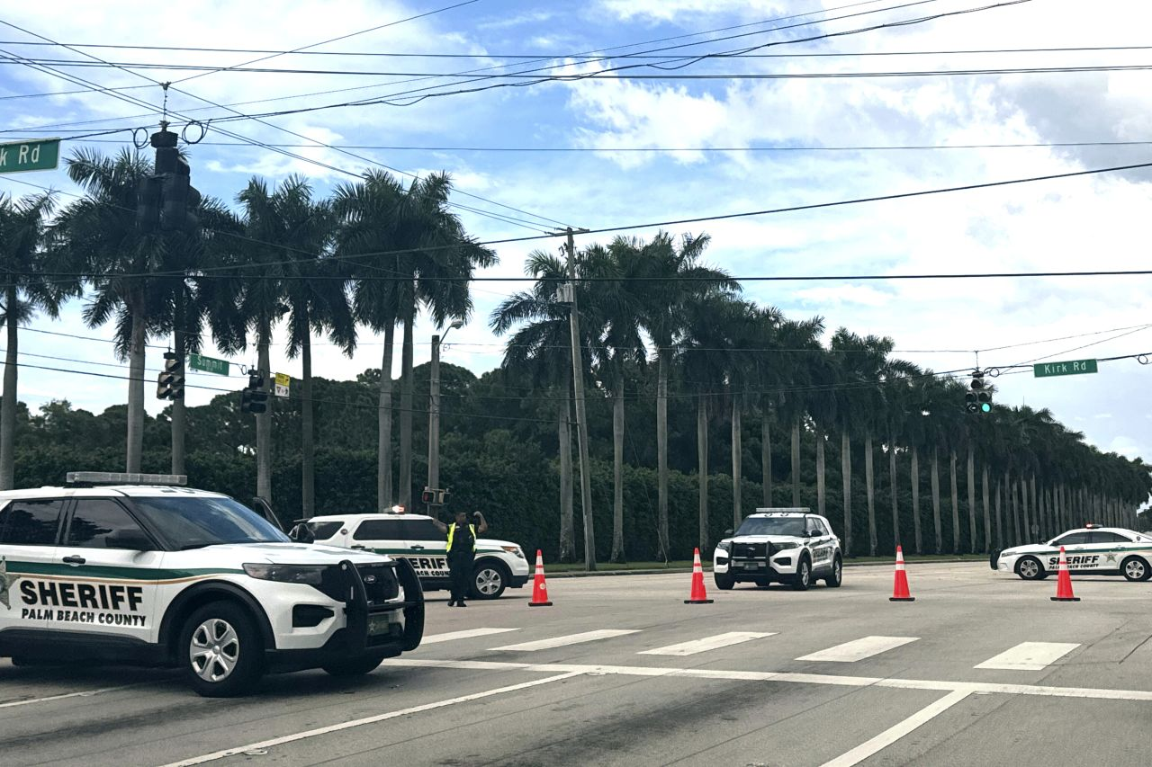

Sheriff vehicles are seen near Trump International Golf Club in West Palm Beach, Florida, on September 15, after gunshots were reported in the vicinity of former President Donald Trump.

Stephanie Matat/AP

President Joe Biden and Vice President Kamala Harris are both “relieved to know” that Donald Trump is safe and have been briefed on the security incident involving the former president while he was golfing earlier Sunday, according to the White House.

Biden and Harris, both of whom are in Washington, DC, with no public events today, will be kept updated by their team.

“The President and Vice President have been briefed about the security incident at the Trump International Golf Course, where former President Trump was golfing. They are relieved to know that he is safe. They will be kept regularly updated by their team,” according to a statement from the White House.

In [her own statement](https://twitter.com/VP/status/1835403813475570113) posted on social media Sunday, Harris said, “I have been briefed on reports of gunshots fired near former President Trump and his property in Florida, and I am glad he is safe. Violence has no place in America.”

*This post has been updated with additional information.*

3:44 a.m. 8:53:31, September 16, 2024

**Person detained following incident at Trump International Golf Club, source says**

From CNN's Evan Perez and John Miller

A person has been detained in connection to the incident at Trump International Golf Club on Sunday, according to a law enforcement source.

Secret Service fired at the suspect, according to multiple sources.

A long gun has been recovered, according to the source.

Officials believe an armed individual intended to target former President Donald Trump at his golf club, according to sources briefed on the matter.

3:35 a.m. 8:53:31, September 16, 2024

**Officials believe intention was to target Trump, sources say**

From CNN's Kristen Holmes and John Miller

Officials believe an armed individual intended to target former President Donald Trump at Trump International Golf Club, according to sources briefed on the matter.

A car has been stopped in relation to the incident nearby, according to a law enforcement official.

3:10 a.m. 8:53:31, September 16, 2024

**Secret Service investigating "protective incident" involving Trump**

From CNN's Holmes Lybrand

The Secret Service said on X that it is working with the Palm Beach County Sheriff’s Office to investigate a protective incident involving former President Donald Trump. The Secret Service said the incident occurred shortly before 2 p.m. ET.

“The Secret Service, in conjunction with the Palm Beach County Sheriff’s Office, is investigating a protective incident involving former President Donald Trump that occurred shortly before 2 p.m. The former president is safe. @pbso will have more details soon.”

The Palm Beach County Sheriff’s Office is planning to speak at 3:15 p.m. ET to share more information, spokesperson Teri Barbera told CNN.

2:51 a.m. 8:53:31, September 16, 2024

**Trump is "safe following gunshots in his vicinity," campaign says in statement**

From CNN's Kate Sullivan

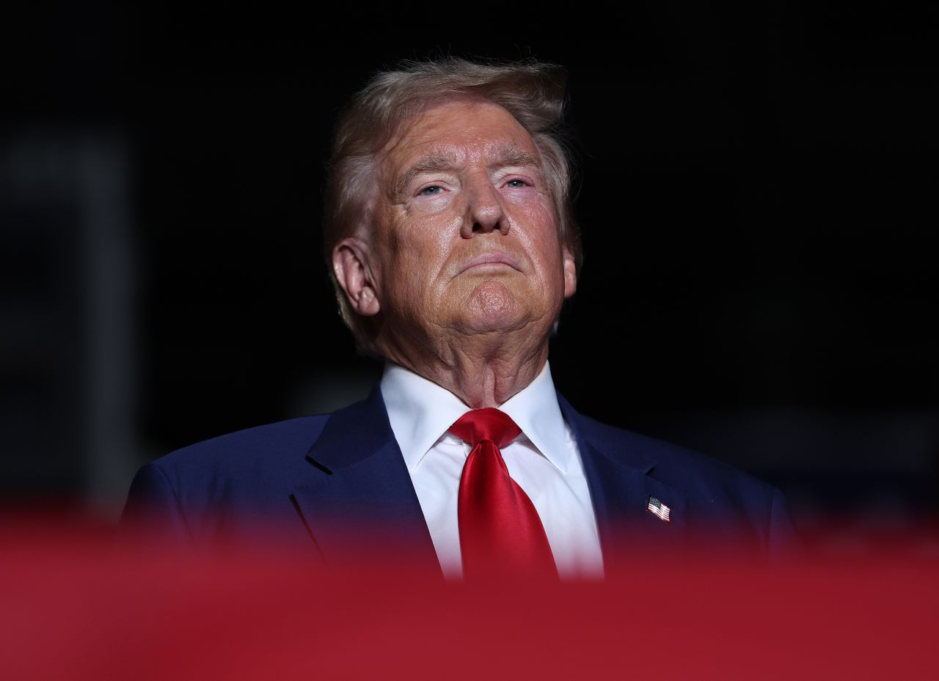

Former President Donald Trump attends a campaign rally in Las Vegas on September 13.

Justin Sullivan/Getty Images/File

Former President Donald Trump is safe “following gunshots in his vicinity,” his campaign said Sunday.

Trump was playing golf at Trump international Golf Club in West Palm Beach when shots were fired. The course was immediately locked down, according to a source familiar.

“President Trump is safe following gunshots in his vicinity. No further details at this time,” Trump campaign spokesman Steven Cheung said in a statement.

2:14 a.m. 8:53:31, September 16, 2024

**Here's what the candidates are up to this week**

From CNN's Isabelle D'Antonio

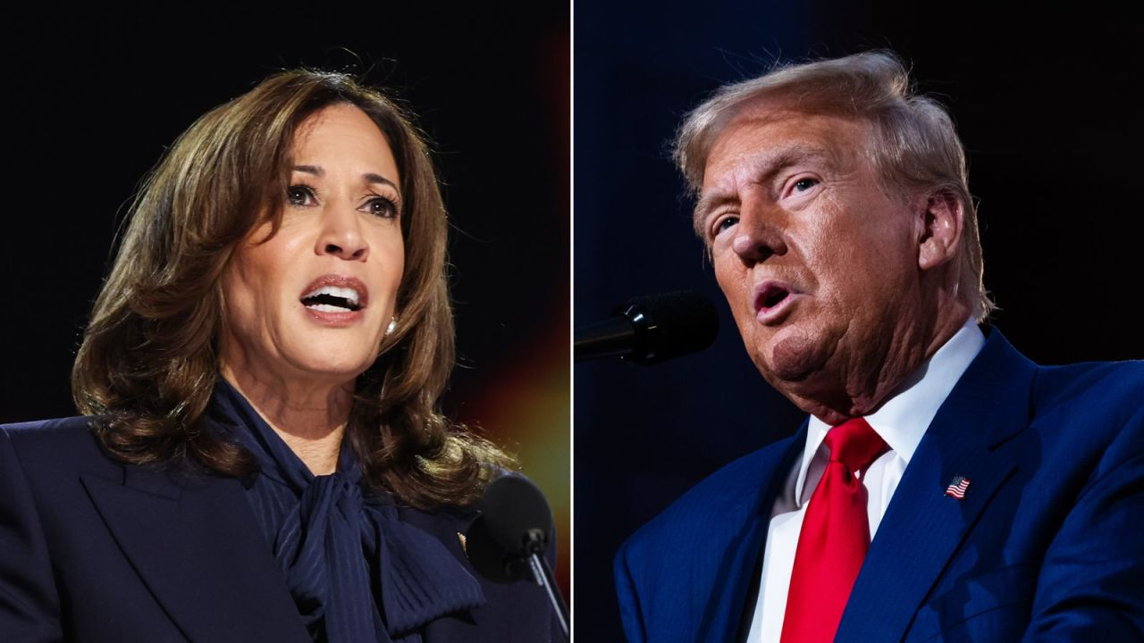

Vice President Kamala Harris and former President Donald Trump.

Getty Images

As the 2024 campaign enters its final sprint, the candidates are hitting the trail this week, with Vice President Kamala Harris visiting key swing states and former President Donald Trump holding events in the Midwest.

Here’s what the campaigns are up to:

**Monday:**Trump will introduce a new cryptocurrency business at his Mar-a-Lago estate in Florida. His running mate, Ohio Sen. JD Vance, will deliver remarks at the Georgia Faith & Freedom Coalition’s annual dinner. Harris, meanwhile, will attend a roundtable with the Teamsters at the union’s headquarters in Washington, DC, as she seeks to win over support from organized labor.

**Tuesday:**Harris will participate in a “fireside chat” hosted by the National Association of Black Journalists in Philadelphia. Trump will host a town hall in Flint, Michigan, while Vance will deliver remarks at events in Michigan and Wisconsin.

**Wednesday:** Trump will host a rally in Uniondale, New York, while Vance will speak at a rally in Raleigh, North Carolina.

**Thursday:** Trump will address the Israeli American Council’s summit in Washington, DC, as a featured speaker. Harris, meanwhile, will be in Michigan, where she will join Oprah Winfrey for a livestreamed event with grassroots groups.

**Friday:**Harris will campaign in Wisconsin.

**Saturday:** Trump will hold a rally in Wilmington, North Carolina, while Vance will join Tucker Carlson in Hershey, Pennsylvania, as part of the former Fox News host’s tour across the country.

2:16 a.m. 8:53:31, September 16, 2024

**Springfield mayor concerned about community safety after false rumors about Haitian immigrants**

From CNN's Chris Boyette

The city of Springfield, Ohio, is going through “a very difficult time,” the mayor said Sunday, adding that it would be helpful if politicians who amplified false [rumors about immigrants eating pets](https://www.cnn.com/2024/09/15/politics/vance-immigrants-pets-springfield-ohio-cnntv/index.html) in his city “understood the weight of their words.”

Springfield Mayor Rob Rue said city officials, including city commissioners, have received threats for the past three days.

“We have been shined under a spotlight that is so bright that it’s hard to see some of the things that we actually need to be focusing on, and that’s been difficult for sure,” the mayor told CNN’s Dana Bash on “State of the Union,” adding that “we’re concerned about the security in our community, and we’re focused on that right now.”

Republican vice presidential candidate JD Vance reiterated the false claims about Haitian immigrants eating the pets of Springfield residents in an interview with Bash earlier Sunday. But he rejected the notion that his rhetoric has led to the bomb threats against city officials, schools, hospitals and universities in Springfield.

Rue said he has not heard from Vance directly, “and that’s fine,” but said that he and others propagating the rumors should know that authorities in Springfield are telling the truth.

“We are telling the truth to our community. We are not ignoring the strain that the immigration has put in our community, but we are here to try to put our arms around it and to work as peaceably as possible to have our community secure and safe and thriving,” Rue said.

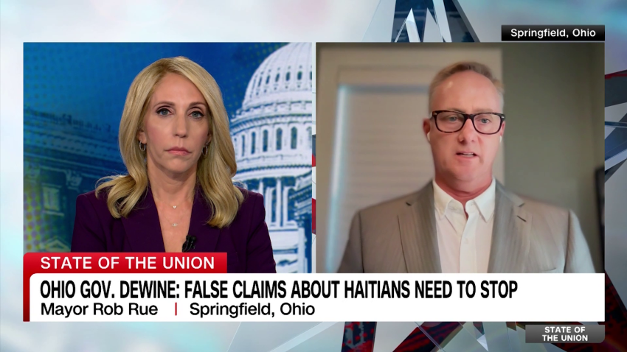

04:52 - Source: cnn

1:27 a.m. 8:53:31, September 16, 2024

**Harris surrogate Gov. Moore criticizes Vance over relationships with local officials**

From CNN's Mina Allen

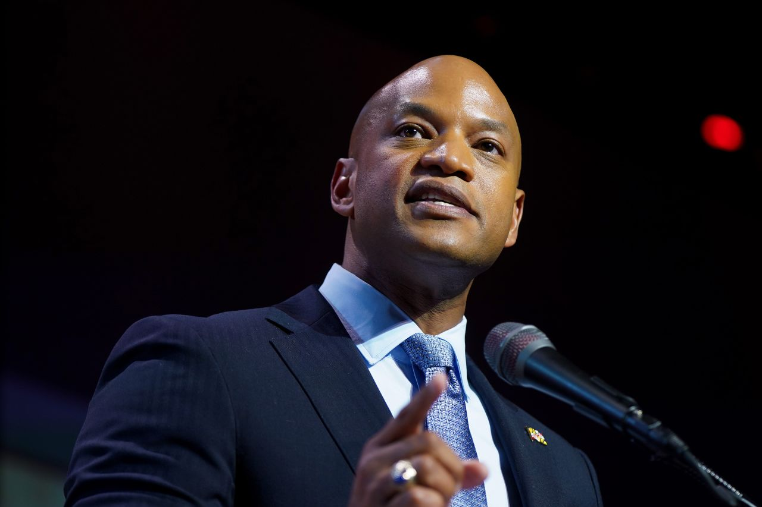

Wes Moore, governor of Maryland, speaks onstage during the Congressional Black Caucus Foundation's 53rd Annual Legislative Conference National Town Hall on September 12, in Washington, DC.

Leigh Vogel/Getty Images

Maryland Gov. Wes Moore on Sunday criticized GOP vice presidential nominee JD Vance for his lack of “partnerships” with local officials, after the Ohio senator [continued to spread baseless rumors](https://www.cnn.com/2024/09/15/politics/vance-immigrants-pets-springfield-ohio-cnntv/index.html) about migrants eating pets in the state.

Moore said Vance emphasizing a handful of constituents and dismissing the mayor of Springfield, Ohio, shows he does not understand the importance local politicians play.

“These are people who are closest to the ground. These are the people closest to their constituents, these are public servants and these are partners inside the work,” Moore said Sunday on CBS’ “Face the Nation.”

“It just gives a sense about how he views partnership and how he views the intelligence that’s coming from us.”

Springfield [Mayor Rob Rue](https://www.cnn.com/2024/09/14/politics/donald-trump-kamala-harris-laura-loomer/index.html) said Thursday the false claims are “hurting our citizens and hurting our community,” adding it’s “frustrating” that some of the rhetoric is coming from Vance, a Republican from Ohio.

Rue on Thursday night urged national candidates — a clear reference to Trump and Vance — to “pay attention to what their words are doing to cities like ours.”

“We need help, not hate,” Rue said.

12:52 a.m. 8:53:31, September 16, 2024

**Harris campaign uses Taylor Swift puns to slam Trump after he expresses hatred for singer**

From CNN's Aaron Pellish

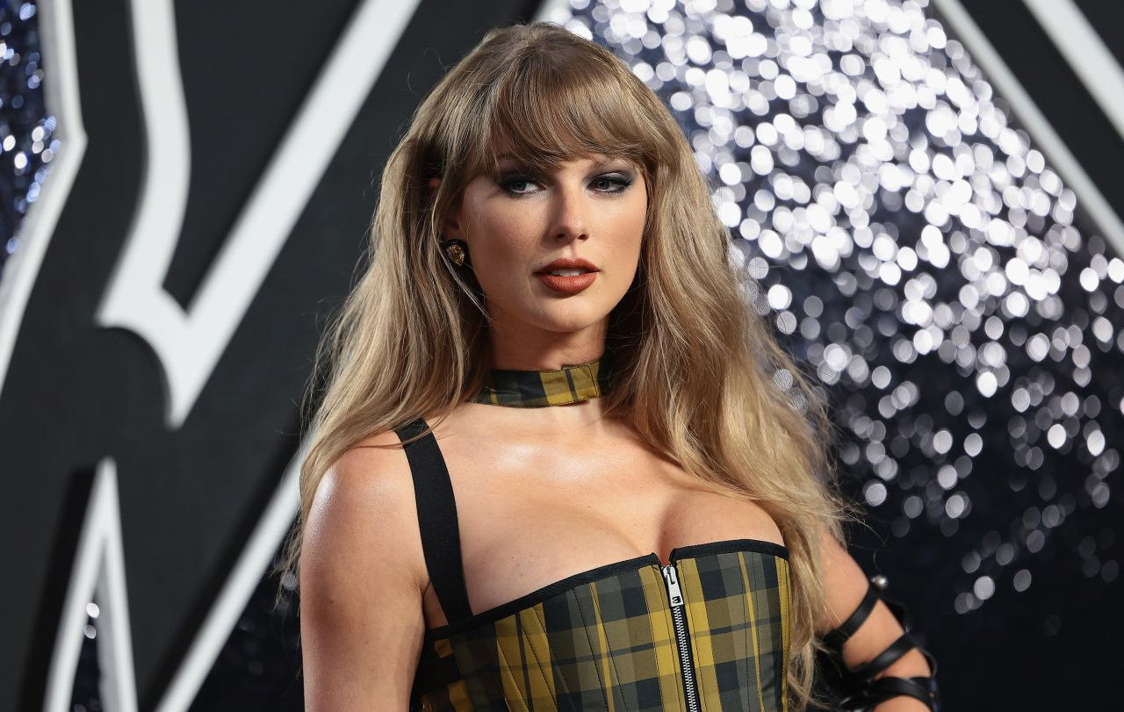

Taylor Swift attends the 2024 MTV Video Music Awards at UBS Arena on September 11, in Elmont, New York.

Dimitrios Kambouris/Getty Images

Kamala Harris’ campaign on Sunday slammed Donald Trump in a statement filled with Taylor Swift song references after the former president [expressed hatred](https://www.cnn.com/politics/live-news/trump-harris-election-09-15-24#h_7acc198637837a5bb929719ea78c38e2) for the singer.

“Donald Trump’s week of whining and spouting conspiracy theories has voters on both sides of the aisle ready to Forget That He Existed. The American people want to be Out of the Woods of the chaos and division of the Trump era, leave behind the Blank Space of Trump’s broken promises, and Begin Again by electing Vice President Harris to ensure America’s future of opportunity is Long Lived,” Harris campaign spokesperson Sarafina Chitika said in a statement.

Trump had posted to his Truth Social platform earlier Sunday, “I HATE TAYLOR SWIFT!”

The music superstar [endorsed Harris after the ABC presidential debate](https://www.cnn.com/2024/09/10/entertainment/taylor-swift-endorsement-kamala-harris/index.html) on Tuesday, ending speculation about whether she would share her political views ahead of November’s election.

12:48 a.m. 8:53:31, September 16, 2024

**Trump and allies have spent $38 million in ad spending to highlight Harris' comments on "Bidenomics"**

From CNN's David Wright

On an [August afternoon last year](https://www.whitehouse.gov/briefing-room/speeches-remarks/2023/08/04/remarks-by-vice-president-harris-highlighting-the-impacts-of-bidenomics-and-announcing-increasing-support-for-small-businesses/) in Washington, [Kamala Harris](https://www.cnn.com/interactive/2024/08/politics/kamala-harris-key-issues-dg/) appeared at a retail village to promote the Biden administration’s [economic record](https://www.cnn.com/2024/09/03/politics/harris-economic-proposals).

“Bidenomics is working,” the vice president announced, touting the latest round of job numbers. “That is called Bidenomics, and we are very proud of Bidenomics.”

The Trump campaign and its allies have spent more than $38 million replaying that soundbite almost 70,000 times in campaign advertisements since Harris became the Democratic nominee, looking to capitalize on persistent voter concerns about the economy and blunt Harris’ turn-the-page messaging by yoking her to President Joe Biden’s record.

Throughout the campaign, Trump and his allies have taken a two-track approach to their attacks against Harris — on the one hand linking immigration and crime, and amplifying public safety concerns; while on the other, slamming the Biden-Harris economic record, with a particular focus on inflation.

The spree of ads replaying Harris’ endorsement of “Bidenomics” reflects the latter approach, and that share of the pro-Trump messaging has been [increasing](https://urldefense.com/v3/__https:/mediaproject.wesleyan.edu/releases-091224/__;!!AQdq3sQhfUj4q8uUguY!ilhp17UtGezd_DGqKP78PqWqFYjPEBja2Bo7EMOXSr7BJDbtVYH0r-_ZNsOFnjHlt9aRXpgpyMsTcX9RTFot90ckLj4vy9njq_FH$) as the campaign fine-tunes its advertising strategy for the final weeks of the race.

Democrats — including Biden and Harris — ditched the “Bidenomics” branding long ago as part of their messaging on the economy. For the vice president, her approach to the issue since ascending to the top of the Democratic ticket speaks to the balancing act she has faced when it comes to embracing the administration’s record.

**Read more**[**here**](https://www.cnn.com/2024/09/15/politics/kamala-harris-bidenomics-trump-advertisements/index.html)

2:11 a.m. 8:53:31, September 16, 2024

**Fed's released closed-door meetings from Trump's first term show concerns with his economic agenda**

From CNN's Elisabeth Buchwald

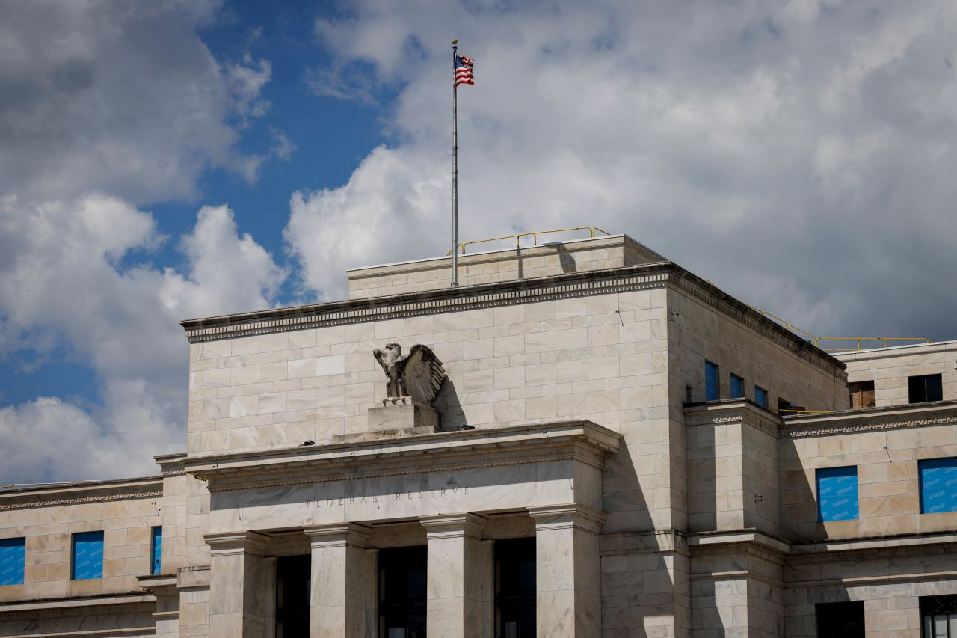

The Marriner S. Eccles Federal Reserve building is seen in Washington, DC, on August 21.

 Ting Shen/Bloomberg/Getty Images

Federal Reserve officials won’t say how former President Donald Trump [winning a second term could impact the economy](https://www.cnn.com/2024/09/10/economy/economy-plans-trump-harris/index.html), striving to stay apolitical. But transcripts of closed-door Fed meetings from Trump’s first term, now publicly available, give some clues about top economists’ true feelings about the former president’s economic agenda.

“The professed goal of the Trump administration, to get tough on trade, could lead not necessarily to better trade deals for the United States, but just a significant increase in trade barriers and the resultant bad set of consequences that would flow from that, including higher inflation,” William Dudley, then vice chair of the Fed, said at a monetary policy meeting that took place from January 31 to February 1, 2017.

“So it seems to me that we may be trading a greater likelihood of a sustained expansion over the next year or two for a greater likelihood of a hard landing later,” Dudley added. A hard landing refers to when the Fed is unable to bring inflation down without causing the economy to enter a recession.

Dudley, who is now president of Washington and Lee University, did not respond to CNN’s request for a comment.

If voted into office in the November presidential election, Trump has promised to [impose sweeping tariffs](https://www.cnn.com/2024/09/05/business/trump-economy-tariffs/index.html) of at least 10% on all foreign imports, up to 60% for some Chinese products, and levies as high as 100% for countries that abandon the dollar as their reserve currency.

If enacted, those policies could have [wide-reaching effects on the US economy](https://www.cnn.com/2024/09/12/business/trump-economy-tariffs-dollar/index.html) as well as economies across the globe.

The Fed declined to comment to CNN.

**Read more**[**here**](https://www.cnn.com/2024/09/15/economy/federal-reserve-concerns-about-trump/index.html)

1:32 a.m. 8:53:31, September 16, 2024

**Robert F. Kennedy Jr. claims he's under investigation for collecting whale's specimen**

From CNN's Veronica Stracqualursi and Aaron Pellish

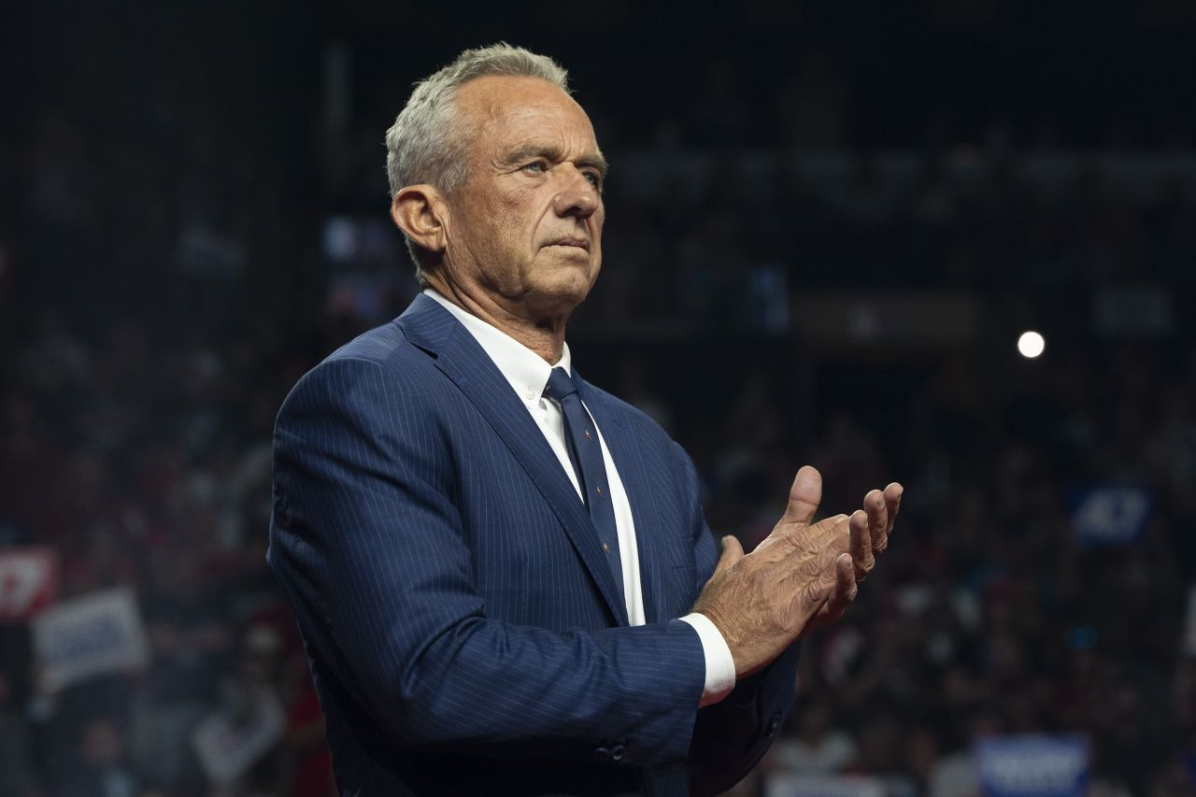

Former Republican presidential candidate Robert F. Kennedy Jr. listens during a campaign rally for Republican presidential nominee, former U.S. President Donald Trump at Desert Diamond Arena on August 23, in Glendale, Arizona.

Rebecca Noble/Getty Images

Former presidential candidate Robert F. Kennedy Jr. on Saturday claimed that he’s under investigation for [collecting a whale’s specimen](https://www.cnn.com/2024/08/27/politics/environmental-group-calls-for-investigation-rfk-jr-dead-whale/index.html) nearly two decades ago.

“This week I received, right after I endorsed President Trump, I received a letter from the National Marine Fisheries Institute saying that they were investigating me for collecting a whale’s specimen 20 years ago,” Kennedy said at a campaign event for Donald Trump in Glendale, Arizona.

Kennedy likely misspoke about the name of the investigating agency, as the National Marine Fisheries Services is an organization that falls under the National Oceanic and Atmospheric Administration. CNN has reached out to the agencies for comment.

On Saturday, Kennedy claimed he wrote a letter in response, accusing the investigators of killing whales and marine wildlife with “giant offshore wind farms off the East Coast.”

A story resurfaced last month that Kennedy once used a chainsaw to cut off the head of a dead whale carcass that washed onshore of his Cape Cod family home and then drove the whale head back to New York. The story was recounted by Kennedy’s daughter Kathleen “Kick” Kennedy in a 2012 interview with Town & Country Magazine.

An environmental group, the Center for Biological Diversity Action Fund, had called for Kennedy to be investigated over the incident, arguing in a letter to NOAA that his actions could have jeopardized scientific research .

2:14 a.m. 8:53:31, September 16, 2024

**Pennsylvania Gov. Josh Shapiro calls Vance "pathetic" over baseless claims about Haitian migrants**

From CNN's Jalen Beckford

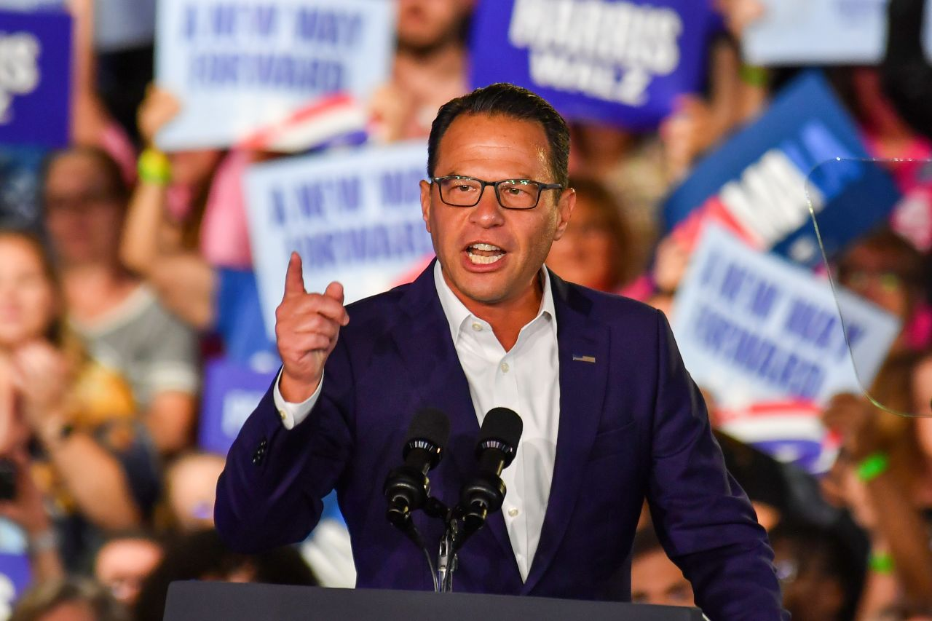

Pennsylvania Governor Josh Shapiro speaks during the campaign rally on September 13, in Wilkes-Barre, Pennsylvania.

Aimee Dilger/SOPA Images/LightRocket/Getty Images

Pennsylvania Gov. Josh Shapiro on Sunday condemned Republican vice presidential nominee and Ohio Sen. JD Vance for refusing to walk back his baseless claims that migrants are eating pets in Springfield, Ohio.

“This guy is so pathetic,” Shapiro said Sunday on “State of the Union,” adding “JD Vance should be ashamed of himself.”

Shapiro’s comments came after Vance defended false claims about Haitian immigrants eating pets earlier Sunday in an interview with CNN’s Dana Bash. Officials at the city and state level have repeatedly tried to end the rumor. Springfield officials have told press and city commission meetings that [there are no credible reports](https://www.cnn.com/2024/09/09/politics/republicans-vance-hatian-immigrants-pets-rumors/index.html) of animal abuse by immigrants in the area.

Shapiro also told CNN that he anticipates a close race between Trump and Vice President Kamala Harris in Pennsylvania but noted that he’s optimistic his state will show up for Harris.

“I think what I’m seeing more and more of is not just the folks who are lining up to vote for her, but those who are enthusiastic about her candidacy in communities that oftentimes are not enthusiastic about Democratic candidates — and encouraging their neighbors to be for them as well,” Shapiro said. “So I’m really hopeful.”

12:20 a.m. 8:53:31, September 16, 2024

**Trump claims without evidence it's “not possible” for USPS to “run the 2024 Presidential Election”**

From CNN's Kate Sullivan

Former President Donald Trump on Sunday continued raising doubts about [election integrity](https://www.cnn.com/2024/09/07/politics/elections-voting-security-what-matters/index.html) and claimed, without evidence, that it was “not possible” for the US Postal Service to properly “run the 2024 Presidential Election.”

“The United States Postal Service has admitted that it is a poorly run mess that is experiencing mail loss and delays at a level never seen before. With this being the FACT, how can we possibly be expected to allow or trust the U.S. Postal Service to run the 2024 Presidential Election? It is not possible for them to do so. HELP!” Trump [posted](https://truthsocial.com/@realDonaldTrump/posts/113141335012375231) on Truth Social.

While election officials have warned that the US Postal Service[may delay mail-in voting](https://www.cnn.com/2024/09/14/politics/video/smr-election-officials-warn-u-s-postal-service-may-delay-mail-in-voting), citing systemic issues in the postal service as more Americans prepare to cast their ballots by mail, there is no evidence that its “not possible” for the postal service to handle mail-in ballots.

11:44 p.m. 8:53:31, September 15, 2024

**Republican Ohio governor denies false rumor about pet-eating and praises Haitian immigrants**

From CNN’s Chris Boyette

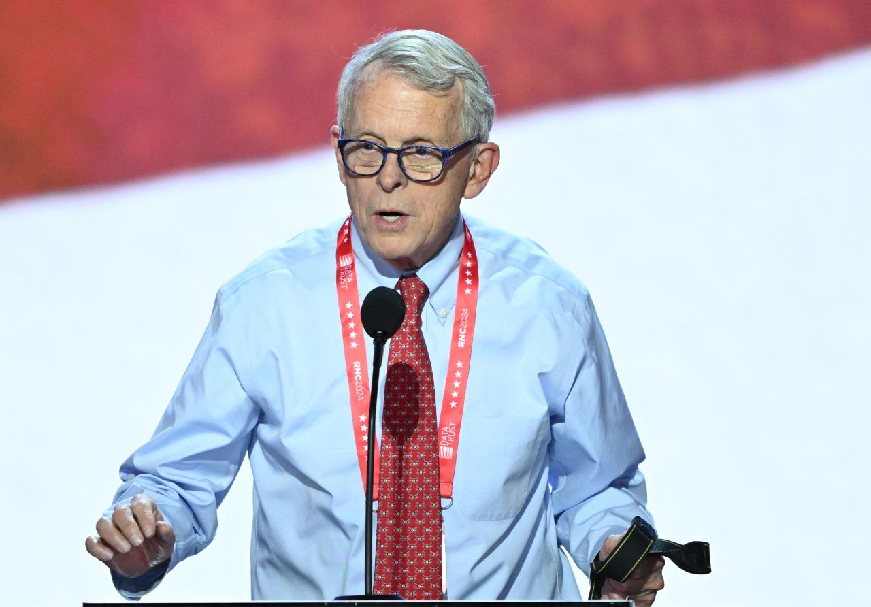

Ohio Governor Mike DeWine takes part in a sound check at the Fiserv Forum ahead of the 2024 Republican National Convention on July 14, in Milwaukee, Wisconsin.

Andrew Caballero-Reynolds/AFP/Getty Images

Republican Ohio Gov. Mike DeWine on Sunday flatly denied the [false rumor spread by Donald Trump](https://www.cnn.com/2024/09/14/politics/donald-trump-kamala-harris-laura-loomer/index.html) that Haitian immigrants are eating pets in Ohio and praised immigrants for their positive influence on the community.

“No. Absolutely not,” DeWine said when asked if he’d seen any evidence of the pet-eating rumor, a tale many Republicans, including Trump and his running mate, Ohio Sen. JD Vance, have promoted.

“Let me tell you what we do know, though. What we know is that the Haitians who are in Springfield are legal,” the governor said on ABC’s “This Week.”

“They came to Springfield to work.”

DeWine acknowledged the city was having some issues adjusting to the influx of mostly Haitian immigrants through a federal immigration program, but he said they were working to deal with the issues.

“When you go from a population of 58,000 and add 15,000 people onto that, you’re going to have some challenges and some problems,” the governor said. “And we’re addressing those. We’re working on those every single day.”

But the governor said the Haitian immigrants in Springfield are “positive influences” on the community and “any comment about that otherwise, I think is hurtful and is not helpful to the city of Springfield and the people of Springfield.”

11:42 p.m. 8:53:31, September 15, 2024

**Vance says "I've learned my lesson" on speaking for Trump**

From CNN's Kit Maher

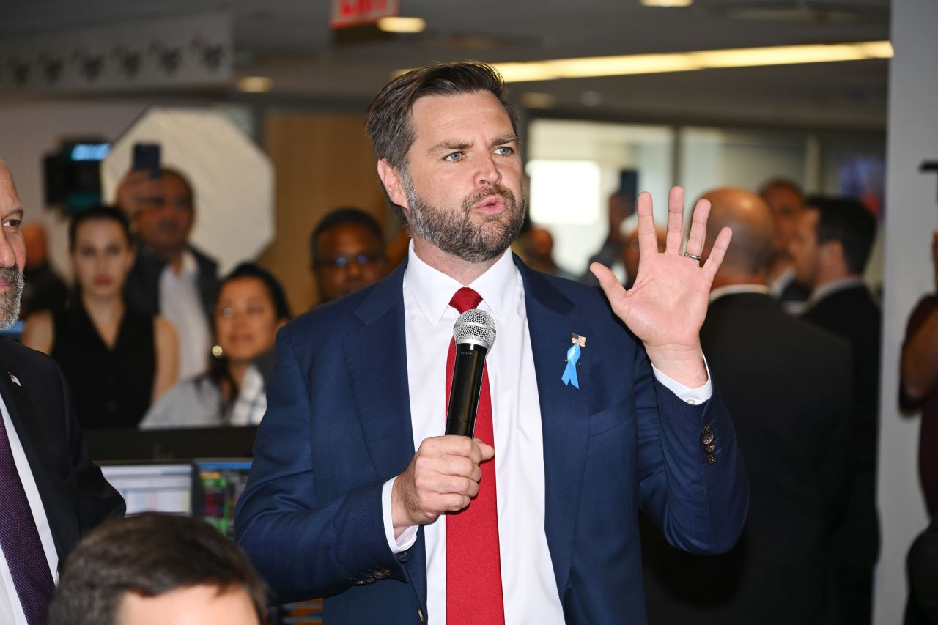

JD Vance attends Charity Day 2024 hosted by The Cantor Fitzgerald Relief Fund at BGC Group on September 11, in New York City

Dave Kotinsky/Getty Images

Republican vice presidential candidate JD Vance on Sunday said he learned his lesson about speaking for Donald Trump after [previously stating](https://www.cnn.com/2024/08/25/politics/video/jd-vance-trump-national-abortion-ban-veto-nr-digvid) the former president would veto a [national abortion ban](https://www.cnn.com/2024/07/17/politics/kfile-jd-vance-abortion-comments/index.html).

“I think that I’ve learned my lesson on speaking for the president before he and I have actually talked about an issue. What he has said at the debate, which is quite explicit, is he doesn’t support a national ban. He thinks it’s ridiculous to talk about vetoing a piece of legislation that isn’t going to come before the president in the first place,” Vance said on NBC’s “Meet the Press.”

On the debate stage, Trump said that [he doesn’t support a national abortion ban](https://www.cnn.com/2024/04/10/politics/trump-says-he-wouldnt-sign-federal-abortion-ban/index.html), but wouldn’t explicitly say he would veto one, rather that it wouldn’t make it through Congress.

“We hadn’t discussed it,” Vance said. “We still haven’t discussed it, by the way, because it’s not realistic.”

“I think that was the point that he made during the debate is he’s been incredibly clear that he doesn’t support a national abortion ban. He wants abortion policy to be made by the states, because he thinks, look, Alabama is going to make a different decision from California, and that’s okay. We’re a big country. We can disagree. The best way to actually facilitate us coming together despite that disagreement is by allowing each individual, individual state to make their own abortion policy,” Vance continued.

11:34 p.m. 8:53:31, September 15, 2024

**Vance seeks to distance Trump campaign from far-right agitator Laura Loomer**

From CNN's Kit Maher

Republican vice presidential candidate JD Vance on Sunday sought to distance the Trump campaign from [far-right agitator Laura Loomer](https://www.cnn.com/2024/09/13/politics/donald-trump-laura-loomer/index.html), stating that while he doesn’t agree with her comments about Vice President Kamala Harris, it is not “an issue of national import” or insulting to talk about “dietary preferences.”

Two days [before the ABC presidential debate](https://www.cnn.com/2024/09/12/politics/laura-loomer-donald-trump-influence/index.html), Loomer said if Harris, whose mother was from India, wins the 2024 election, “the White House will smell like curry & White House speeches will be facilitated via a call center.”

“Laura Loomer is not affiliated with the Trump campaign. She said something about curry in the White House that I first read about this morning, actually, because I knew that you would ask me about it,” Vance said on NBC’s “Meet the Press.” “I make a mean chicken curry. I don’t think that it’s insulting for anybody to talk about their dietary preferences or what they want to do in the White House.”

Pressed on whether he disavows those comments, especially considering his wife is the daughter of Indian immigrants, Vance said, “I just told you I don’t like those comments, and I think that we ought to focus on Kamala Harris’ policy failures.”

When Trump landed in Philadelphia on Tuesday before his debate against Vice Kamala Harris, Loomer was among the close allies seen deboarding his private plane. He said Friday that he doesn’t control Loomer, whom he described as a “free spirit” and “supporter.”

11:26 p.m. 8:53:31, September 15, 2024

**Trump posts, "I HATE TAYLOR SWIFT!"**

From CNN's Kate Sullivan

Former President Donald Trump on Sunday said he hates Taylor Swift, days after the pop megastar endorsed Vice President Kamala Harris.

“I HATE TAYLOR SWIFT!” Trump posted on his Truth Social platform

Swift endorsed Harris after the ABC presidential debate on Tuesday, ending speculation about whether she would share her political views ahead of November’s election.

“Recently I was made aware that AI of ‘me’ falsely endorsing Donald Trump’s presidential run was posted to his site. It really conjured up my fears around AI, and the dangers of spreading misinformation,” Swift posted on Instagram.

“It brought me to the conclusion that I need to be very transparent about my actual plans for this election as a voter,” Swift continued. “The simplest way to combat misinformation is with the truth. I will be casting my vote for Kamala Harris and Tim Walz in the 2024 Presidential Election.”

Asked about the endorsement on Fox News Wednesday morning, Trump cast Swift as a “very liberal person” and said she will “probably pay a price for it in the marketplace.”

11:50 p.m. 8:53:31, September 15, 2024

**Fact check: Trump falsely claims Harris is talking about bringing back the military draft**

From CNN's Daniel Dale

Former President Donald Trump has conjured up an inflammatory false claim about Vice President Kamala Harris’ policy positions — baselessly saying Friday that Harris is talking about forcing Americans to serve in the military.

Trump [claimed](https://www.youtube.com/live/Sv8HjnLGIiE?feature=shared&t=4311) at a rally in Las Vegas that voting for Harris means voting for war with Russia and voting to bring back the draft, a system in which some men are conscripted into involuntary service in the armed forces.

Trump continued: “Would anybody like to be drafted, in the audience? Because that’s what they’re doing. She’s already talking about bringing back the draft. She wants to bring back the draft, and draft your child, and put them in a war that should never have happened.”

**Facts First**: *Trump’s claim is false. Harris is not talking about bringing back the draft and has not put forward any proposals to bring back the draft.*

Trump’s campaign did not respond Saturday to CNN’s requests for any evidence for his claim. A Harris campaign aide said, “We have no idea what he’s talking about.”

The US [has not had a draft](https://www.cnn.com/2020/01/03/politics/military-draft-selective-service-site-crash-trnd/index.html) [since 1973](https://www.sss.gov/history-and-records/), the year it completed its military withdrawal from Vietnam. (Trump [received five draft deferments](https://www.nytimes.com/2016/08/02/us/politics/donald-trump-draft-record.html) during the Vietnam War draft, four because he was a college student and a fifth on account of a doctor’s diagnosis of bone spurs in his heels.) Since 1973, the country has used an [all-volunteer force](https://www.defense.gov/News/News-Stories/Article/Article/3316678/all-volunteer-force-proves-successful-for-us-military/).

Regardless of the wishes of any president, launching a new draft [would require Congress to pass legislation](https://www.sss.gov/about/return-to-draft/#:~:text=Draft%20Authorization%3A%20Congress%20and%20the,personnel%20into%20the%20Armed%20Forces.).

10:57 p.m. 8:53:31, September 15, 2024

**JD Vance defends baseless rumor about Haitian immigrants eating pets**

From CNN's Kit Maher

Republican vice presidential candidate JD Vance on Sunday defended false claims about Haitian immigrants eating the pets of residents in Springfield, Ohio in an interview with CNN’s Dana Bash on “State of the Union.”

Asked to support his claims, Vance pointed to what he said are firsthand accounts from constituents who have told him this is happening, though he didn’t provide the evidence.

“The American media totally ignored this stuff until Donald Trump and I started talking about cat memes. If I have to create stories so that the American media actually pays attention to the suffering of the American people, then that’s what I’m going to do,” Vance said on CNN’s State of the Union.

Bash replied, “You just said that this is a story that you created.”

Vance said, “It comes from firsthand accounts from my constituents. I say that we’re creating a story, meaning we’re creating the American media focusing on it. I didn’t create 20,000 illegal migrants coming into Springfield thanks to Kamala Harris’ policies. Her policies did that. But yes, we created the actual focus that allowed the American media to talk about this story and the suffering caused by Kamala Harris’ policies.”

The city of Springfield notes on its website that approximately 12,000 to 15,000 immigrants live in Clark County, and that Haitian immigrants are there legally as part of a parole program that allows citizens and lawful residents to apply to have their family members from Haiti come to the United States.

Local officials at the city and state level have repeatedly tried to end the rumor about immigrants eating pets. Springfield officials have told press and city commission meetings that [there are no credible reports](https://www.cnn.com/2024/09/09/politics/republicans-vance-hatian-immigrants-pets-rumors/index.html) of animal abuse by immigrants in the area.

On Tuesday, Vance said it’s possible the false claim might not be true, but he encouraged his followers to continue posting “cat memes.”

As CNN reported, Springfield Mayor Rob Rue said Thursday that the claims are “hurting our citizens and hurting our community,” adding it’s “frustrating” that some of the rhetoric is coming from Vance.

10:19 p.m. 8:53:31, September 15, 2024

**Buttigieg swipes at Trump campaign over baseless claims of immigrants eating pets in Ohio**

From CNN's Sam Fossum

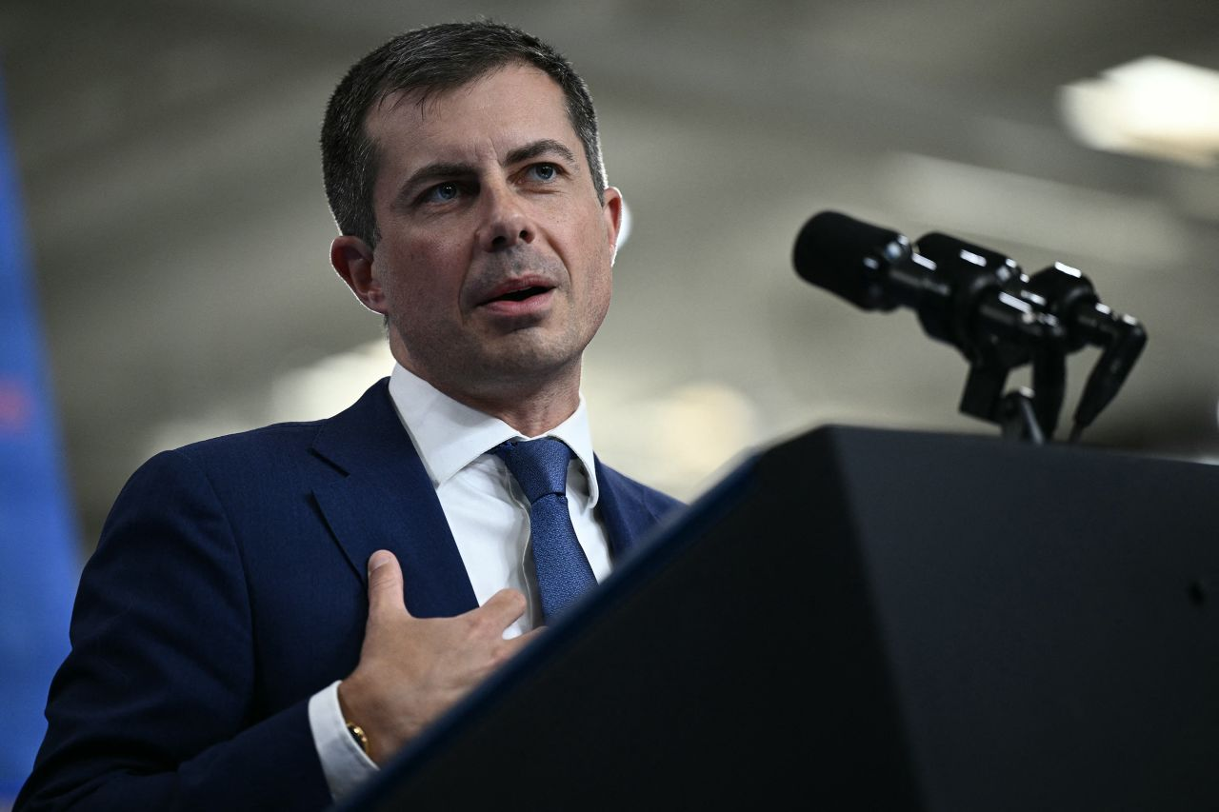

US Transportation Secretary Pete Buttigieg speaks in Ann Arbor, Michigan on September 6.

Brendan Smialowski/AFP/Getty Images

US Transportation Secretary Pete Buttigieg on Sunday swiped at former President Donald Trump over the [baseless claims he’s pushed that immigrants in Springfield, Ohio are eating pets](https://www.cnn.com/2024/09/14/politics/donald-trump-kamala-harris-laura-loomer/index.html).

“Let’s be very clear that community and the very real people who are dealing with some really ugly stuff right now, like the bomb threats, are having that inflicted on them as part of the strategy from a campaign that wants to talk about anything but their actual record and their actual agenda,” Buttigieg said Sunday on NBC’s “Meet the Press.”

Local officials at the city and state level have repeatedly tried to end the rumor. Springfield officials have told press and city commission meetings that [there are no credible reports](https://www.cnn.com/2024/09/09/politics/republicans-vance-hatian-immigrants-pets-rumors/index.html) of animal abuse by immigrants in the area.

Buttigieg continued, “They go for something that is so outrageous that you actually can’t ignore it. The media can’t ignore what’s going on, because very real pain has been inflicted on and fear, by the way, on people in this community and other communities around the country.”

9:31 p.m. 8:53:31, September 15, 2024

**Manchin signals he could endorse Harris while Romney stays coy**

By CNN's Manu Raju and Morgan Rimmer

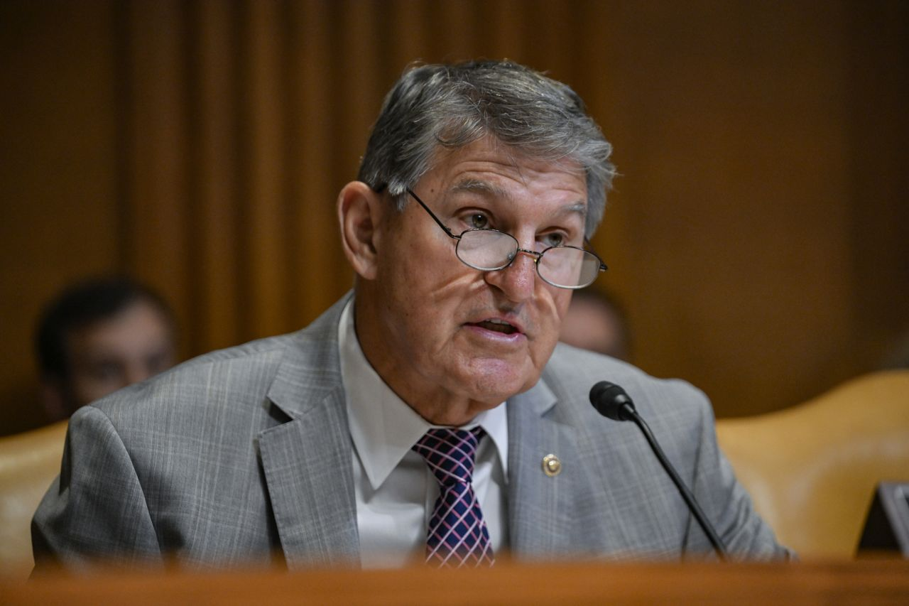

Senator Joe Manchin speaks during a Senate Appropriations Subcommittee hearing on June 4, in Washington, DC.

Celal Gunes/Anadolu/Getty Images

Sen. Joe Manchin, the conservative [Democrat-turned-independent](https://www.cnn.com/2024/05/31/politics/joe-manchin-registers-independent/index.html) who had toyed with a presidential run and has long been a thorn in the side of the left, has been mum about the candidate he’s backing in November.

But that could soon change, as Manchin signaled he may get off the sidelines and plans to speak to Vice President Kamala Harris soon.

“Oh I could see that, yes,” Manchin told CNN when asked if he’d endorse a candidate before November.

Sen. Mitt Romney, the Republican Party’s 2012 presidential nominee who voted [twice to convict former President Donald Trump](https://www.cnn.com/2020/02/05/politics/mitt-romney-impeachment-vote-remarks/index.html) in his impeachment trials, reiterated his disdain for Trump – and objected to the former president’s refusal to say at last week’s debate that he wanted Ukraine to win its war against Russia.

Asked twice if he could endorse Harris, Romney pointedly refused to say.

“I’m certainly not going to be voting for former President Trump, and I think that’s been very clear,” Romney said.

The comments by Manchin and Romney – two retiring senators who have been on the outs with their respective party’s base – underscore how Trump has turned off some more moderate voters but also how Harris herself has yet to close the deal with right-leaning voters turned off by the former president.

A third Trump detractor, GOP Sen. Lisa Murkowski of Alaska, doesn’t plan to vote for Harris, even as she said of the former president’s debate performance, “I don’t think it was Donald Trump’s best evening.”

***Read more***[***here***](https://www.cnn.com/2024/09/15/politics/joe-manchin-mitt-romney-intv/index.html)***.***

12:26 a.m. 8:53:31, September 16, 2024

**University in Springfield, Ohio, taking “extreme precautions” after campus shooting threat targeting Haitians**

From CNN’s Paradise Afshar

Wittenberg University in Springfield, Ohio, is taking “extreme precautions” in response to an email that threatened an on-campus shooting targeting Haitians on Sunday, according to university officials.

The threat comes as several prominent Republicans, including former President Donald Trump and his running mate, Sen. JD Vance, have promoted false claims that Haitian migrants in Ohio are killing and eating family pets.

Local officials at the city and state level have repeatedly tried to end the rumor. Springfield officials have told press and city commission meetings that [there are no credible reports](https://www.cnn.com/2024/09/09/politics/republicans-vance-hatian-immigrants-pets-rumors/index.html) of animal abuse by immigrants in the area.

The threat to Wittenberg University “targeted Haitian members of our community,” a [statement released Saturday](https://www.wittenberg.edu/alert) said. “Wittenberg Police are cooperating with the Springfield Police Division and the FBI to investigate this threat.”

All activities have been canceled on Sunday, and the Springfield Police Division will increase patrols on campus, the university’s statement said, adding that those who are on or near campus should “prepare for additional instructions or a lockdown if we learn more from the ongoing investigation.”

“University administrators recognize that the city of Springfield has experienced an increase of threats to local government, businesses, and schools in the past week,” the statement from Wittenberg University said. “We take this threat seriously and will provide updates to the campus as we learn more about the situation.**”**

Wittenberg University had 1,288 undergraduate students enrolled in the fall 2023 term, according to its [website.](https://www.wittenberg.edu/about/witt-by-the-numbers)

CNN has reached out to the Wittenberg Police Department for additional information.

8:38 p.m. 8:53:31, September 15, 2024

**How a false rumor about pets in Ohio and Laura Loomer’s presence helped derail Trump’s planned attacks on Harris**

From CNN's Eric Bradner

[Donald Trump](https://www.cnn.com/politics/president-donald-trump-45) wanted to spend this week attacking one of Democratic rival Kamala Harris’ biggest political vulnerabilities. Instead, he spent most of the week falsely claiming that migrants are eating pets in a small town in Ohio and defending his embrace of a far-right agitator whose presence is causing concern among his allies.

Trump’s repeated parroting of unfounded social media rumors about Haitian migrants in Ohio eating pets stole headlines during a trip West, including stops in Arizona and Nevada, late this week. The promotion of the claims overshadowed a series of speeches aimed at the economy and blaming Harris for border security failures.

Trump, in a news conference in California on Friday, promised “large deportations” from Springfield, Ohio — the town that has become a political flashpoint as Republicans, including Trump and his running mate, Ohio Sen. JD Vance, spread [false claims about Haitian immigrants eating pets](https://www.cnn.com/2024/09/12/politics/springfield-ohio-migrants-jd-vance/index.html).

The city of Springfield notes on its website that approximately 12,000 to 15,000 immigrants live in Clark County, and that Haitian immigrants are there legally as part of a parole program that allows citizens and lawful residents to apply to have their family members from Haiti come to the United States.

***Read more***[***here***](https://www.cnn.com/2024/09/14/politics/donald-trump-kamala-harris-laura-loomer/index.html)***.***

9:25 p.m. 8:53:31, September 15, 2024

**New poll finds no change in presidential race post-debate**

From CNN's Jennifer Agiesta

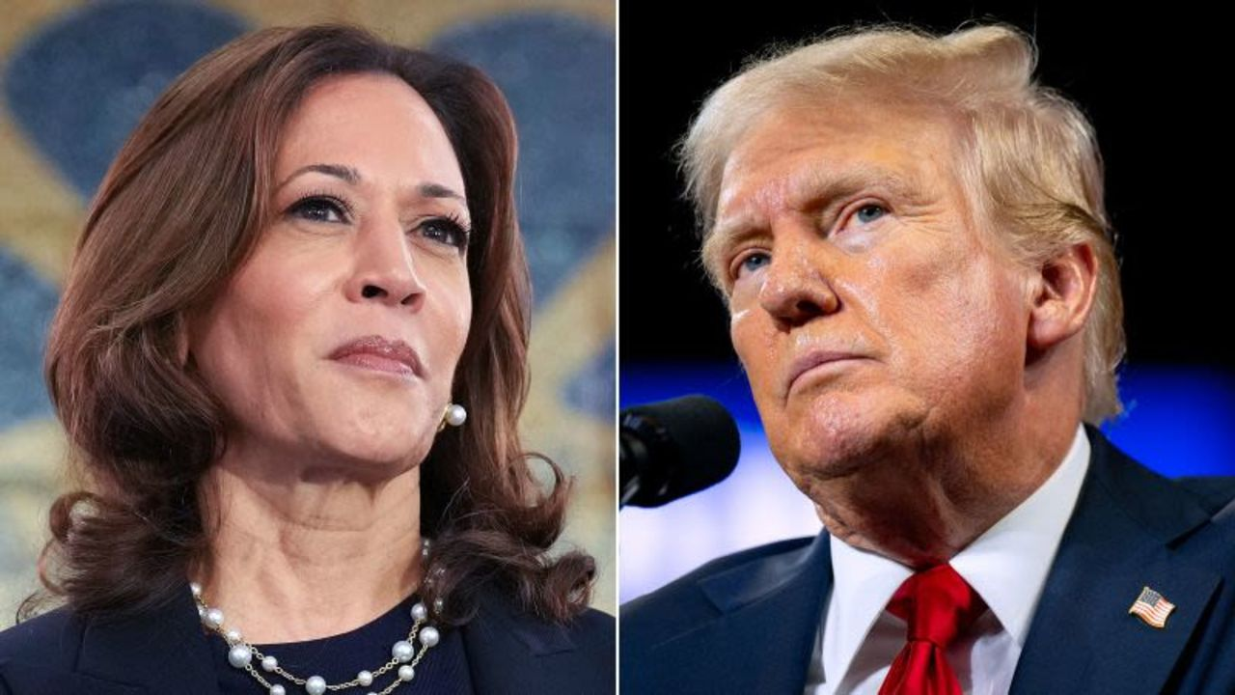

Vice President Kamala Harris and former President Donald Trump.

Getty Images

New polling post-debate from [ABC News and Ipsos](https://abcnews.go.com/Politics/harris-debate-winner-maintaining-slight-lead-trump-poll/story?id=113673862) finds Vice President Kamala Harris leading former President Donald Trump among likely voters, with the margin in the race unchanged from ABC News polling conducted in late August.

Overall, 52% of likely voters back Harris, 46% Trump in the poll, the same margin the pollsters found among likely voters in an August 23 through 27 poll.

* Among likely voters, Harris holds an edge among independent likely voters (53% to 44%).
* Women who are likely to vote break for Harris 55% to 44%, while men likely voters split evenly, 49% for each.
* The survey suggests Harris holds a wide advantage among likely voters younger than 30, 59% back her compared with 40% for Trump, including a 38-point advantage among younger women in that group (68% Harris to 30% Trump) even though men in that same category split almost evenly, 51% Harris to 48% Trump.

Among adults, the survey suggests little change in the dynamic between the candidates on the campaign’s central issues. Trump continues to be more widely trusted to handle the economy (46% Trump to 39% Harris) and immigration (47% Trump to 37% Harris), while Harris is broadly more trusted on abortion (48% Harris to 34% Trump) and protecting American democracy (45% Harris to 38% Trump).

The ABC News poll was conducted online Sept. 11-13 among a random national sample of 3,276 adults and has a margin of sampling error of plus or minus 2 points. For results among the 2,196 likely voters, the error margin is plus or minus 2 points.

8:18 p.m. 8:53:31, September 15, 2024

**How a battle over Nebraska's election laws could have a major impact on the presidential race**

From CNN's Jeff Zeleny

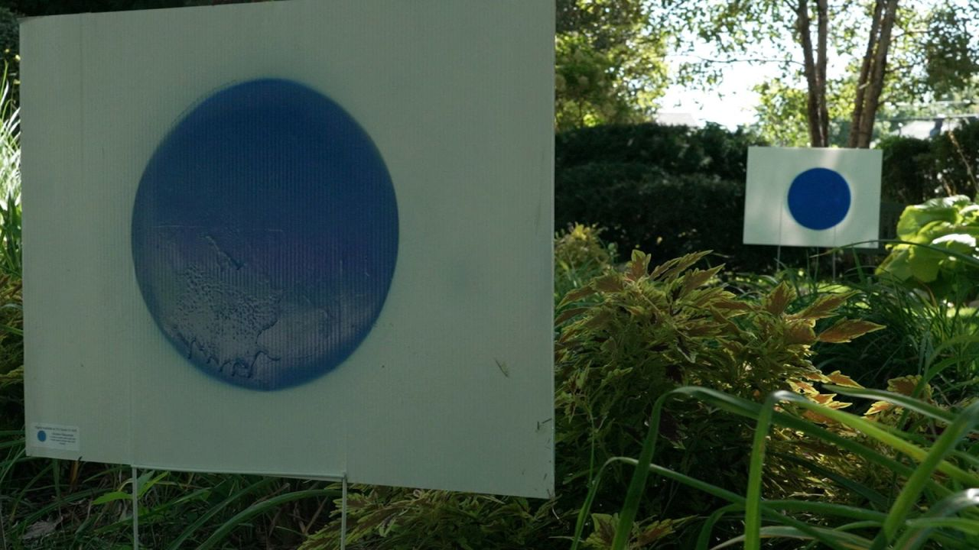

This screengrab from a video shows yard signs with blue circles in Omaha, Nebraska. The signs, made by Kamala Harris supporter Jason Brown, represent the "blue dot" of Omaha in a sea of Nebraska red.

CNN

Vice President Kamala Harris’ campaign and Nebraska Democratic officials are keeping a close eye on any [last-minute efforts to change the election law](https://www.cnn.com/politics/live-news/trump-harris-election-09-14-24#h_a77e405b500771fc714b901a75ab0ed0) that awards the state’s electoral votes by congressional district, rather than statewide winner.

Nebraska’s unique law presents an opportunity for Democrats to secure one of the state’s votes by winning the district surrounding Omaha — a [critical blue dot](https://www.cnn.com/2024/09/04/politics/nebraska-2nd-district-electoral-vote/index.html) in a sea of red.

The state’s Republican Gov. Jim Pillen made it clear Friday that he is willing to call a special legislative session on changing the state to a “winner takes all” model before the November election — but said in a statement that he doesn’t yet have “concrete and public indication” that enough lawmakers would back the move.

Nebraska Democratic chairwoman Jane Kleeb said Saturday that Pillen’s statement signals Republicans “do not have the votes to change the fair electoral system we have in Nebraska.”

“Both Trump and Harris have the ability to compete for Nebraskans’ votes,” Kleeb told CNN. “Democrats take our responsibilities seriously and are spending our time knocking doors, calling voters and putting out yard signs rather than wasting our time bullying elected officials, which is all the Republicans seem to be doing these days.”

When the matter of changing the law came up for a vote in the state legislature earlier this year, it was 17 votes shy of passing. Kleeb said Saturday that those 17 votes remain “very solid.”

**Bottom line:**If Vice President Kamala Harris can win the “blue wall” states of Wisconsin, Michigan and Pennsylvania, plus the blue dot vote in Nebraska, she can likely reach 270 electoral votes without winning a single other contested battleground state.

That means a potential change to the law — which would be a shocking development so close to the election — could have serious implications for each presidential campaign.

11:59 p.m. 8:53:31, September 15, 2024

**Walz appeals to voters considering leaving Harris over Gaza, saying Trump offers them "nothing"**

From CNN's Aaron Pellish

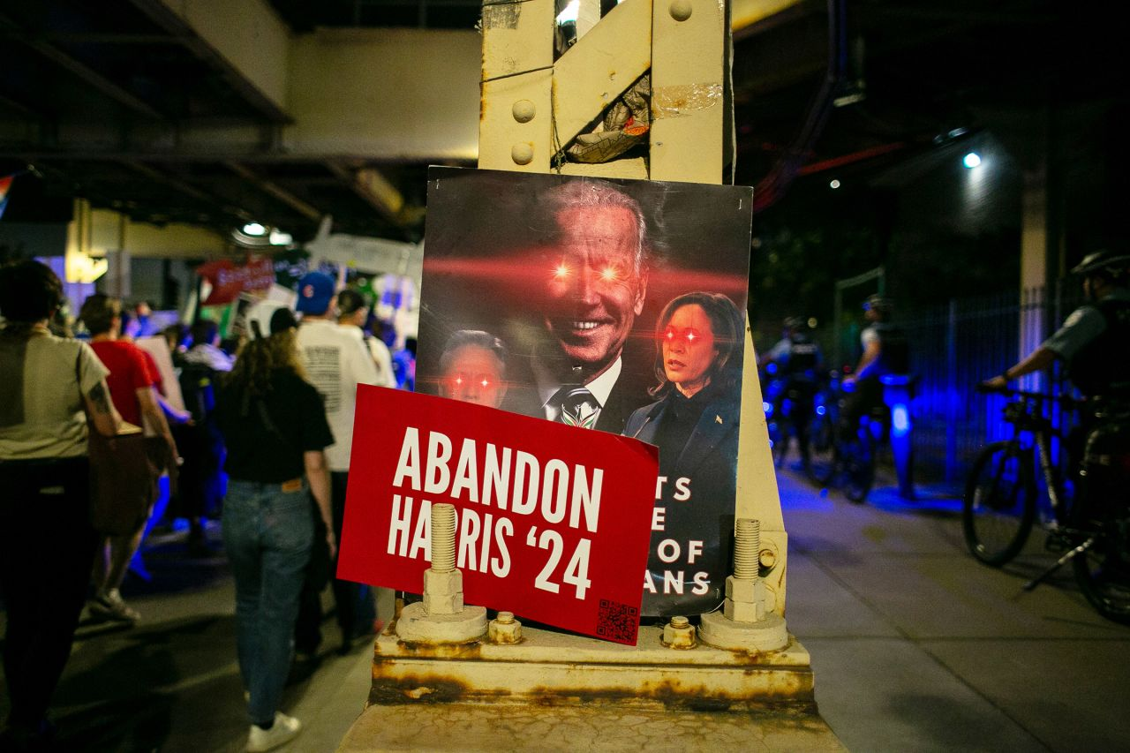

Pro-Palestine signs are displayed in the street near the United Center in Chicago, Illinois, where the Democratic National Convention is being held, on August 22.

Jim Vondruska/Getty Images/File

Democratic vice presidential nominee Tim Walz made a direct pitch to Muslim and Arab American voters in Michigan, addressing those concerned about the Biden administration’s handling of the war in Gaza.

The Minnesota governor used an interview Friday to reiterate Vice President Kamala Harris’ support for a ceasefire-hostage deal between Israel and Hamas, and argued Trump’s record of targeting Muslim Americans is “not in your best interest.”

Harris is more cognizant of the suffering of Palestinians than Trump, Walz said in the interview with WXMI in Grand Rapids, Michigan, addressing those from the [“Abandon Harris” movement](https://www.cnn.com/2024/08/20/politics/dnc-protests-day-2/index.html).

Illustrating the [constant balancing act](https://www.cnn.com/2024/08/08/politics/harris-gaza-conflict-campaign-trail/index.html) for the Democratic ticket on the Middle East, Walz also emphasized the importance of Israel’s self-defense.

“Kamala Harris has been clear. She’ll defend Israel’s right to defend itself — making sure, though, that we need to get a ceasefire that returns these hostages as part of that, and understands that the human suffering that’s happening in Gaza has to end,” Walz said.

“That’s why she’s the person to move us toward a two-state solution, where Israel can be protected, we get our hostages back, and Gaza can be self-determined,” he added.

Walz contrasted Harris’ view with Trump’s previous support of a travel ban that targeted people from Muslim-majority countries, and his calls to [send some](https://x.com/realDonaldTrump/status/1150381394234941448) Muslim members of Congress to their countries of origin.

“Donald Trump is offering you nothing,” Walz said, to voters skeptical of Harris over the issue. “That is not in your best interest.”

窗体顶端

窗体底端

* [**US**](https://www.cnn.com/us)
  + [Crime + Justice](https://www.cnn.com/us/crime-and-justice)
* [**World**](https://www.cnn.com/world)
  + [Africa](https://www.cnn.com/world/africa)
  + [Americas](https://www.cnn.com/world/americas)
  + [Asia](https://www.cnn.com/world/asia)
  + [Australia](https://www.cnn.com/world/australia)
  + [China](https://www.cnn.com/world/china)
  + [Europe](https://www.cnn.com/world/europe)
  + [India](https://www.cnn.com/world/india)
  + [Middle East](https://www.cnn.com/world/middle-east)
  + [United Kingdom](https://www.cnn.com/world/united-kingdom)
* [**Politics**](https://www.cnn.com/politics)
  + [SCOTUS](https://www.cnn.com/politics/supreme-court)
  + [Congress](https://www.cnn.com/politics/congress)
  + [Facts First](https://www.cnn.com/politics/fact-check)
  + [2024 Elections](https://www.cnn.com/election/2024)
* [**Business**](https://www.cnn.com/business)
  + [Tech](https://www.cnn.com/business/tech)
  + [Media](https://www.cnn.com/business/media)
  + [Calculators](https://www.cnn.com/business/financial-calculators)
  + [Videos](https://www.cnn.com/business/videos)
* [**Markets**](https://www.cnn.com/markets)
  + [Pre-markets](https://www.cnn.com/markets/premarkets)
  + [After-Hours](https://www.cnn.com/markets/after-hours)
  + [Fear & Greed](https://www.cnn.com/markets/fear-and-greed)
  + [Investing](https://www.cnn.com/business/investing)
  + [Markets Now](https://www.cnn.com/business/markets-now)
  + [Nightcap](https://www.cnn.com/business/markets/nightcap)
* [**Health**](https://www.cnn.com/health)
  + [Life, But Better](https://www.cnn.com/interactive/life-but-better/)
  + [Fitness](https://www.cnn.com/health/life-but-better/fitness)
  + [Food](https://www.cnn.com/health/life-but-better/food)
  + [Sleep](https://www.cnn.com/health/life-but-better/sleep)
  + [Mindfulness](https://www.cnn.com/health/life-but-better/mindfulness)
  + [Relationships](https://www.cnn.com/health/life-but-better/relationships)
* [**Entertainment**](https://www.cnn.com/entertainment)
  + [Movies](https://www.cnn.com/entertainment/movies)
  + [Television](https://www.cnn.com/entertainment/tv-shows)
  + [Celebrity](https://www.cnn.com/entertainment/celebrities)
* [**Tech**](https://www.cnn.com/business/tech)
  + [Innovate](https://www.cnn.com/business/tech/innovate)
  + [Foreseeable Future](https://www.cnn.com/business/tech/foreseeable-future)
  + [Mission: Ahead](https://www.cnn.com/business/tech/mission-ahead)
  + [Work Transformed](https://www.cnn.com/business/work-transformed)
  + [Innovative Cities](https://www.cnn.com/business/tech/innovative-cities)
* [**Style**](https://www.cnn.com/style)
  + [Arts](https://www.cnn.com/style/arts)
  + [Design](https://www.cnn.com/style/design)
  + [Fashion](https://www.cnn.com/style/fashion)
  + [Architecture](https://www.cnn.com/style/architecture)
  + [Luxury](https://www.cnn.com/style/luxury)
  + [Beauty](https://www.cnn.com/style/beauty)
  + [Video](https://www.cnn.com/style/videos)
* [**Travel**](https://www.cnn.com/travel)
  + [Destinations](https://www.cnn.com/travel/destinations)
  + [Food & Drink](https://www.cnn.com/travel/food-and-drink)
  + [Stay](https://www.cnn.com/travel/stay)
  + [News](https://www.cnn.com/travel/news)
  + [Videos](https://www.cnn.com/travel/videos)
* [**Sports**](https://www.cnn.com/sports)
  + [Pro Football](https://bleacherreport.com/nfl)
  + [College Football](https://bleacherreport.com/college-football)
  + [Basketball](https://bleacherreport.com/nba)
  + [Baseball](https://bleacherreport.com/mlb)
  + [Soccer](https://bleacherreport.com/world-football)
  + [Olympics](https://www.cnn.com/sport/paris-olympics-2024)
  + [Hockey](https://bleacherreport.com/nhl)
* [**Watch**](https://www.cnn.com/videos)
  + [Live TV](https://www.cnn.com/live-tv)
  + [CNN Headlines](https://www.cnn.com/videos/fast/cnn-headlines)
  + [CNN Shorts](https://www.cnn.com/shorts/cnn-shorts)
  + [Shows A-Z](https://www.cnn.com/specials/tv/all-shows)
  + [CNN10](https://www.cnn.com/cnn10)
  + [CNN Max](https://www.max.com/channel/cnn-max)
  + [CNN TV Schedules](https://www.cnn.com/tv/schedule/cnn)
  + [FlashDocs](https://www.cnn.com/subscription/video/flashdocs/library)
* [**Listen**](https://www.cnn.com/audio)
  + [CNN 5 Things](https://www.cnn.com/audio/podcasts/5-things)
  + [Chasing Life with Dr. Sanjay Gupta](https://www.cnn.com/audio/podcasts/chasing-life)
  + [The Assignment with Audie Cornish](https://www.cnn.com/audio/podcasts/the-assignment)
  + [One Thing](https://www.cnn.com/audio/podcasts/one-thing)
  + [Tug of War](https://www.cnn.com/audio/podcasts/tug-of-war)
  + [CNN Political Briefing](https://www.cnn.com/audio/podcasts/political-briefing)
  + [The Axe Files](https://www.cnn.com/audio/podcasts/axe-files)
  + [All There Is with Anderson Cooper](https://www.cnn.com/audio/podcasts/all-there-is-with-anderson-cooper)
  + [All CNN Audio podcasts](https://www.cnn.com/audio)
* [**CNN Underscored**](https://www.cnn.com/cnn-underscored)
  + [Electronics](https://www.cnn.com/cnn-underscored/electronics)
  + [Fashion](https://www.cnn.com/cnn-underscored/fashion)
  + [Beauty](https://www.cnn.com/cnn-underscored/beauty)
  + [Health & Fitness](https://www.cnn.com/cnn-underscored/health-fitness)
  + [Home](https://www.cnn.com/cnn-underscored/home)
  + [Reviews](https://www.cnn.com/cnn-underscored/reviews)
  + [Deals](https://www.cnn.com/cnn-underscored/deals)
  + [Gifts](https://www.cnn.com/cnn-underscored/gifts)
  + [Travel](https://www.cnn.com/cnn-underscored/travel)
  + [Outdoors](https://www.cnn.com/cnn-underscored/outdoors)
  + [Pets](https://www.cnn.com/cnn-underscored/pets)
  + [CNN Store](https://store.cnn.com/?utm_source=cnn.com&utm_medium=referral&utm_campaign=navbar)
* [**Science**](https://www.cnn.com/science)
  + [Space](https://www.cnn.com/science/space)
  + [Life](https://www.cnn.com/science/life)
  + [Unearthed](https://www.cnn.com/science/unearthed)
* [**Climate**](https://www.cnn.com/climate)
  + [Solutions](https://www.cnn.com/climate/solutions)
  + [Weather](https://www.cnn.com/weather)
* [**Weather**](https://www.cnn.com/weather)
  + [Video](https://www.cnn.com/weather/video)
  + [Climate](https://www.cnn.com/climate)
* [**Ukraine-Russia War**](https://www.cnn.com/world/europe/ukraine)
* [**Israel-Hamas War**](https://www.cnn.com/world/middleeast/israel)
* [**About CNN**](https://www.cnn.com/about)
  + [Subscribe](https://www.cnn.com/subscription?source=sub_web_footersubnav-link)
  + [Photos](https://www.cnn.com/world/photos)
  + [Investigations](https://www.cnn.com/us/cnn-investigates)
  + [CNN Profiles](https://www.cnn.com/profiles)
  + [CNN Leadership](https://www.cnn.com/profiles/cnn-leadership)
  + [CNN Newsletters](https://www.cnn.com/newsletters)
  + [Work for CNN](https://careers.wbd.com/cnnjobs)

[**Politics**](https://www.cnn.com/politics)

[Watch](https://www.cnn.com/video)[Listen](https://www.cnn.com/audio)[Live TV](https://www.cnn.com/live-tv)

**Follow CNN Politics**

Sign in

[Terms of Use](https://www.cnn.com/terms)[Privacy Policy](https://www.cnn.com/privacy)[Cookie Settings](https://edition.cnn.com/politics/live-news/trump-harris-election-09-15-24/index.html)[Ad Choices](https://www.cnn.com/ad-choices)[Accessibility & CC](https://www.cnn.com/accessibility)[About](https://www.cnn.com/about)[Subscribe](https://www.cnn.com/subscription?source=sub_web_footerlink-link)[Newsletters](https://www.cnn.com/newsletters)[Transcripts](https://www.cnn.com/transcripts)[Help Center](https://help.cnn.com/)

© 2024 Cable News Network. A Warner Bros. Discovery Company. All Rights Reserved.  
CNN Sans ™ & © 2016 Cable News Network.